headline
By Sanjay Deshpande
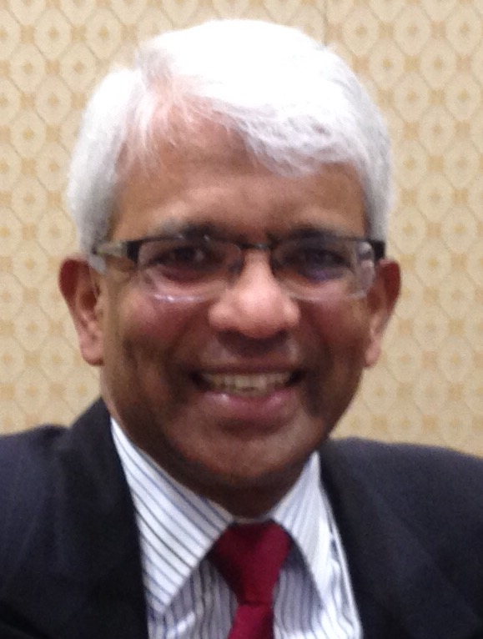
Article here.

If you have any questions, please contact either District Grants Subcommittee Chair Jorge Yarzebski at yj.rotary@gmail.com or me, District Foundation Committee Chair Sanjay Deshpande, sanjdesh51@aol.com.

For the Foundation Notes archive, click here

Learn more about District 7910 Foundation Grants:
- Rotary Areas of Focus Policy Statements (PDF Format)
- District 7910 Eligible and Ineligible Activities in a District Grant (Word Format)
- Timeline for District 7910 Foundation Grants (Web Page)
- District 7910 Grant Qualification Table (Excel Format)
- District 7910 Grant Proposals and Qualifications Status (Web Page)
- District 7910 2015-2016 Foundation Contributions Report - (Excel Format)
- Foundation Grants in 2016-'17 and Beyond (PDF Format)
- District 7910 2016-2017 District Grant Proposal Template (PDF Format)
- District Grant Proposal Form (Word Format)
- Global Grant Proposal Form (Word Format)
- District 7910 District Grants Scoring Rubric (PDF format)
- District 7910 Club Memorandum of Understanding (PDF Format)

Return to October 3 Newsletter

View past issues
Visit our website
'Like' our Facebook page
'Follow' our Twitter page

