Headline here
By Karin Gaffney
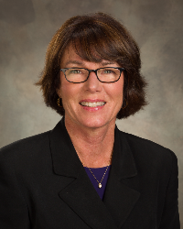
Article here.

District Governor-Elect Karin Gaffney may be reached at karin.gaffney@rocklandtrust.com.
Return to October 3 Newsletter

View past issues
Visit our website
'Like' our Facebook page
'Follow' our Twitter page

