GOVERNOR'S MESSAGE
Nomination Process 101
By Pat and Skip Doyle
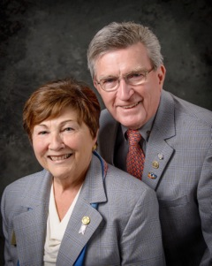As a retired Social Studies teacher, Pat is very disturbed with the current lack of knowledge exhibited by voters concerning our election process. She feels this should not be the case for Rotarians in District 7910 when it comes to our process for choosing a District Governor. This has led us to develop a crash course: Nomination Process 101 District 7910.
An invitation is sent by August 15 each year to all clubs in the district to propose qualified candidates for District Governor Nominee, for 2018-2019. The invitation will outline the procedures to follow, the qualifications required and the necessary form to fill out. The deadline for receiving these nominations is October 15.

Regarding District Governor for '19-'20, all applicants must have served as a club president and have been in Rotary for a minimum of seven years.

The District Nominating Committee shall schedule and conduct interviews of the candidates proposed by the clubs. The committee may nominate additional candidates it feels would also fulfill the requirements. The committee submits its selection to the governor no later than December 1.

Further guidelines can be found on page 177 of the District Directory or in the District Resolutions.

It is a fundamental principle in Rotary that the best-qualified candidate should be selected for service in Rotary’s elective offices. Therefore, any effort to influence the selection process in either a positive or negative manner by campaigning, canvassing, electioneering or otherwise is prohibited under the Rotary International Bylaws.
District Governor and Trustee Nomination Time
Remember that even though the Nominating Committee can only choose one District Governor each year, all Past Presidents are eligible to be considered. We have met so many qualified Past Presidents as we visited Clubs, and as we say any one of you could be District Governor. Give it a try. The application deadline is this October 15.

More than likely, all of you are just as tired as we are about elections, voting and candidates. But this reminder is for all Rotarians. Now is the time for Clubs to nominate candidates for the very important positions of District Governor and Trustee. Please review the nomination details and nomination forms, below. We hope to hear from many Clubs because there are so many potential candidates among our members.

Nomination Details
Nominating Form Supplemental Statement
District Governor Nomination Form
Trustee Nominating Form
Always remember, you can call us with questions at 508-393-9031.

District Governors Pat and Skip Doyle may be reached at pwdoyle2@verizon.net and skipdoyle2@verizon.net, respectively.

Click here to submit content for the October 10 issue to Immediate Past District Governor/Newsletter Editor Jim Fusco.

Click here for past issues.

WELCOME, NEW ROTARIANS
Please join us in welcoming these new Rotarians to clubs in our District (alphabetical by last name):
Hollie Calderon, Westborough
Ray Donovan, Southborough
Thomas Gray, Fitchburg
Alan Herzog, Marlborough
Tracy LaFeur, Fitchburg
Bopha Malone, Bedford
Laura O'Callaghan, Milford
Harold Pinkham, Westborough
Jennifer Sanderson, Fitchburg

CLUB MEMBERSHIP GROWTH, ’16-‘17
We share with you the results of club-membership growth in our district during Rotary year 2016-2017, which began July 1.

This is a unique opportunity for Rotarians and friends to discuss partnering on humanitarian projects affecting our local communities.

READ MORE

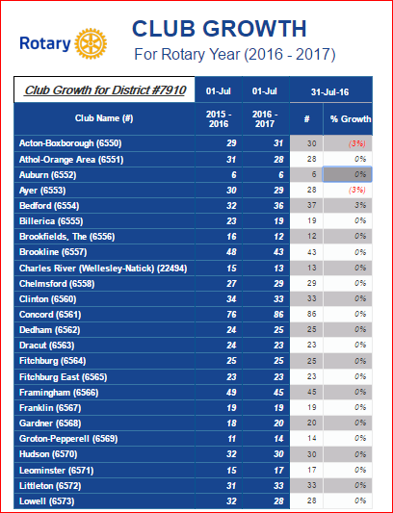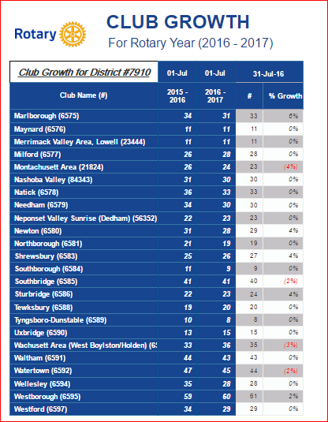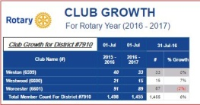

CLUB PLANNING WORKSHEET '16-'17
In both Excel and PDF formats, we share with you the Club Planning Worksheet for Rotary year 2016-2017, which began on July 1.
Please enter your club information in the indicated cells.

Excel Format

PDF Format

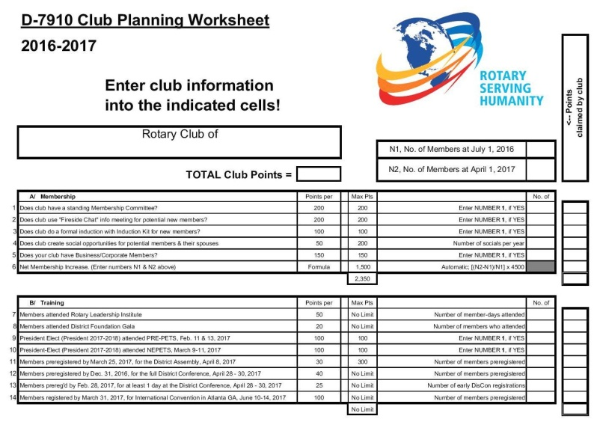

OUR PRESIDENTS SPEAK
Chris Spear, Nashoba Valley

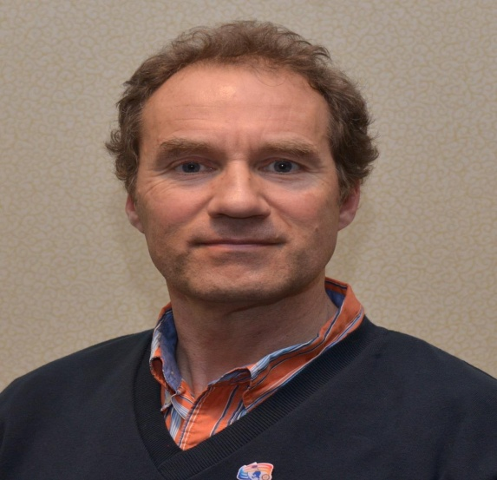

Please tell us what factors helped you decide to join Rotary.

I decided to join Rotary to spend more time with my wife.

READ MORE

DISTRICT & CLUB ROUNDS
Governor Baker Hosted at Meet & Greet Rotary Clubs of Bedford, Billerica, Lowell, Newton & Shrewsbury
To watch a video by Concord Rotarian Steve Kirk, which was played at this event, click here.
To view photos of this event, taken by Frank Sibley of Acton-Boxborough Rotary and Rich Prager of Worcester Rotary, click here.
Left to right: Immediate Past District Governor Jim Fusco; Charles River Rotarian Jon Fetherston; Littleton Gino Frattalone Rotarian; Governor Charlie Baker; and Billerica Rotarian John Peterson.
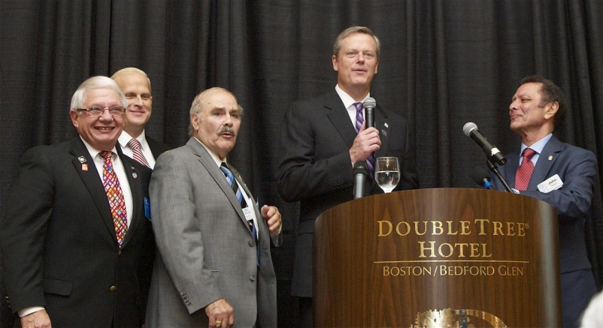

Jim Fusco (left) informs Governor Baker (right) of the presence of Rotary in Massachusetts (158 clubs with 1,580 Rotarians), while Gino Frattalone (center) looks on.
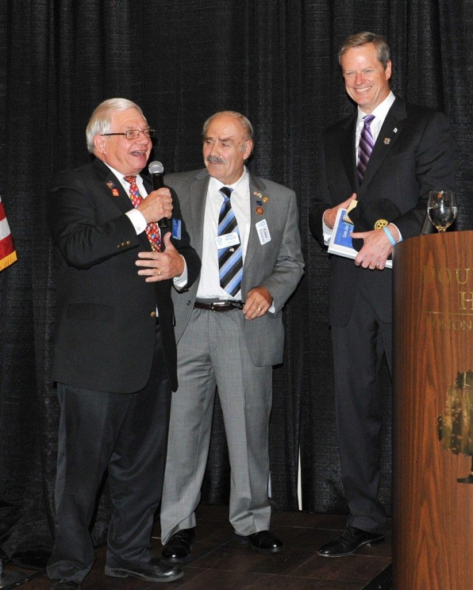

Zone Institute in Winnipeg, Canada

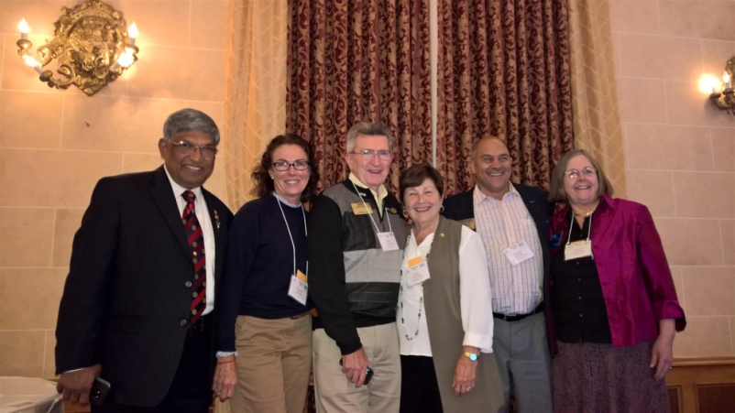

Our District was well-represented at the Zone Institute in Winnipeg, Canada. The Institute included intensive training for our future District leaders.

Left to right: Assistant Governor Satya Mitra; District Governor-Elect Karin Gaffney; District Governors Pat and Skip Doyle; District Governor-Nominee Steve Sager; and Past District Governor Carol Toomey.

Steering Committee Meets in Winnipeg

Your District Steering Committee, consisting of the District Governor, District Governor-Elect and District Governor-Nominee, meets monthly to guide your District. Last week, they took time out at the Zone Institute to hold their September meeting.

Left to right: DGs Skip and Pat Doyle; DGE Karin Gaffney; and DGN Steve Sager.

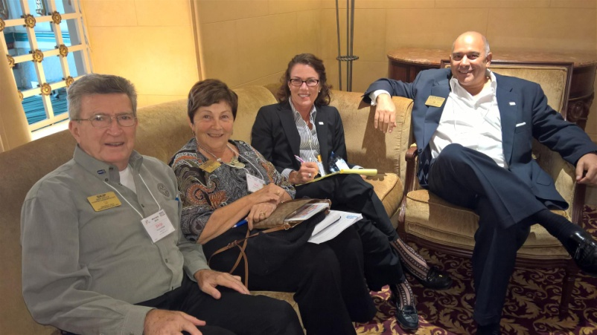

Our District Governor-Nominee with His DG Class of '18-'19

Left to right: Bill Tenant, District 7950; Bob Wood, D7930; Larry Gardner, D7980; Kate Sims, D7980; Larry Vars, D7850; Venu Rao, D7870; Jon LoBosco, D7780; and Steve Sager, D7910.
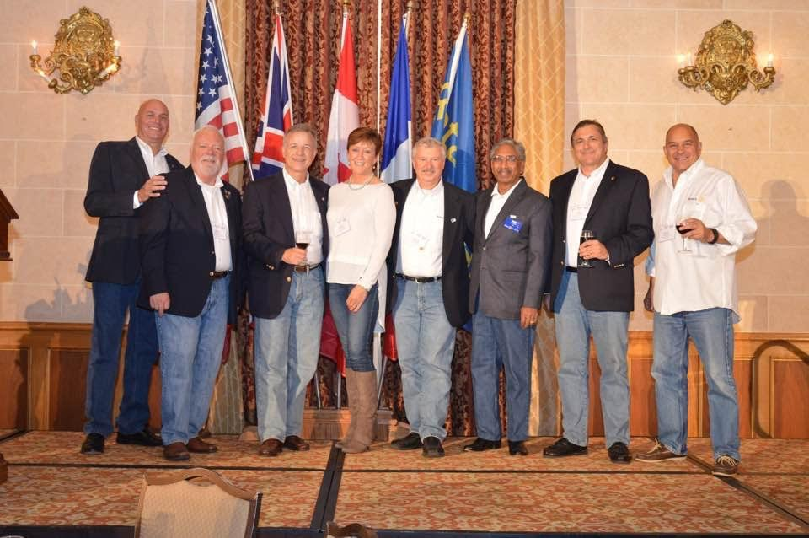

Women in Rotary: A Radio Interview

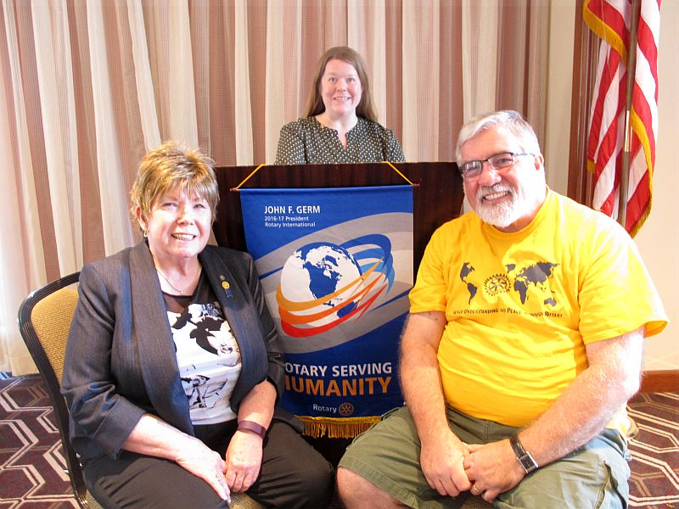

Boston Rotaract will host the Women in Rotary: Not (Just) Your Grandfather’s Rotary Club forum this Wednesday, October 5 from 6:30 8:30 p.m. at the Back Bay Social Club in Boston. READ MORE

Left to right: District Governor Sheryl Meehan of District 7930; Boston Rotaract President Amy Collinsworth; and District Governor-Elect Dave Gardner of D7930.

Fitchburg Inducts Two Members

Left to right: Club sponsor Corrine pins Tracy LaFeur as a new member and Jennifer Sanderson is pinned as a new member by club sponsor Bill Lakso, while Immediate Past District Governor Jim Fusco watches.

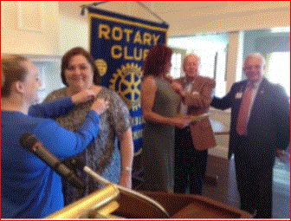

Auburn Congratulates Marcia Davis for Becoming A Paul Harris +1

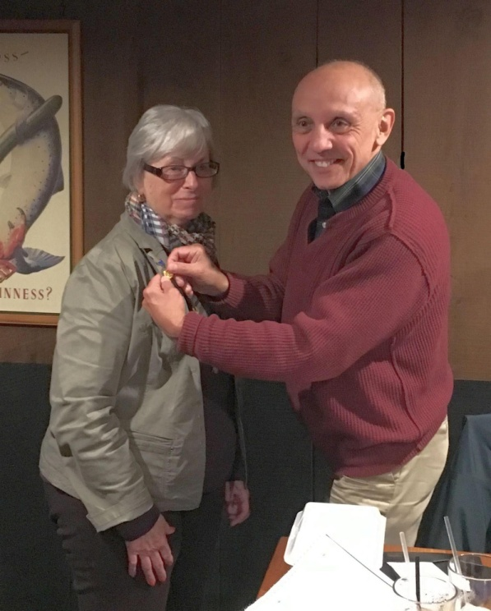

Congratulations to Marcia Davis (left), current treasurer and immediate past president of Auburn Rotary, for being awarded a Paul Harris Fellow +1 pin. She is shown being pinned by club President Steve Jones-D'Agostino.

To learn more about The Rotary Foundation's Recognition Points, click here.

To learn more about Auburn Rotary, click here.

District Interact Teen and Advisor Training Seminar A Huge Success
Nearly 50 participants from 14 Rotary communities took part in a District Interact Teen and Advisor Training Seminar, which was held on Saturday, September 17 at the Sheraton Hotel in Needham.

READ MORE (including links to Seminar videos and photos)

Framingham's Liz Kaprielian Awarded Bill Rabkin Volunteer of Year Award

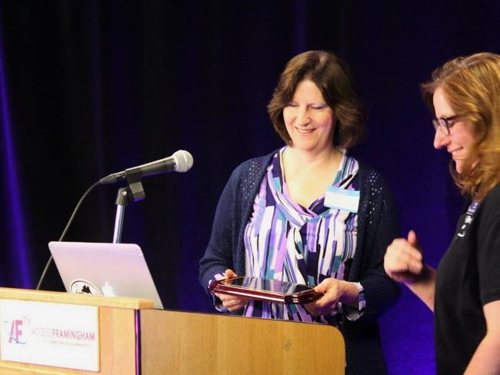

Liz Kaprielian, a member of the Rotary Club of Framingham, was surprised when she was was awarded the Bill Rabkin Volunteer of the Year award at Access Framingham.

READ MORE

Bandey Hefler Report

District 7910 travelers have been having a great time in England. They arrive home on October 4 and will be reporting on the trip in the next several newsletters.

READ MORE

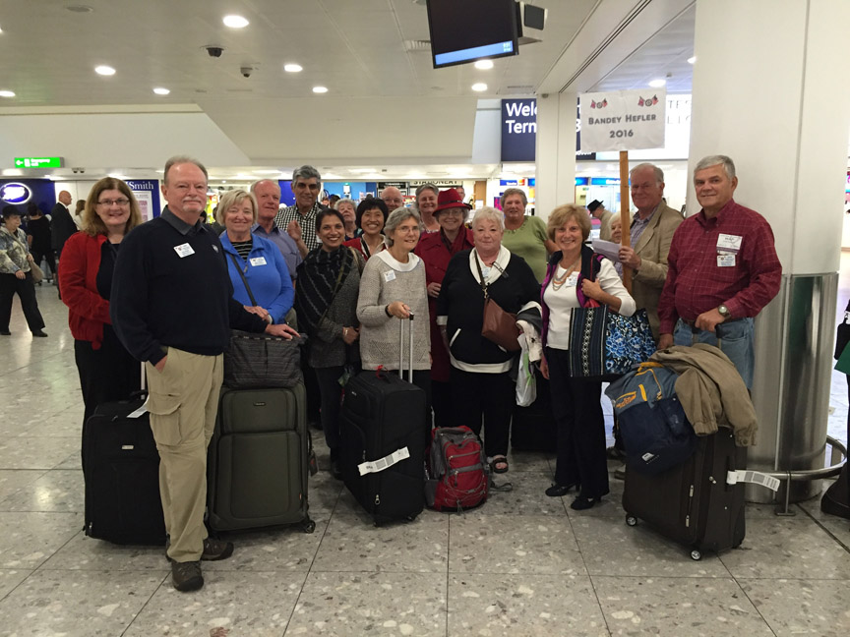

Sturbridge Participates in Day of Caring

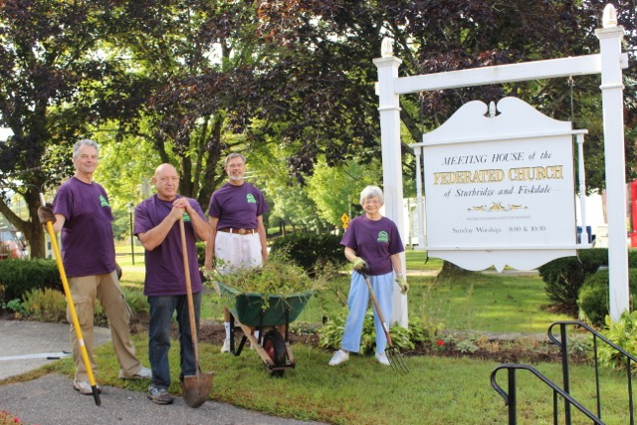

For the seventh year, Sturbridge Rotary has participated in United Way's annual Day of Caring. Nine club members were part of the 130 volunteers working at 14 project sites.

READ MORE

Westborough Sponsors Down Syndrome Buddy Walk

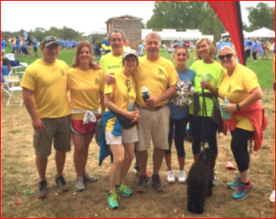

One of Westborough Rotary's giving requests was to be a sponsor of the Down Syndrome Buddy Walk and Harvest Festival, which was held on Sunday, September 18. A group of Rotarians (shown here) participated in the walk and had a great time supporting a wonderful cause.

District Polio Team Visits Lowell Rotary

Carl Good III, chair of the District Polio Committee, and his polio team continue to visit clubs. Recently, he visited Lowell Rotary to spread the polio message. He learned that Lowell has the largest artist colony in the U.S. and that the Lowell club promised to discuss a polio event at their next board meeting. Thank you, Lowell!

If you would to join the polio team, just let Carl know at carlgood@yahoo.com or 978-273-7880.

Carl Good III (left) posing with Lowell President Maureen Couture.

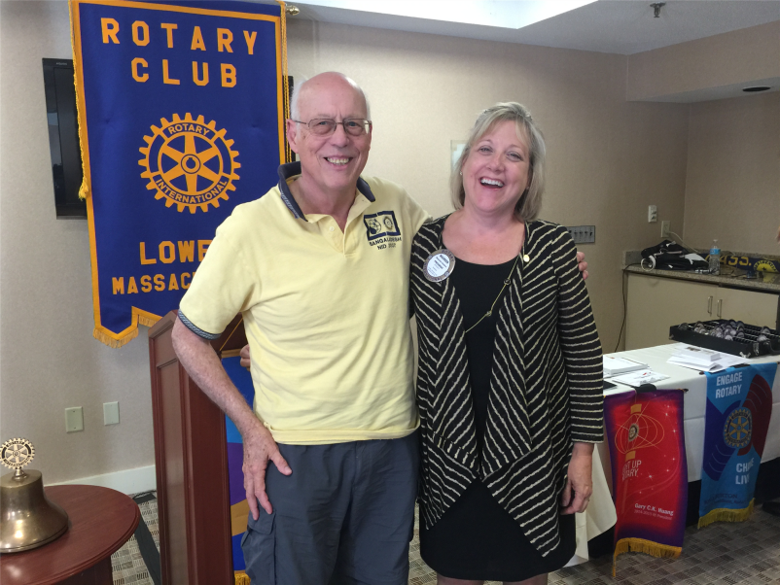

Nashoba Valley Sponsors Razia's Ray Of Hope Event On October 27 - 'Celebrate 500 Tour' Features CNN Hero Razia Jan

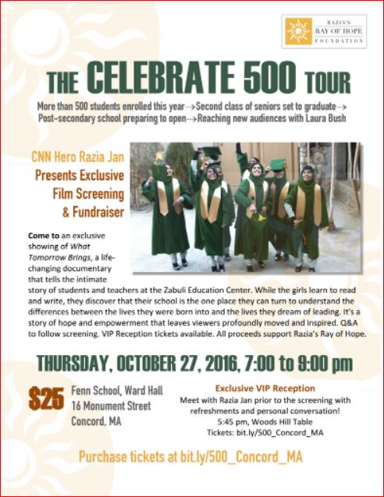The Rotary Club of Nashoba Valley is proud to sponsor the local premiere of What Tomorrow Brings, event to benefit Razia’s Ray of Hope, on Thursday, October 27 from 7:00 to 9:00 p.m. at the Warn Hall of the Fenn School, located at 6 Monument St. in Concord.

READ MORE

President Elects Start Their Pre-PETS Training

District Governor-Elect Karin Gaffney recently kicked off the training for presidents-elect at Concord Academy. Karin is shown motivating the PEs.

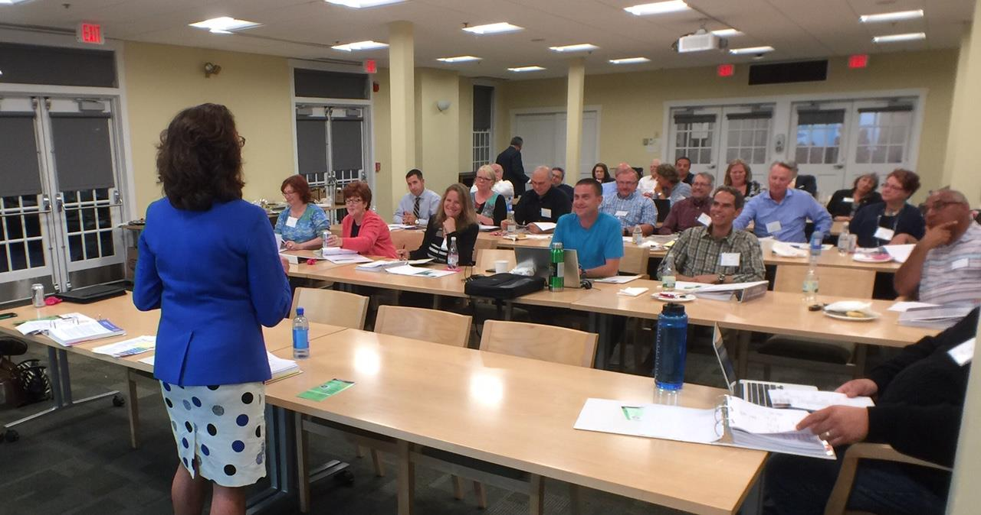

Pat and Skip Doyle Installed As '16-'17 DGs

District 7910's 2016 Rotary Youth Leadership Awards were held on June 24 through 26 at Fitchburg State University, ending with the installation of longtime RYLA supporters Pat and Skip Doyle as District Governors for 2016-2017. The three-day RYLA event was attended by 188 sophomores. To learn more about RYLA, visit ryla7910.org.

Click on the image, to view a video of the installation of Pat and Skip Doyle as '16-'17 DGs

District Leadership Meeting A Huge Success

How HUGE? So HUGE that another is planned for October 17!

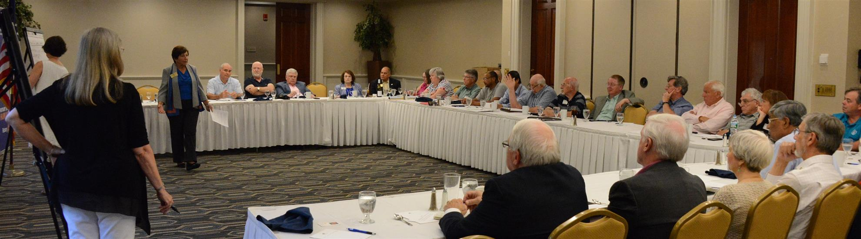
District Governors Pat and Skip Doyle held their Leadership Meeting on July 19 at the DoubleTree Hotel in Leominster. This is an annual event for which DGs bring their District leaders and committee chairs together to review the goals for the new Rotary year.

This, year the event was presented in a facilitated format. The results will be consolidated and sent to all attendees so that the District Goals for each committee can be set.

District Banners Available

Our district banners are available for your to use when you have an upcoming event or fundraiser.

If you want to reserve one of the banners, please contact PR Chair Laura Spear at laura@spear.net.

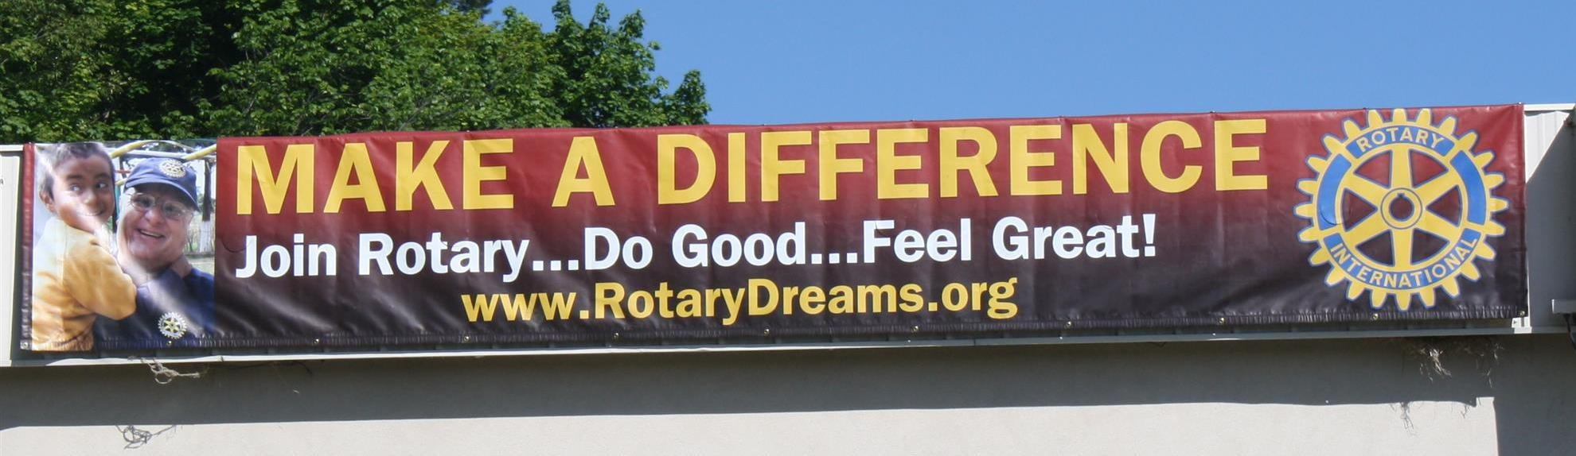

On To Atlanta In 2017

Planning to attend? Contact District Chair Steve Glines.

More than 43,000 attendees left the Rotary International Convention in South Korea inspired to end polio for good, to celebrate The Rotary Foundation's centennial, and to champion changes that will help Rotary appeal to a broader audience.
On the last day, RI President K.R. “Ravi” Ravindran shared a personal story of his mother’s triumph over polio.

To read the story, click here.

To register for the 2017 RI Convention in Atlanta, click here

MAJOR DISTRICT & CLUB HAPPENINGS: FAll
Wednesday, October 5: Boston Rotaract - 'Women in Rotary'
To buy tickets, click here.

To hear a 29-minute radio interview by Auburn Rotarian Steve Jones-D'Agostino with Boston Rotaract President Amy Collinsworth, District 7930 Governor Sheryl Meehan and D7930 Governor-Elect David Gardner, which aired this Sunday, September 25 on 90.5 WICN, click here.

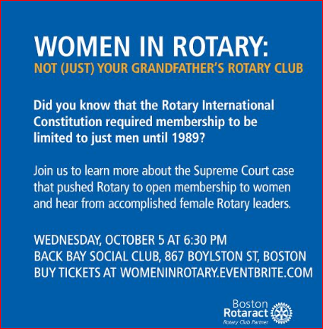

Friday, October 14: Montachusett Area Rotary - 'Comedy Night,' Knights of Columbus, Leominster

For tickets and information, contact club President Jennifer Peck at montachusettarearotary@gmail.com.

Saturday October 15: Franklin Rotary in conjunction with Simon Properties - 'Chalkfest,' Wrentham Outlets, Wrentham

READ MORE

Saturday, October 22: Fitchburg Rotary - 'Roast The Mayor Night'

Fitchburg has a new mayor, Steve DiNatale, and to celebrate his first year in office, Fitchburg Rotary will sponsor a Roast the Mayor Night.

For more information, contact club President Dan Cunnimham at danc1@comcast.net.

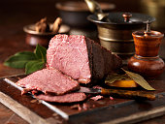

Saturday, October 22: Concord - 'Octoberfest'

You’ll hear five live bands, sample food and beer, enter a pie-eating contest, create the best scarecrow, show off hula-hoop skills, jump in the bouncy house, shop craft vendors, visit community organization booths, and more.

For more Information, click here.

Sunday, October 23: Westborough Rotary - 'Trivia Bee'

Westborough Rotary has accepted an invitation from the Westborough Education Foundation to sponsor a team for this Trivia Bee, will provide three Rotarians and an alternate, and hopes to bring back a trophy this year!

For more information, contact club President Gerry Gross at gerrygross@gmail.com.
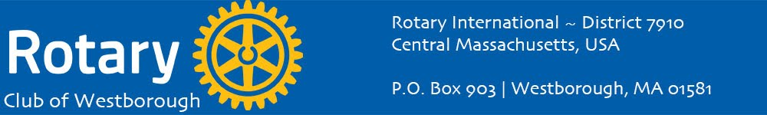

Saturday, October 29: Sturbridge Rotary - 'Antique Appraisal Show'

To download the event flyer, click here

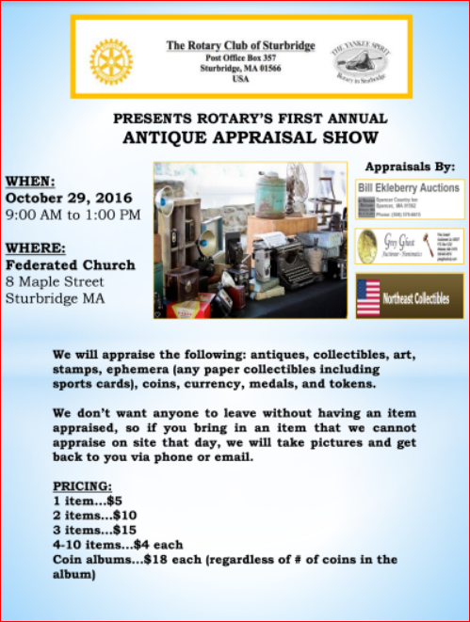

Tuesday, November 1: Marlborough Rotary - 'Reality Fair 2016'

To download the Confirmation of Participation form, click here

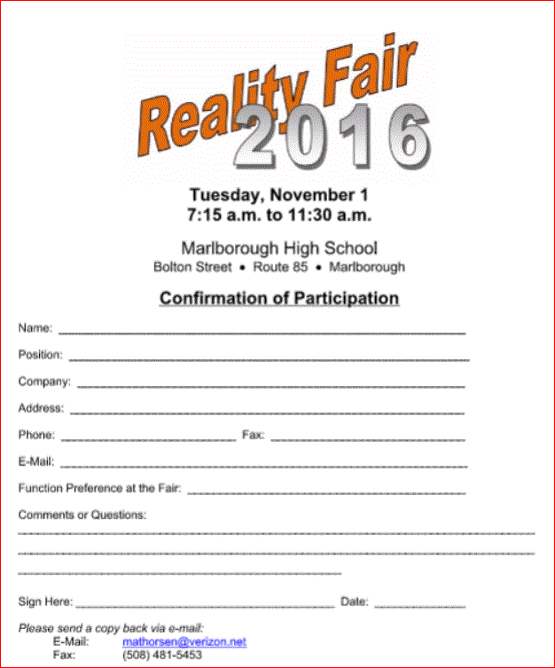

Monday, December 5: Sturbridge Rotary - 'Lottery Ticket Raffle'

To download the event flyer, click here.

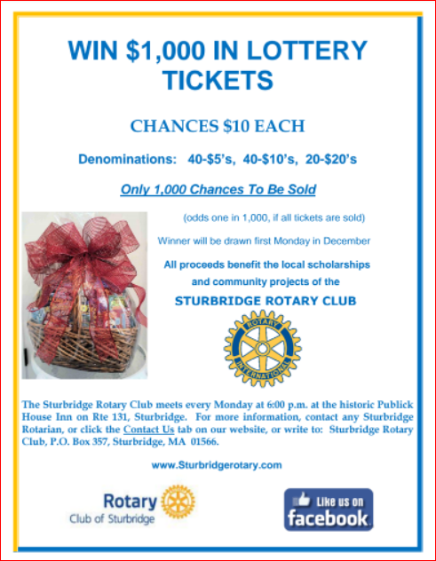

SUBMIT MAJOR CLUB HAPPENINGS

Send flyers of your club's major events and activities, in either JPEG or PDF format, to Immediate Past District Governor/Newsletter Editor Jim Fusco
at jim.fusco2@gmail.com.

