Dear $NICK_NAME$,

It is our pleasure to share with you the October 31 issue of Rotary District 7910 Newsletter.

For the complete issue, click here.

To explore past issues, click here.

Highlights of October 31 issue:

Governor's Message: District-wide Food Packaging Event in 12 days - By Pat and Skip Doyle

District-wide Food Packaging Event: Saturday, November 12 at Solomon Pond Mall in Marlborough - By Carol Toomey

District Governor-Elect Report: Karen Fusco, on why should we go to the Rotary International Convention - By Karin Gaffney

PolioPlus Update: Tracking World Polio Day events - By Carl Good III

Membership Corner: Member Workshops recap - By Tom Sturiale

Rotary Leadership Institute: Next RLI in our area is scheduled for November 12 in Chicopee - By Doug Detweiler

RAAGNE Newsletter: Update on visioning process - By Klaus Hachfeld

Foundation Note: Available District Designated Funds for Global Grants - By Sanjay Deshpande

Bandey Hefler Report: Our district's travelers are back - By Victor Tom

PR Tips: When a press release isn't the answer! - By Laura Spear

Interact Actions: How to launch an Interact club - By Bob Anthony

Speakers Bureau: Do you need a speaker for your club? By Steve Levitsky

Communications Link: Seeking club photo, video albums - By Steve Jones-D'Agostino

Treasurer's Report: Message about your dues - By Jack Hoell

District Charity Fund: How does DCF operate? - By Al Bowers

Our next newsletter will come out on Monday, November 7. The submission deadline is this Friday, November 4. Text content must be submitted in Word format. Image content must be submitted in either JPEG or PDF format. Send your content submissions to Immediate Past District Governor/Newsletter Editor Jim Fusco at jim.fusco2@gmail.com.

Governors Pat & Skip

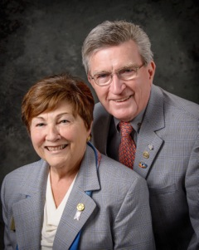Pat and Skip Doyle
2016-2017 Governors
Rotary District 7910
pwdoyle2@verizon.net
skipdoyle2@verizon.net

