GOVERNOR'S MESSAGE

COUNTDOWN TO OUR DISTRICT-WIDE FOOD PACKAGING EVENT: 12 DAYS LEFT
By Pat and Skip Doyle
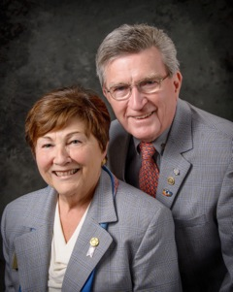Our last two weeks have been jam-packed with events in our district. We officially visited five clubs, participated in a District Leadership Workshop and an Assistant Governors Meeting, interviewed a candidate for Peace Scholar, and attended the Acton-Boxborough club's Masquerade Ball, the Auburn club's Pancake Breakfast, four Membership Workshops in four corners of the district, and a District Trustees Meeting.
As we write this, today is our first day without an official Rotary event in almost 14 days. Rather than complain, we want you all to know how much we have enjoyed the past 14 days. We took so much away from each event, and we learned so much about our district by participating in the Membership Workshops. Our thanks to all those members and facilitators who took time from their busy lives to discuss ways to increase the membership in our clubs. We only wish more of you had taken advantage of the convenience of these events.

The Masquerade Ball was loads of fun, good food, entertainment, and so many Rotarians having a good time. And, Pancake Breakfasts always bring out the best in our clubs. Hope to see you all at these events next year.

What is our goal for the next 12 days?

Raise as much money as possible to support our district's Stop Hunger Now Food Packaging Event on Saturday November 12from 12:00 noon to 3:00 p.m. at the Solomon Pond Mall in Marlborough.

We are thankful for the many members - young and old - as well as their families and friends who are volunteering to help us package the meals. But more help means we need more food to package. And that means we need more monetary donations to provide the raw materials. Please visit our Stop Hunger Now website and make a donation and volunteer. To donate and to volunteer, click here.

Always remember, you can call us with questions at 508-393-9031.

District Governors Pat and Skip Doyle may be reached at pwdoyle2@verizon.net and skipdoyle2@verizon.net,
respectively.

Click here to submit content for the October 24 issue to Immediate Past District Governor/Newsletter Editor Jim Fusco.

Click here for past issues.

WELCOME, NEW ROTARIANS

- Ronald Faccenda, Newton

Last Week's Quiz: Do You Know Who They Are?
Surprise! Our District Governors, Pat and Skip Doyle!
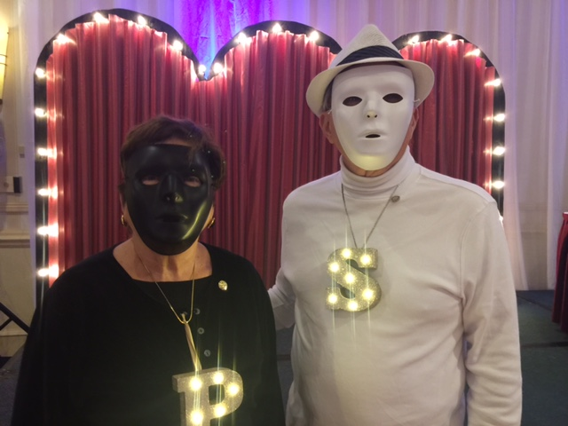

CLUB MEMBERSHIP GROWTH, ’16-‘17

We share with you the results of club-membership growth in our district during Rotary year 2016-2017, which began July 1.

This is a unique opportunity for Rotarians and friends to discuss partnering on humanitarian projects affecting our local communities.

READ MORE

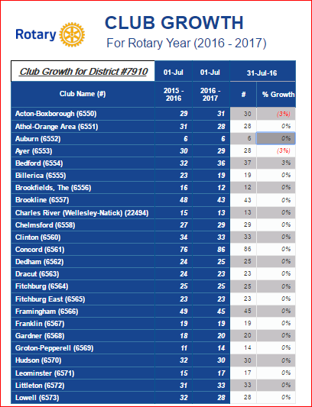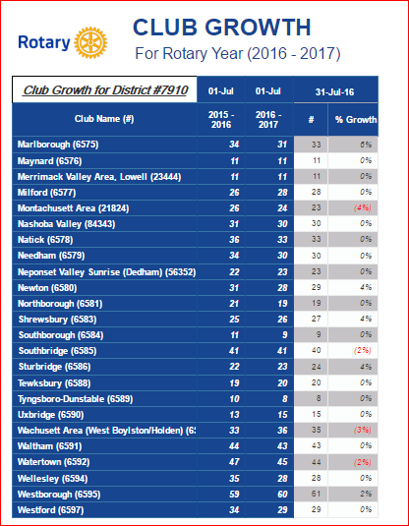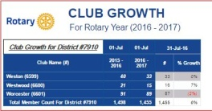

CLUB PLANNING WORKSHEET '16-'17
In both Excel and PDF formats, we share with you the Club Planning Worksheet for Rotary year 2016-2017, which began on July 1.
Please enter your club information in the indicated cells.

Excel Format

PDF Format

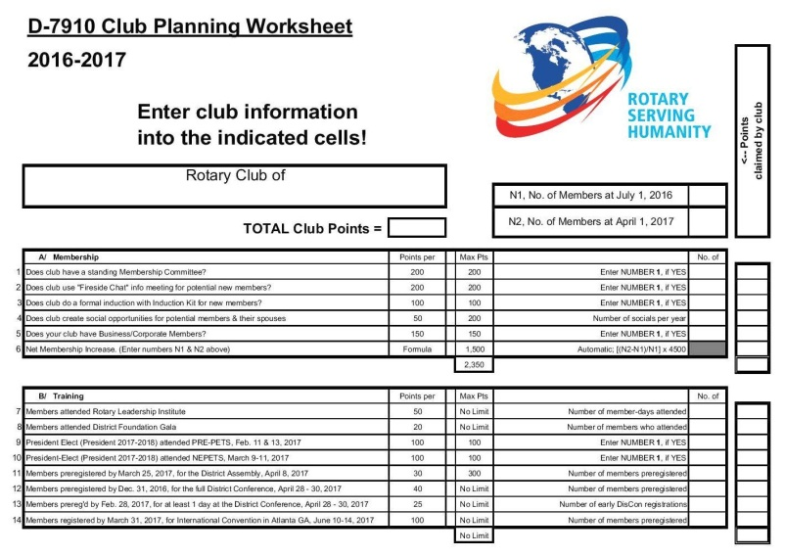

OUR PRESIDENTS SPEAK
Joe Badenhoff, Acton-Boxborough

Please tell us what factors helped you decide to join Rotary.

To join a service-based organization. I wanted to be involved with an organization that wasn’t just networking. Also, as a former RYLAn, I was exposed to Rotary many years ago, and it felt right to join as a member at that point in my life.

READ MORE

DG VISITS LAST WEEK
Bedford (charted 1956)

Left to right: District Governor Skip Doyle; President Linda Cargiulolo; and District Governor Pat Doyle.

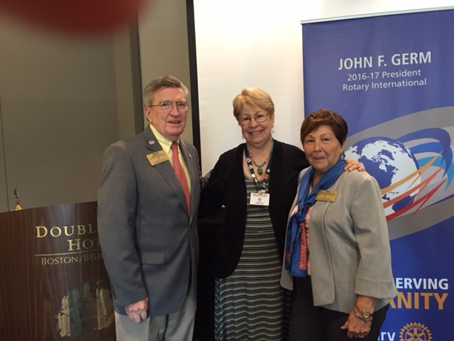

Neponset Valley Sunrise (chartered 2001)

Shown: President Mike Podolski.

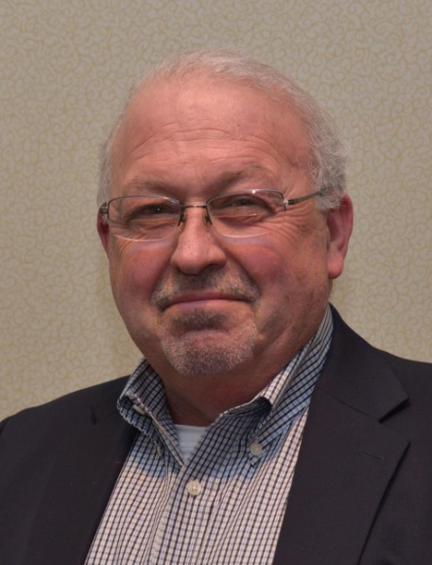

DISTRICT & CLUB ROUNDS

Membership Workshops a Huge Success
Shown: The District Membership Workshop on October 25 at Chuck's Steak House in Auburn, which was attended by members of the Auburn, Brookfields, Marlborough, Northborough, Shrewsbury, Southborough, Southbridge, Sturbridge, Uxbridge, Westborough and Worcester clubs.

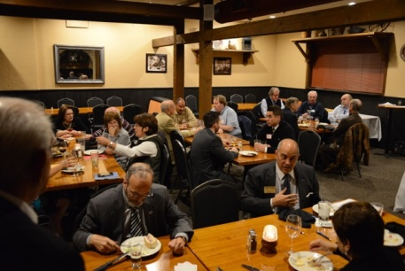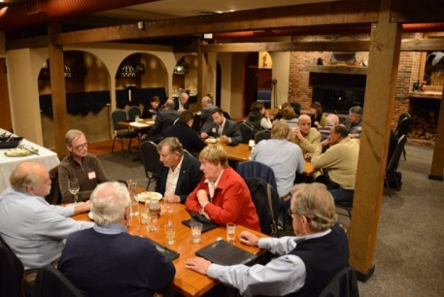

\

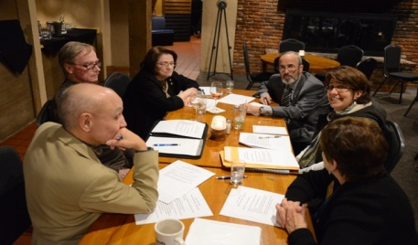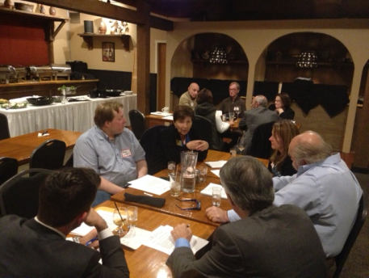

Sturbridge, Stoubridge Celebrate Sister Club ‘Rotary Friendship Day’

Since 1988, the presidents of the Rotary Club of Sturbridge and its Sister Club, the Rotary Club of Stourbridge, U.K., have exchanged letters of greetings and goodwill in October via snail-mail. The chair of the Sturbridge Board of Selectmen also mails a proclamation declaring October 16 as Stourbridge/Sturbridge Rotary Friendship Day and likewise, the mayor of Dudley in the U.K. does the same for the Sturbridge Club.

Shown on top, left to right: Sturbridge President Otto Prohaska and Sturbridge Selectmen Chair Mary Blanchard.

Shown on bottom, left to right: Stourbridge President Rob Franks, Dudley Mayor Mohammed Hanif, and Dudley Mayoress Zabeda Khanam.

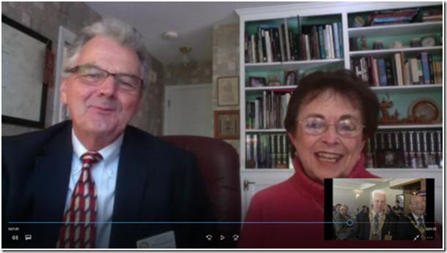

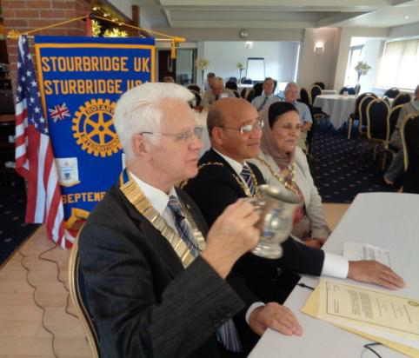

This year for the first time, the greetings were exchanged live via Skype. Mary Blanchard, chair of the Sturbridge Selectmen, and Sturbridge Rotary President Otto Prohaska arrived early at the home of Past District Governor Klaus Hachfeld and his wife and fellow Sturbridge Rotarian, Glenys Hachfeld, to deliver their messages during the regular weekly luncheon meeting of the Stourbridge Club. Similar messages from the Stourbridge President Rob Franks and Dudley Mayor Mohammed Hanif were reciprocated.

The meeting concluded with President Franks toasting the health of the Sturbridge members using the tankard that Sturbridge had presented to them 28 years ago. The friendship has remained strong with nine visits alternating between clubs. Note the twinning banner in the background of the U.K. photo.

Bandey Hefler Travelers Are Back Home from England

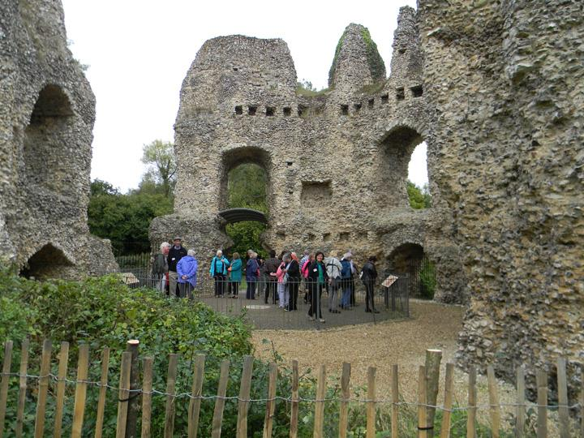

To read an article by Victor Tom, co-chair of District 7910's Bandey Hefler Fellowship Exchange, click here.

Shown, are Bandey Hefler travelers at Odiham Castle in England.

Concord's Oktoberfest a Great Success

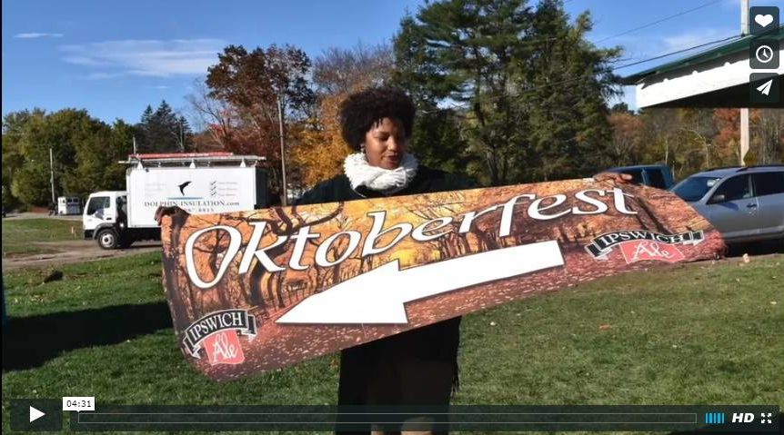

The Rotary Club of Concord held Oktoberfest on October 22 at Verrill Farm in Concord to support local and international service projects. More than a dozen local brewers offered tastings of their unique craft beers. Among them were the Battle Road Brewing Company of Maynard and Jack’s Abby of Framingham. Down the Road Beer Company offered traditional German-style brews served at Concord restaurants, including Bondir and 80 Thoreau. The Craft Brewers Guild presented a portfolio of locally crafted beers. From the Boston area, were beers from Castle Island Brewery and from Stowe, Vermont, selections from the Von Trapp Brewing Company. Sample them all!

To watch the four-and-a-half-minute video by Concord President Steve Kirk, click here.

Wellesley Hears from Polish Senator Anna Maria Anders-Costa

The Rotary Club of Wellesley was glad to recently welcome Wellesley resident Anna Maria Anders-Costa (shown), who was a Wellesley Rotarian from 2009 to 2011. Member-at-Large Vincent Spoto introduced Anna Maria. In a personal and engaging presentation Anna Maria spoke of her background (born of Polish parents in London, traveling the world, and presently an elected Polish senator and a minister in the Republic of Poland).

READ MORE

Tewksbury Rotary, High School Honor Two Students

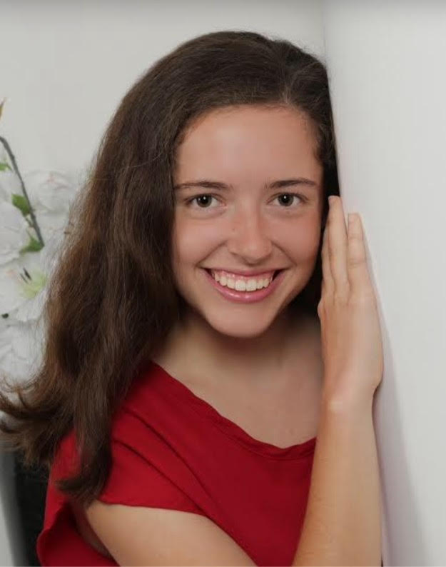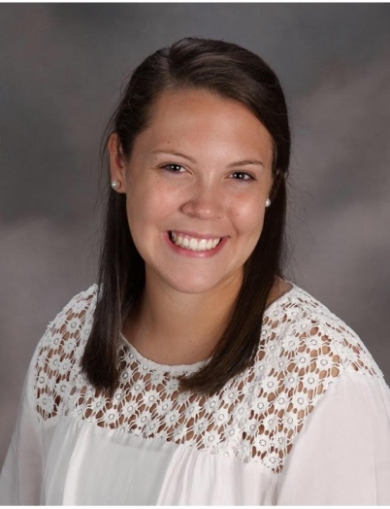

The Tewksbury High School two students, Amy Glover (shown, left)and Colleen MacNeil (shown, right), were nominated for the Rotary Club of Tewksbury's October 2016 Hats Off Award Luncheon. The Hat's Off Award, a joint initiative of Tewksbury Rotary and Tewksbury High, recognizes those students who have distinguished themselves academically

READ MORE

ESSEX Students Attend Auburn Pancake Breakfast

Left to right: Greg Reimonn, an ESSEX (Eastern States Student Exchange) student from Hopkinton, Worcester Railers Hockey Club mascot Trax; ESSEX student Yuka Ichikawa from Japan, and ESSEX student Kaitlyn Denson from Hopkinton.

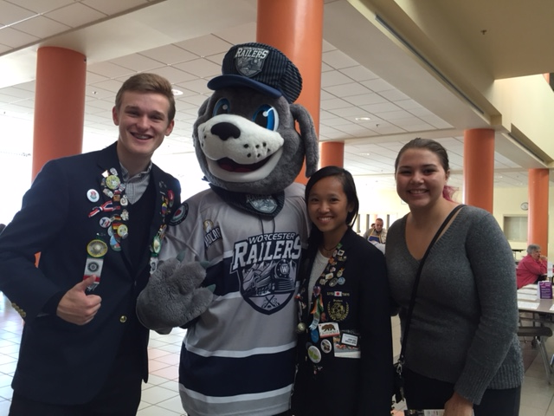

Fitchburg Does Purple Pinky Day at Halloween Parade

Sitting at table, left to right: President Dan Cunningham; and Member Karen Fusco, who is also an assistant governor.

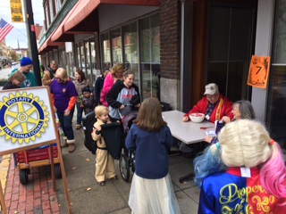

Acton-Boxborough and Littleton Raise $15,000 for Food Pantries

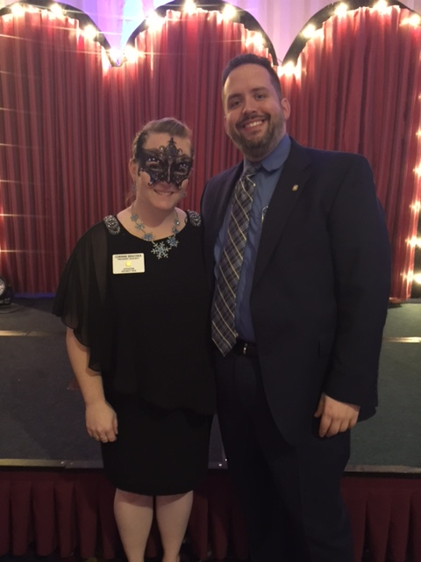

The Rotary Clubs of Acton-Boxborough and Littleton held their Annual Rotary Masquerade Ball on October 22 at the Holiday Inn in Boxborough to benefit two local food pantries: Loaves and Fishes Food Pantry; and The Acton Community Supper and Food Pantry.

Left to right: Littleton President Corinne Braciska, and Acton-Boxborough President Joe Badenhoff.

READ MORE & VIEW PHOTOS

Auburn Holds 'Flips for Scholars' Pancake Breakfast

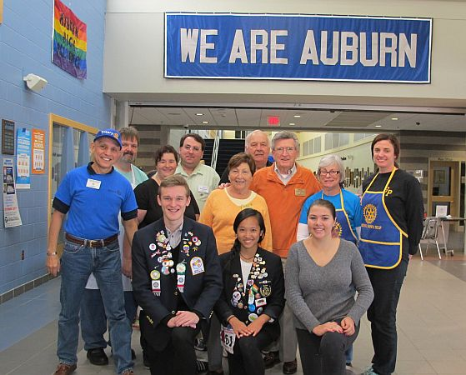

To learn more and view event photos, click here.

Standing, left to right: President Steve Jones-D'Agostino; Member Tom Dufour; Secretary Heather Chivallatti; Member Jon Manning; District Governor Pat Doyle; Member John Convent; District Governor Skip Doyle; Treasurer and Immediate Past President Marcia Davis, who chairs the District ESSEX (Eastern States Student Exchange) Committee; and Member Jennifer Reil.

Kneeling, left to right: ESSEX students Greg Reimonn from Hopkinton, Yuka Ichikawa from Japan, and Kaitlyn Denson from Hopkinton.

Fitchburg Rotary Roasts the Mayor

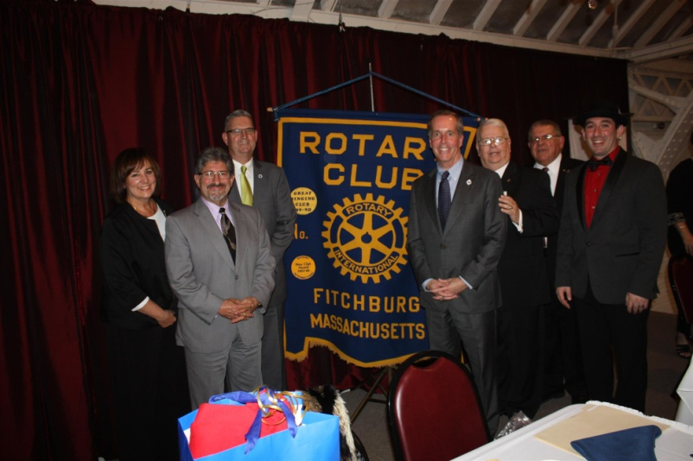

Fitchburg has a new mayor this year and a Mayoral Roast was in order.

Left to right: Mayor's Administrative Assistant Joan David; Mayor Stephen DiNatale; State Representative Stephan Hay; State Representative William "Smitty" Pignatelli; club President Dan Cunningham; Tony Gasbarro, a member of Montachusett Area Rotary; and Emcee Travis Condon of radio station WPKZ.

To watch promotional video, click here.

Franklin Chalks One Up for Charity

To view event photos, click here.

READ MORE

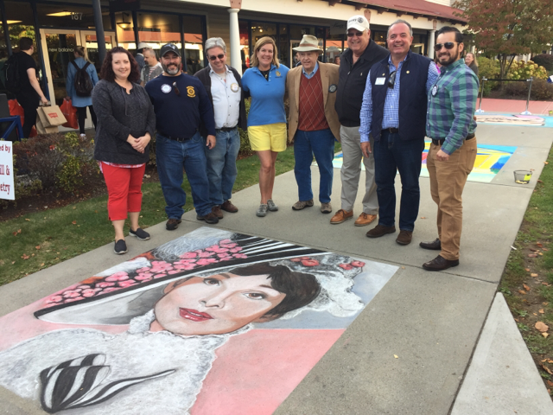

l

Left to right: First-place artist Kerry Wippie; President Elect Scott Martin; Past President and Board Member Fran McKeown; Past President and Vocational Services/RYLA Chair Julie Rougea; Past President Herb Hunter; Past President and Board Member Dan Gentile; President Terry Katsaros; and new Member Carlos Aguilera.

Milford Celebrates Fall Family Fun Day

Locals gathered on Saturday, October 15 at Milford Town Park for an event designed to raise awareness of and money for Alternatives Unlimited, a charitable organization dedicated to people with physical and emotional disabilities. The fourth annual Fall Family Fun Day was a collaboration of Alternatives Unlimited and the Rotary Club of Milford.
Shown: Jessica Mayancela, 5, of Milford, look at her freshly painted face in a mirror during Fall Family Fun Day. Photo: Dan Holmes, Wicked Local.
READ MORE﻿

Watertown Hosts Senior Citizen Cookout
Left to right: Members Dr. Lee and Kitty Mennilli; and Honorary Members Dottie Morgan and Debbie Boyajian.

READ MORE
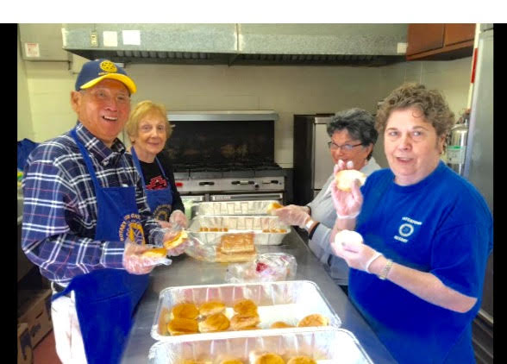

On to Atlanta in 2017: Early-Registration Discount Ends December 15

Planning to attend? Contact District Chair Steve Glines.

More than 43,000 attendees left the Rotary International Convention in South Korea inspired to end polio for good, to celebrate The Rotary Foundation's centennial, and to champion changes that will help Rotary appeal to a broader audience. On the last day, RI President K.R. “Ravi” Ravindran shared a personal story of his mother’s triumph over polio.

To read the story, click here.

To register for the 2017 RI Convention in Atlanta, click here.

Pat and Skip Doyle Installed as '16-'17 DGs

District 7910's 2016 Rotary Youth Leadership Awards were held on June 24 through 26 at Fitchburg State University, ending with the installation of longtime RYLA supporters Pat and Skip Doyle as District Governors for 2016-2017. The three-day RYLA event was attended by 188 sophomores. To learn more about RYLA, visit ryla7910.org.

To watch a video of the installation, click here.

District Banners Available

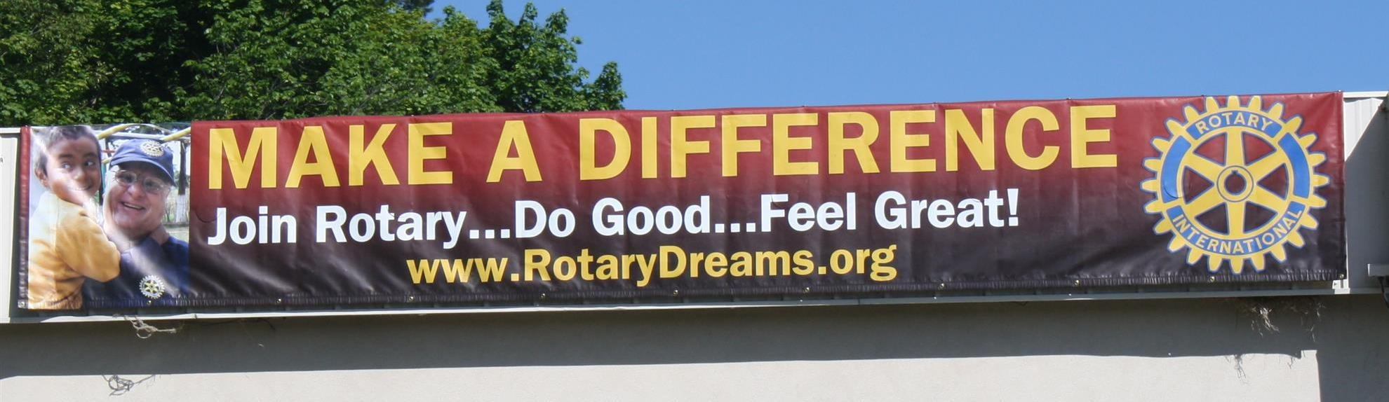
Our district banners are available for your to use when you have an upcoming event or fundraiser.

If you want to reserve one of the banners, please contact PR Chair Laura Spear at laura@spear.net.

MAJOR DISTRICT & CLUB HAPPENINGS: FALL 2016

Tuesday, November 1: Marlborough - 'Reality Fair 2016'
Download the Confirmation of Participation form: click here for PDF format; and, click here for Word format

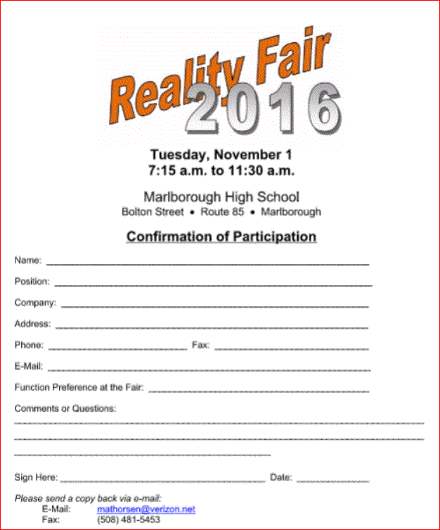

Friday, November 4: Watertown - '10K Raffle'
To e-mail club President Jesse Wallace, click here
To download the event flyer, click here
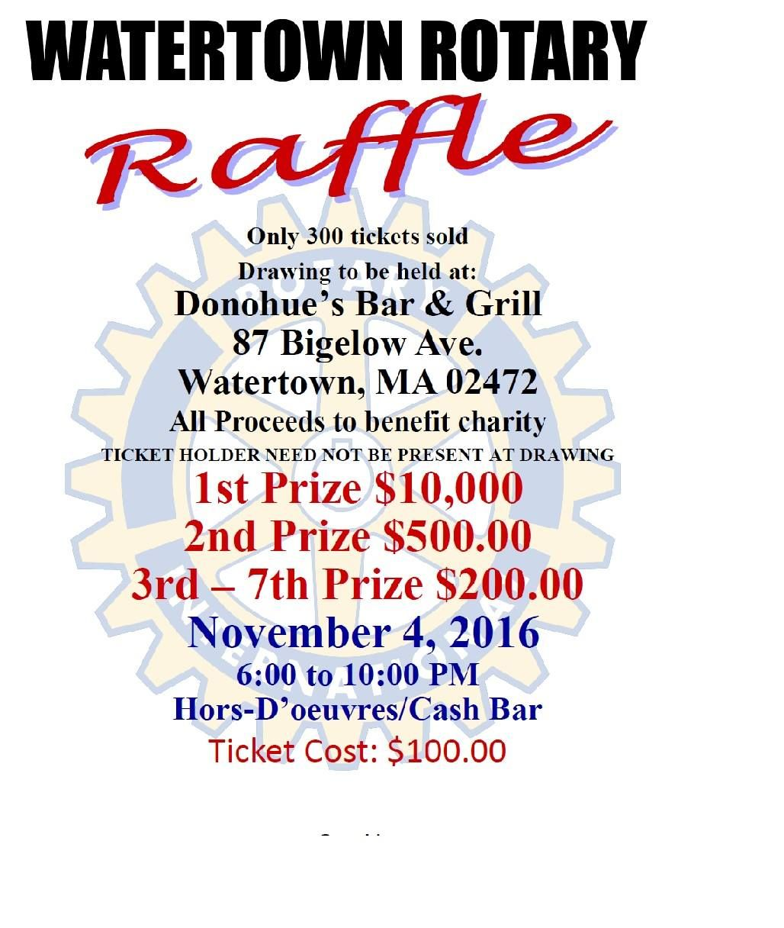

Saturday, November 5: Needham - 'Pancake Breakfast'

For more information and to purchase tickets, click here

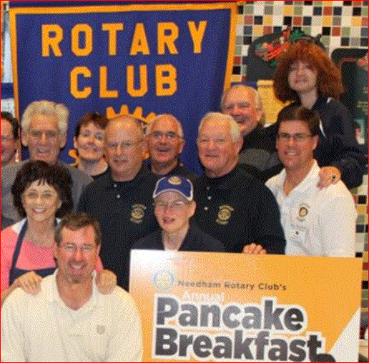

Saturday, November 12: District 7910 - 'Food Packaging Event,' Solomon Pond Mall, Marlborough

To either donate or volunteer, click here

To view the event flyer, click here

To learn more about Stop Hunger Now, click here

Saturday, November 19: Ayer - 'Joey & Maria's Comedy Italian Wedding'

Saturday, November 19: Billerica - 'Cribbage Tournament'

For more information, click here, or contact Brian Goguen at 978-667-4595

Monday, December 5: Sturbridge Rotary - 'Lottery Ticket Raffle'

To download the event flyer, click here.

SUBMIT MAJOR CLUB HAPPENINGS

Send flyers of your club's major events and activities, in either JPEG or PDF format, to Immediate Past District
Governor/Newsletter Editor Jim Fusco at jim.fusco2@gmail.com

