OUR PRESIDENTS SPEAK: Jennifer Peck of Montachusett Area
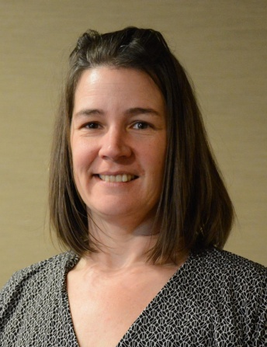
Please tell us what factors helped you decide to join Rotary.

I joined Rotary as a requirement of a new job that I took six-and-a-half years ago. It took me a couple years while adjusting to a new area and new job to understand the value of Rotary. This month, I am taking on another new job and happy to be able to stay on with Rotary as an individual member. Rotary has helped me to overcome many obstacles, including my fear of public speaking.

Of your club’s activities, what do you consider the one thing that best identifies what your club is all about?

Just a couple of weeks ago, we held our first Comedy Night fundraiser. The Montachusett Area Rotary Club has always been known as the “fun” breakfast club, so it seems fitting that we would hold a night of comedy as a fundraiser. For a first-time event, we had great success and look forward to build upon it in the coming years.

What is your club doing this year to attract new members?

Attracting new members has been a challenge over the most recent years. We have implemented a Corporate Membership option that allows up to four people on the membership. We are doing a strategic-planning session, coming up in a couple of weeks during our regular meeting, to brainstorm new ideas around building up membership.

Do you have any advice to offer others in the district about how best to achieve a successful fundraiser?

The best advice I have to other clubs how best to achieve a successful fundraiser is get many members involved in the planning process, and meet regularly to go over plans and tasks to be completed.

Do you have any innovative plans for Rotary-related publicity during your presidency?

Plans for publicity during my presidency include several press releases and possibly getting on the local TV stations to promote the good we do in the community.

What's do you consider to be your biggest concern during your presidency?

The biggest concern during my presidency is the upcoming leadership. We have lost a couple of members in line as president-elect and vice president and are in the situation to recycle past presidents.

What's the best book you've read in the past three years?

The best book I have read in the past three years I would say is The Heart of Yoga.

What's your favorite quote?

My favorite quote is, “To go against the dominant thinking of your friends, of most of the people you see every day, is perhaps the most difficult act of heroism you can perform,” by Theodore H. White.

What's your favorite restaurant in your community?

My favorite restaurant in my community is Becky’s Bistro in Barre.

What is a "must see" in your community?

A “must see” in my community: Johnny Chapman, a.k.a. Johnny Appleseed, was born in Leominster. There is a replica of his home on Appleseed Lane. This is a hidden secret and a must-see!

Jennifer Peck, president of Montachusett Area Rotary, may be reached at tntgal2000@gmail.com. To learn more about Montachusett Area Rotary, click here.

Return to October 24 Newsletter

View past issues
Visit our website
'Like' our Facebook page
'Follow' us on Twitter

