OUR PRESIDENTS SPEAK: Linda Cargiuolo of Bedford
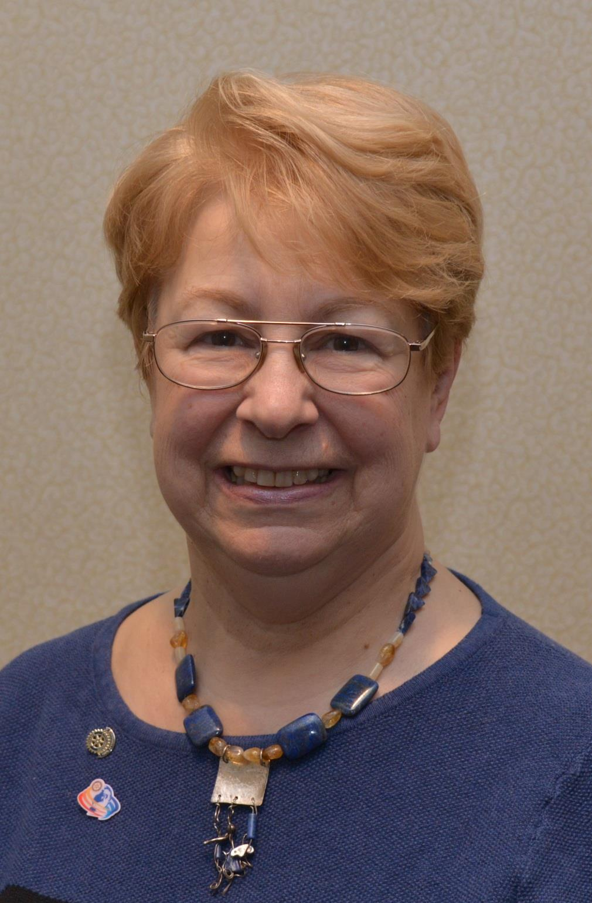Please tell us what factors helped you decide to join Rotary.

My manager was president of the Rotary Club of Lexington and thought that it would be good experience for me. The projects kept me busy and involved.

Of your club’s activities, what do you consider the one thing that best identifies what your club is all about?

We do a lot of local projects for our town that benefit the kids. We also do larger-scale global projects and some actually bring out the many town and school groups such as the Stop Hunger Now Food Packaging Event.

Editor's note: A District-wide Food Packaging Event will be held next Saturday, November 12 from 12:00 noon to 3:00 p.m. at the Solomon Pond Mall in Marlborough. To participate, click here.

What is your club doing this year to attract new members?

We are doing a Rotary Run & Walk 5-Mile Race to attract all age groups. Being in front of by having events helps build membership

Do you have any advice to offer others in the district about how best to achieve a successful fundraiser?

High-profile social and print media blasts starting five to six weeks prior, and increase coverage as you get closer to the date.

Do you have any innovative plans for Rotary-related publicity during your presidency?

Establish an actual PR Committee with a capable chair whom I can work with to develop innovative plans.

What do you consider to be your biggest concern during your presidency?

Finding people to be the leadership next year. Many of our potential leaders are already on big jobs for our club and are overcommitted.

What's the best book you've read in the past three years?

Havoc's Children by C.T. Hutt, a sci-fi fantasy e-book. It has it all: love, war, history, steam punk and the undead. Great illustrations. too.

What's your favorite quote?

"I only quote myself."

What's your favorite restaurant in your community?

Flatbread Pizza. Awesome locally sourced toppings and great atmosphere. Interesting beers, and they are good to our club.

What is a "must see" in your community?

Job Lane House (only opened some Sunday afternoons), a restored Revolutionary-era farmhouse and barn.

Linda Cargiuolo, president of Bedford Rotary, may be reached at carge@verizon.net. To learn more about Bedford Rotary, click here.

Return to November 7 Newsletter

View past issues
Visit our website
'Like' our Facebook page
'Follow' us on Twitter

