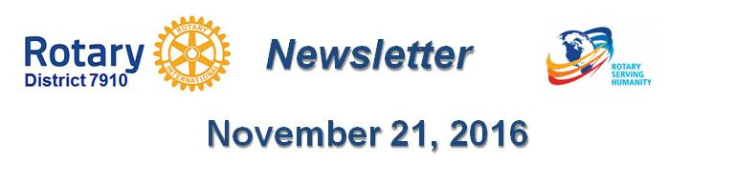

OUR PRESIDENTS SPEAK: Dan cunningham of fitchburg rotary
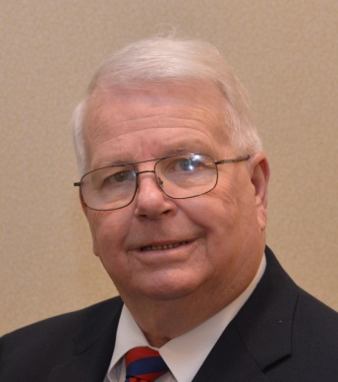Please tell us what factors helped you decide to join Rotary.

My desire to serve!

Of your club’s activities, what do you consider the one thing that best identifies what your club is all about?

Breakfast For The Bands. This fundraiser began over 22 years ago and all the profits for this event get split between the music programs for the Fitchburg and Leominster music programs.The high school football teams from Leominster and Fitchburg have had a long-time Thanksgiving Day football rivalry that started in 1894. This rivalry, also known by locals as the Turkey Bowl, last met for the 132d time overall in 2008.

What is your club doing this year to attract new members?

Asking!

Do you have any advice to offer others in the district about how best to achieve a successful fundraiser?

Just make sure you have plenty of members and volunteers on hand.

What do you consider to be your biggest concern during your presidency?

Keeping the entire club involved!

What's your favorite quote?

"I once complained about my shoes being too tight until I saw a man with no feet."

What's your favorite restaurant in your community?

Slattery's and the 50/50 Diner.

What is a "must see" in your community?

Coggshall Park.

Dan Cunningham, president of Fitchburg Rotary, may be reached at danc1@comcast.net. To learn more about Fitchburg Rotary, click here.

Return to November 21 Newsletter

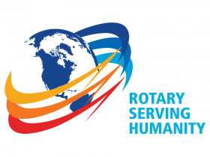
View past issues
Visit our website
'Like' our Facebook page
'Follow' us on Twitter

