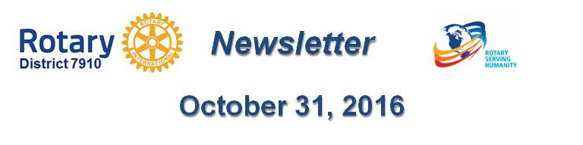

Tracking World Polio Day Events

Watch an update on our progress toward creating a polio-free world
By Carl Good III
Top global health experts and Rotary's polio ambassadors gathered at the headquarters of the U.S. Centers for Disease Control and Prevention for World Polio Day on October 24 in Atlanta, to hail progress made by Rotary and its partners.

To watch the video, click here.

Virtual-reality films bring a new dimension to polio fight

At this year’s World Polio Day celebration in Atlanta, Rotary harnessed the power of virtual-reality technology to build empathy and inspire action in our fight to eradicate polio.

Learn more about the films, click here.

If you are had an event for World Polio Day (or Week), please send me a brief description. We are keeping track of the events.

READ MORE

Thank you for all you do to erase this terrible disease from the face of the Earth.

October is an important month for both The Rotary Foundation and PolioPlus.

READ MORE

See the article in the left column of this newsletter.

For more information on this important month, click here.

Carl Good III, chair of the District Polio Committee, may be reached at carlgood@yahoo.com.

Return to October 31 Newsletter

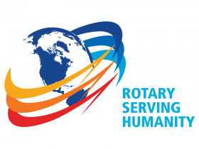
View past issues
Visit our website
'Like' our Facebook page
'Follow' our Twitter page

