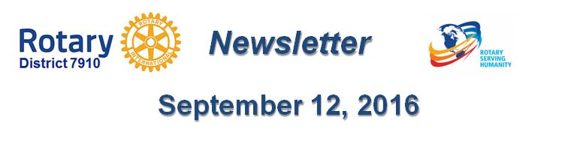

October An Important Month For Foundation, PolioPlus
By Carl Good III
October is an important month for both The Rotary Foundation and PolioPlus. We hope that every club will do something for PolioPlus during that month. This can include a special event, including PolioPlus promotion at a planned event or making a contribution from the club.

I can help with promotional materials. Polio is still here but almost gone - and can come back.

For more information on World Polio Day on October 24, click here and click here.

I also want to let you know that the District Polio Committee been very active. Our committee now includes Chris Spear, Pam Anastasi, Phil Sandler and Amanda Graves. READ MORE

Carl Good III, chair of the District Polio Committee, may be reached at carlgood@yahoo.com.

Return to October 24 Newsletter
Return to October 17 17 Newsletter
Return to October 10 Newsletter
Return to October 3 Newsletter
Return to September 26 Newsletter
Return to September 12 Newsletter

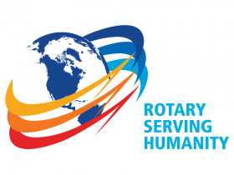
View past issues
Visit our website
'Like' our Facebook page
'Follow' our Twitter page

