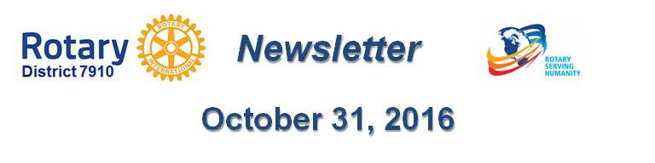

headline here
By Laura Spear

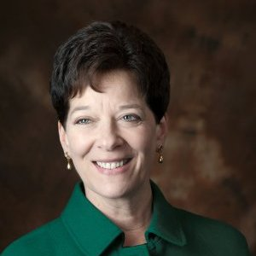
Article here

To learn more about PR for your club, click on the "Public Relations" section of the navigation bar of District 7910 website.

Laura Spear, chair of District 7910's Public Relations Committee, may be reached at laura@spear.net.

Return to October 31 Newsletter

View past issues
Visit our website
'Like' our Facebook page
'Follow' us on Twitter

