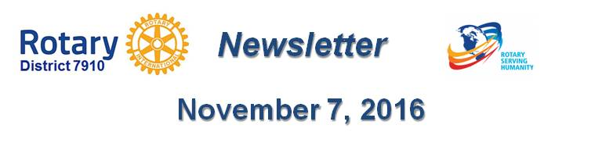

Identify your club’s experts
By Laura Spear

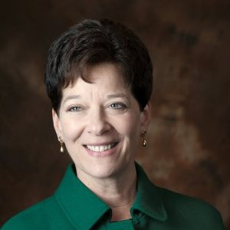
The term “expert” doesn’t have to mean someone with a Ph.D. or who has recently published a medical paper. Rather, it is who has knowledge, experience, and perspective on a particular issue or subject.

Does your club provide resources for the homeless? Does it plant trees on Earth Day? Does it provide scholarships for kids to attend college or summer camp? Whatever your mission is, there is a subject matter that someone is an “expert” at.

Keep in mind that sometimes the expert is the executive director or program manager. But other times, it might be a volunteer or even a recipient of your services. (from nonprofitpr.org)

To learn more about PR for your club, click on the "Public Relations" section of the navigation bar of the District 7910 website.

Laura Spear, chair of District 7910's Public Relations Committee, may be reached at laura@spear.net.

Return to November 7 Newsletter

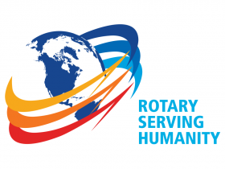
View past issues
Visit our website
'Like' our Facebook page
Follow' us on Twitter

