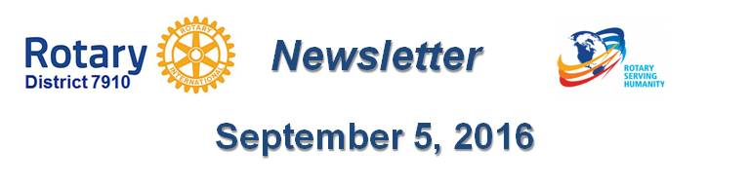

PR Tips: ???
By Laura Spear

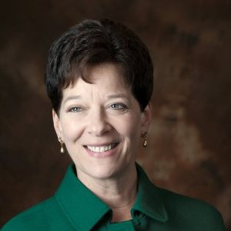

To learn more about PR for your club, click on the "Public Relations" section of the navigation bar of District 7910 website.

Laura Spear, chair of District 7910's Public Image Committee, may be reached at laura@spear.net.

Return to September 5 Newsletter

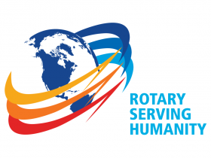
View past issues
Visit our website
'Like' our Facebook page
'Follow' our Twitter page

