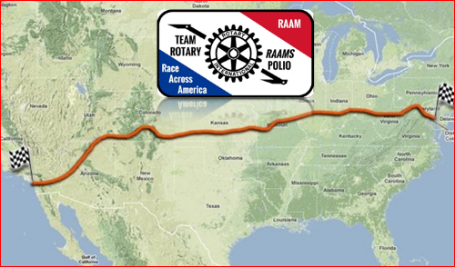

The Team Rotary RAAMs Polio are extremely grateful and thanks to everyone for your support of our Race Across America (RAAM) effort. We were successful in completely 2016 RAAM in 7 days, 1 hour and 16 minutes (169 hours and 16 minutes).
However, we are most honored that were able to raise $300,000 dollars to fund the eradication of Polio. Thank you!
A few more stats regarding the 2016 RAAM we have been asked about:
- 3069.25 miles
- Oceanside, CA to Annapolis, MD
- 175,000 feet of climbing
- 12 states
- 18.13 average miles per hour
- 2nd place in our category
- 9th place overall
- No penalties
- No flats
- No inclement weather, other than heat
  - Highest temperature we experienced, in the range of 117-122 degrees fahrenheit
  - Lowest temperature, we recall around 37 degrees fahrenheit
We all learned and were convinced that RAAM is “The World’s Toughest Bicycle Race” and an “ultra event” for both the cyclists and crew members. Thank you to our Team Rotary RAAM Polio team:
Elite Cyclist
- Bob McKenzie (Tulsa, OK)
- Randy Jackson (Tulsa, OK)
- Steve Schoonover (Draper, UT)
- Kurt Matzler (Italy/Austria)
Crew Members
- Bill Clark – Crew Chief, (Oklahoma)
- Darlene McKenzie (Oklahoma)
- David Armstrong (Texas)
- Erik Ortega (Oklahoma)
- Jack McGlumphy (Oklahoma)
- John Robertson (Arkansas)
- Justyn Rains (Oklahoma)
- Linda Ortega (Oklahoma)
- Marvin Lee (Oklahoma)
- Meinhard Huber (Austria)
- Ryan Jackson (Arkansas)
One other question, we are getting asked. Would you do RAAM again? Each one of us have fond thoughts and enjoyed this experience and working together on this effort. There are whispers about doing RAAMagain but no roar at this time. Stay tuned, we will see.....

