Rotary Leadership Institute (RLI) News
Dave Kaiser, Westborough Rotarian and District 7910 RLI Chair
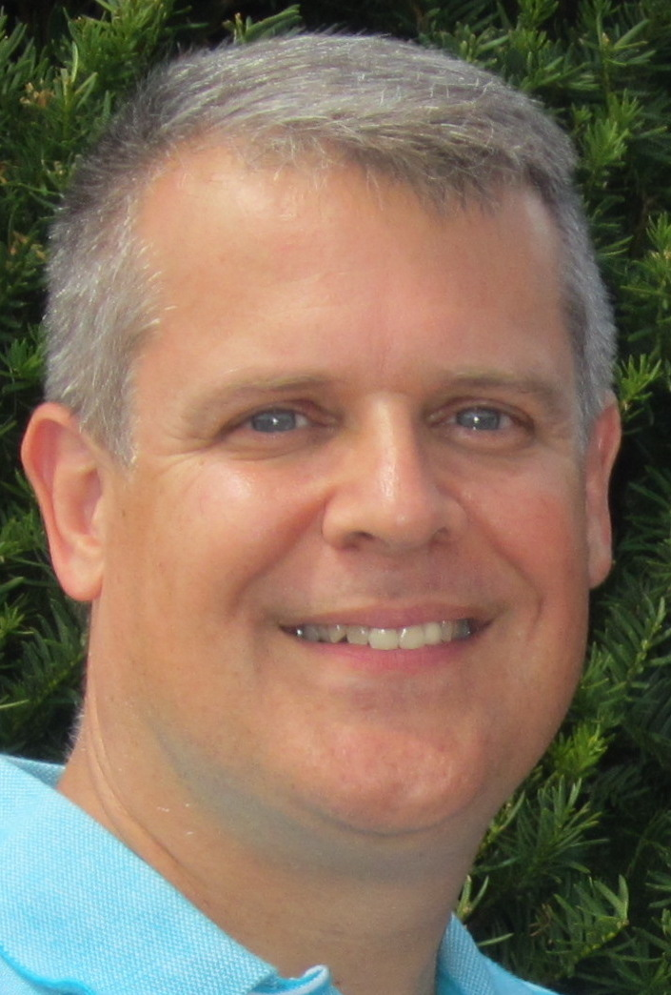

The Who, What, When, Where, Why & How of Rotary Leadership Institute (RLI)
Have you ever heard fellow Rotarians mention RLI and wondered, “What exactly is RLI?” Or, perhaps you do know what RLI is but aren’t sure if you should attend?
As your new District 7910 RLI Chair, I want to ensure I have provided answers to the Who, What, When, Where, Why & How of RLI.
1. WHAT is RLI? The Rotary Leadership Institute (RLI) is a multi-district, grassroots leadership development program of member districts organized into regional divisions in various parts of the world. RLI is not an official program of Rotary International and is not under its control.
The Institute offers a leadership development program in three full-day sessions (Parts I, II and III). The courses are designed to provide Rotary knowledge and to develop leadership skills for voluntary organizations. Some examples of course sessions include:
- A Look Outside the Club
- Membership Orientation and Activation
- Introduction to Leadership
- Creating Service Projects
- Problem Solving Workshops
- Vocational Service
- Effective Committees
- Membership Development
- The Rotary Foundation
- Analyzing a Rotary Club
- The Object of Rotary
- The District
- International Service
- Problems of Leadership
- Creative Service
- Written Communications
- Motivating Rotarians and Effecting Change
2. WHO should attend RLI? RLI seeks to have Rotary Clubs in its member districts identify those Rotarians who appear to have the potential for future club leadership (not necessarily as club presidents) and provide those so identified with a quality education in Rotary knowledge and leadership skills so important in voluntary organizations. Anyone interested in learning more about Rotary and how Clubs, Districts and International interrelate will also find RLI a great resource. Perhaps you have no current interest in a formal Club or District leadership role, but you are interested in helping in a Global grant, growing your Club’s membership, or how to run effective Community / Fundraising projects. RLI may be helpful to you as well.

3. WHEN & WHERE are RLI sessions offered? Each District hosts an RLI each year. The 2017 schedule in our area includes Saturday March 25th in Lincoln, RI and Saturday May 6th in Peabody, MA. Plans are underway for a session to be hosted by our District in January 2018. Having three sessions so close to our District makes it easy for Rotarians to attend and complete the three RLI parts within a year if they so desire. Others may choose to only attend the District session which means completing RLI over the course of a few years. Tuition ranges between $75and $90 per session, with many clubs providing subsidies to cover all or a portion of the cost for their members to attend. See your Club President or Secretary for details on how your club handles RLI.
4. WHY attend RLI? As previously mentioned, RLI can help those interested in getting involved in Club or District leadership, those with a particular interest in segments of Rotary’s endeavors, or those wishing to gain a greater awareness and better understanding of Rotary as a volunteer organization.
5. HOW can you register for RLI or learn more? Go to the official site of the Rotary Leadership Institute of Northeast America at http://www.rlinea.org/.
If you have other questions or would like to arrange for me to speak at a Club meeting, please feel welcome to email me at Kaiser@westboroughrotary.org.

