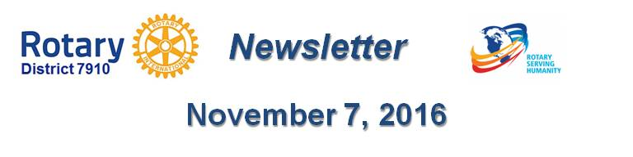

Rotary Means Business: First Meeting on December 7
By Ron Bott

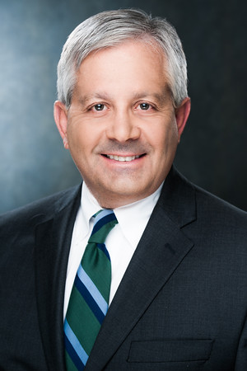
The first Rotary Means Business event in District 7910 will be held on Wednesday, December 7 from 5:30 to 7:30 p.m. at the Sheraton Hotel in Framingham. The cost is $15 for Rotarians and $20 for non-Rotarians. Light appetizers will be served and a cash bar will be available.

Rotary Means Business was founded in 2013 as an official Rotary International Fellowship. RMB provides Rotarians with business networking events to meet and socialize with other Rotarians in business. It encourages Rotarians to support the success of their fellow Rotarians by doing business with them, and by referring others to them.

To register for this event, click here.

For more information, contact me as chair of the District Rotary Means Business Committee at 978-423-0564 or ron@bottgroup.com.

Return to November 7 Newsletter

View pa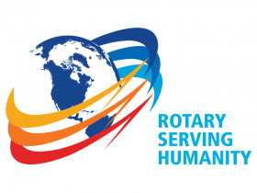st issues
Visit our website
'Like' our Facebook page
'Follow' our Twitter page

