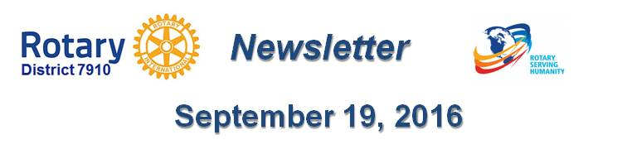

Dear $NICK_NAME$,

It is our pleasure to share with you the September 19 issue of Rotary District 7910 Newsletter.

For the complete issue, click here.

To explore past issues, click here.

Here are the highlights of the September 19 issue:

Earthquake In Italy: A letter from Rotary International General Secretary John Hewko

Governor's Message: ??? - By Pat and Skip Doyle

Our Presidents Speak: Q&A with ???

UN Day: November 12 At The United Nations: Register Now! - By Karin Gaffney

PolioPlus Update: October An Important Month For Foundation, PolioPlus - By Carl Good III

Membership Corner: ??? - By Tom Sturiale

Club Membership Growth: Club goals for 2016-2017

Membership Materials on Sale: Order Now!

Foundation Note: ??? - By Sanjay Deshpande

PR Tips: ??? - By Laura Spear

Treasurer's Report: Message about your dues - By Jack Hoell

District Charity Fund: How Does DCF Operate? - By Al Bowers

Communications Link: Seeking club photo, video albums - By Steve Jones-D'Agostino

Bandey-Hefler Update: Preparing for trip to England - Plane leaves today! - By Victor Tom

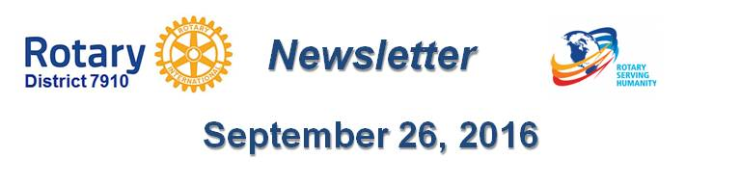Our next newsletter will come out on Monday, September 26. The submission deadline is this Friday, September 23. Text content must be submitted in Word format. Image content must be submitted in either JPEG or PDF format. Send your content submissions to Immediate Past District Governor/Newsletter Editor Jim Fusco at jim.fusco2@gmail.com.

Governors Pat & Skip

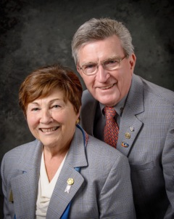Pat and Skip Doyle
2016-2017 Governors
Rotary District 7910
pwdoyle2@verizon.net
skipdoyle2@verizon.net

