GOVERNOR'S MESSAGE
Last Week Was a Full Rotary Week
By Pat and Skip Doyle
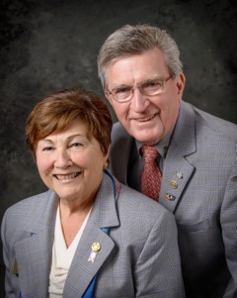
Last week was a full Rotary week as we were welcomed into four clubs: Brookline, Hudson, Leominster and Watertown. The presidents brought their unique personalities to both the club meetings and their well-attended board meetings. We want to thank all the presidents and the members of these clubs for warmly welcoming us as well as the assistant governors who also visited.

Speaking of AGs. we want to thank them all for the efforts they have made to attend these visits with us. For many of them, this is not the first time they have visited their clubs. All of them were right at home, and many of them have already been answering questions from their clubs and helping wherever they can. We both served as AGs in the past and we know what a rewarding position this can be. In fact, as we go around the District visiting clubs, we see many old and dear friends that we made during those tenures. The next Assistant Governors Meeting will be held this Wednesday evening at the Hilton Garden Inn in Marlborough.

The first quarterly meeting of the District Foundation Committee was also held this week. This meeting, chaired by Sanjay Deshpande, was well-attended. In fact we ran out of room. The agenda featured reports from the chair as well as the Alumni, Endowments, Fundraising, Grants, Polio Plus, Scholarship and Stewardship subcommittees. Each subcommittee chair reported marked progress. Those reports will be highlighted in future newsletters.

District Governor and Trustee Nomination Time
Remember that even though the Nominating Committee can only choose one District Governor each year, all Past Presidents are eligible to be considered. We have met so many qualified Past Presidents as we visited Clubs, and as we say any one of you could be District Governor. Give it a try. The deadline for applications is October 15.

More than likely, all of you are just as tired as we are about elections, voting and candidates. But this reminder is for all Rotarians. Now is the time for Clubs to nominate candidates for the very important positions of District Governor and Trustee. Please review the nomination details and nomination forms. We hope to hear from many Clubs because there are so many potential candidates among our members.

See the Top Highlights banner, at the top this newsletter, for detailed information on the nomination process.

Always remember, you can call us with questions at 508-393-9031.

District Governors Pat and Skip Doyle may be reached at pwdoyle2@verizon.net and skipdoyle2@verizon.net, respectively.

Click here to submit content for the September 26 issue to Immediate Past District Governor/Newsletter Editor Jim Fusco.

Click here for past issues.

WELCOME, NEW ROTARIANS
Please join us in welcoming these new Rotarians to clubs in our District (alphabetical by last name):

- Melissa Dilorenzo, Montachusett Area
- Lynn Gerrits, Montachusett Area
- Andrea Mitchell, Montachusett Area
- Matt Walsh, Waltham
- Donna Wolf, Milford

CLUB MEMBERSHIP GROWTH, ’16-‘17
We share with you the results of club membership growth in our District during Rotary 2016-2017, which began July 1.

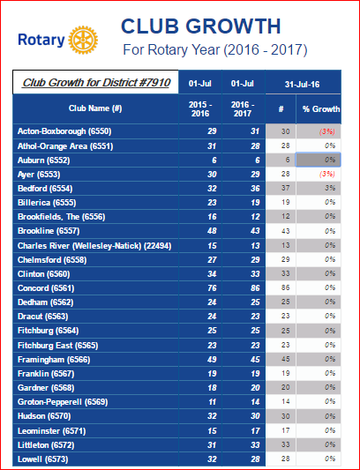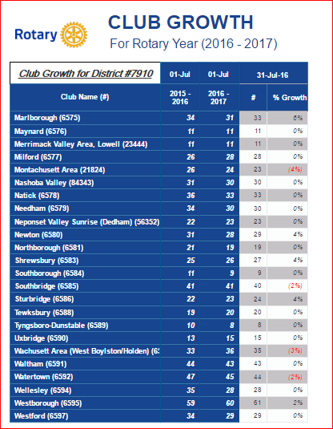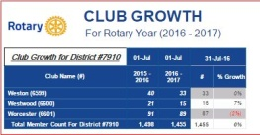

READ MORE

This is a unique opportunity for Rotarians and friends to discuss partnering on humanitarian projects affecting our local communities.

MEET & GREET WITH GOVERNOR CHARLIE BAKER
Tuesday, September 27: Bedford, Billerica, Lowell, Newton and Shrewsbury Rotary - 'Governor Baker - Featured Speaker at Rotary'

5:00-9:00 p.m., DoubleTree Bedford Glen Hotel, Bedford

Click here to register

Limited seating, so register now!

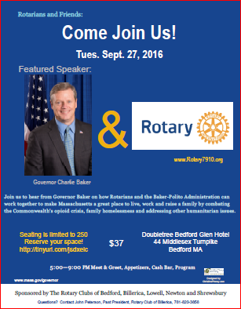

OUR PRESIDENTS SPEAK
Jennifer Stacy, Leominster

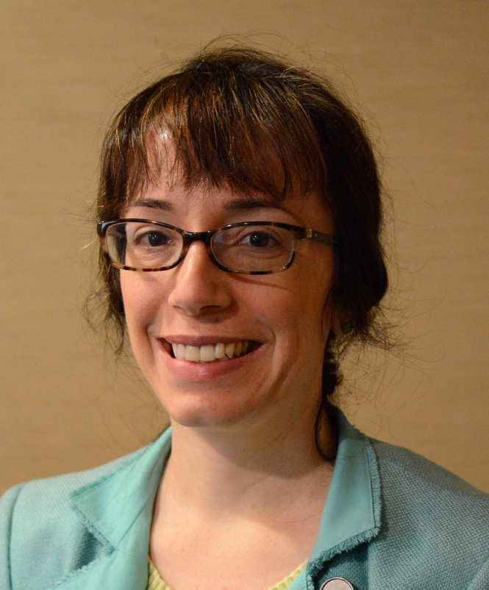

Please tell us what factors helped you decide to join Rotary.

Friendly members, networking opportunity, company pays dues, opportunity for community service.

READ MORE

DISTRICT & CLUB ROUNDS
District Interact Training Seminar A Huge Success

Nearly 50 participants from 14 Rotary communities took part in a District Interact Teen and Advisor Training Seminar, which was held on Saturday, September 17 at the Sheraton Hotel in Needham.

Shown, left to right, are Juliana Walsh and her mother, Palma Cicchetti of Acton-Boxborough Rotary, Bob Anthony, Diana Nestorova of Acton-Boxborough Rotary, Nadja Reilly of Family and Educational Wellness Center, and Steve Jones-D'Agostino of Auburn Rotary.

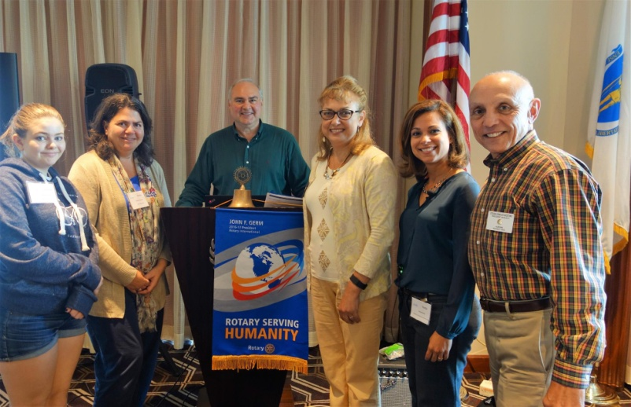

Shown, left to right, are Bob Anthony, Rick Carrero of Bay Path Regional Vocational Technical High School, Jen Reil of Auburn Rotary, Jamie Butkiewicz of Bay Path Interact, Steve Jones-D'Agostino, Veronica Martinez and Hannah Garabedian of Bay Path Interact, and Nadja Reilly.
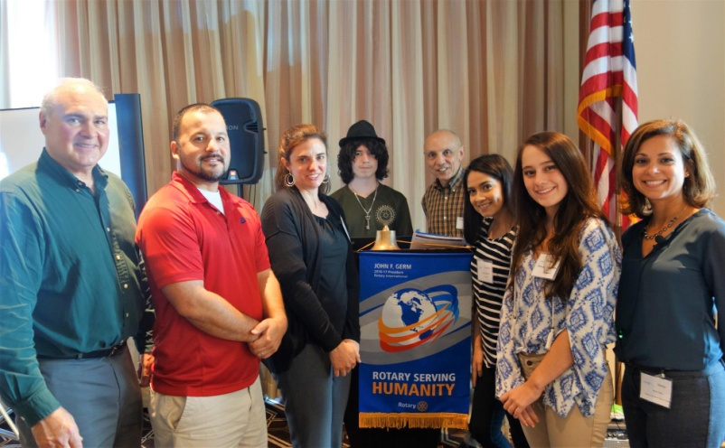

To view additional seminar photos, click here. In next week's newsletter, we'll have more photos plus videos of the seminar presentations.

For more information on Interact, contact Bob at bobanthony@adolescentwellness.org, Or, click here.

Foundation Committee Holds Quarterly Meeting

Shown, left to right, are Past District Governor Klaus Hachfeld, Austin Jenkins, DG Nominee Steve Sager, DGs Pat & Skip Doyle, Foundation Chair Sanjay Deshpande, Ron Bott, Victor and Bharti Bhakta, John Peterson, and Indira Desai

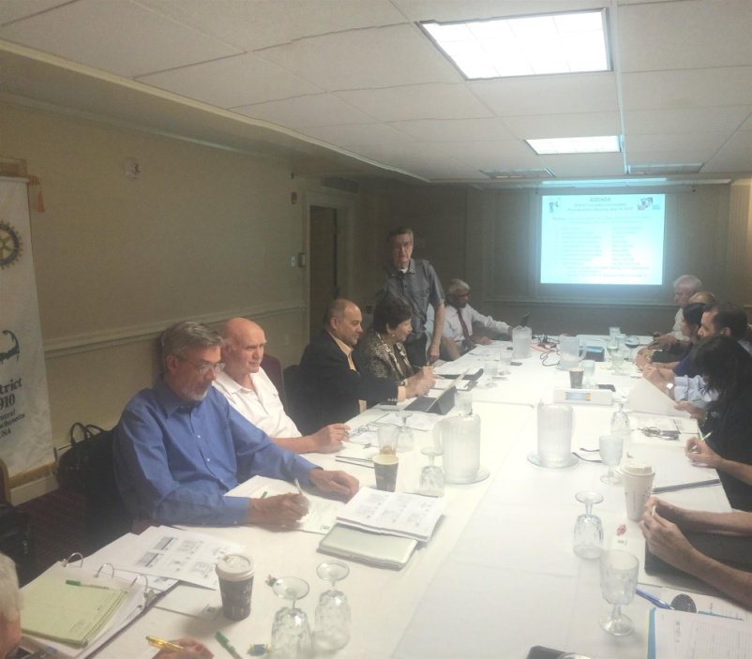

Wellesley Inducts Three New Members

Shown, left to right, are new members William Westerman and Martin Chiu, District Governors Pat and Skip Doyle, and new member Cynthia Sibold.

READ MORE

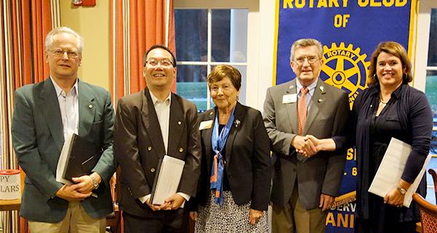

District Polio Team Visits Lowell Rotary

Carl Good III, chair of the District Polio Committee, and his polio team continue to visit clubs. Last week, he visited Lowell Rotary to spread the polio message. He learned that Lowell has the largest artist colony in the U.S. and that the Lowell club promised to discuss a polio event at their next board meeting. Thank you, Lowell!

If you would to join the polio team, just let Carl know at carlgood@yahoo.com or 978-273-7880.

Carl Good III (left) posing with Lowell President Maureen Couture.

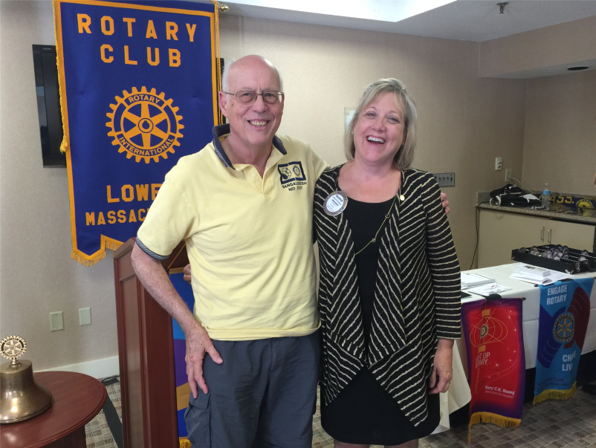

Montachusett Area Supports Literacy At Project Apples
For Montachusetts Area Rotary literacy is a high priority. Project Apples is a literacy event at which local organizations gather together to provide school children with free books. This year, the event was held in the food court of the Mall at Whitney Field in Leominster, This is the eighth consecutive year that Montachusett Area has participated in Project Apples. To learn more about Project Apples, click here.
Shown, left to right, are Montachusett Area Rotarians Leslie Storrs, Jean Storrs, Tony Gasbarro, Joan Ficarra and Andria Mitchell at this year's Project Apples event.
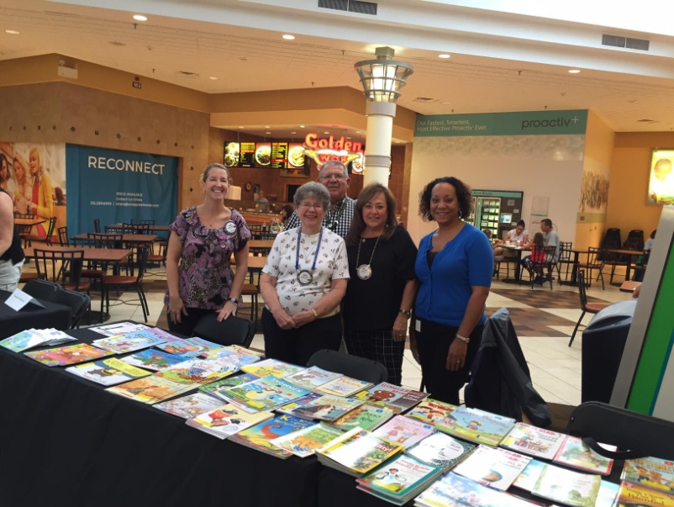

Nashoba Valley Sponsors Razia's Ray Of Hope Event On October 27

The Rotary Club of Nashoba Valley is proud to sponsor the local premiere of What Tomorrow Brings, event to benefit Razia’s Ray of Hope, on Thursday, October 27 from 7:00 to 9:00 p.m. at the Ward Hall of the Fenn School, located at 6 Monument St. in Concord. Razia's Ray of Hope is a school for girls in Afghanistan that was founded by Razia Jan, a CNN Top 10 Hero.

READ MORE



District Governors' Visits Last Week

Brookline (Chartered 1938)

Shown, left to right are Assistant Governor Karen Wetmore, Brookline President Elmon Hendrickson, Brookline Vice President Claudia Dell'Anno, and District Governors Pat and Skip Doyle.

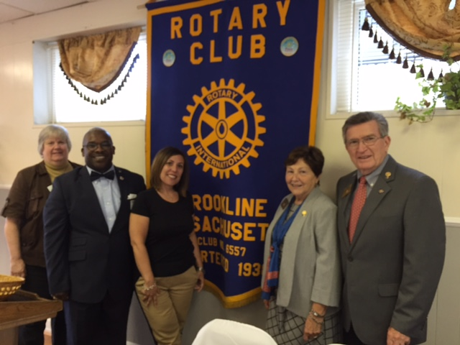

Hudson (Chartered 1923)

Shown, left to right, are Hudson Treasurer Justin Provencher, Hudson President Robin Frank, District Governors Pat and Skip Doyle, Hudson Vice President Trevor Rank, and Hudson President Elect Pam Cooper.

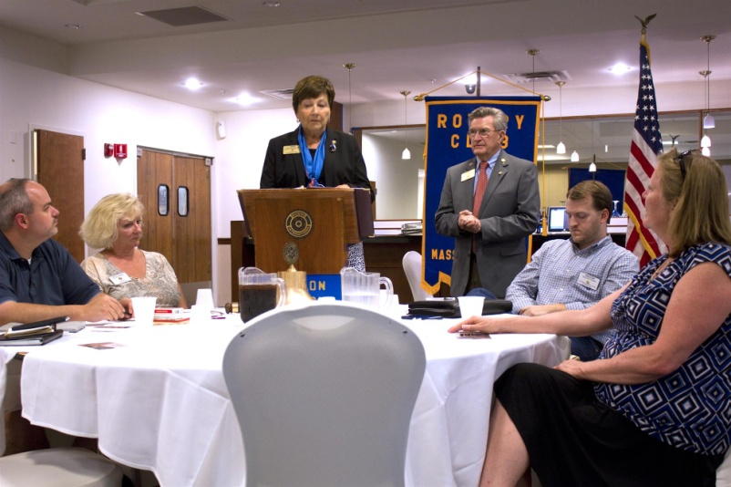

Leominster (Chartered 1925)

Shown, left to right, are DG Pat Doyle, Leominster President Jennifer Stacy, and DG Skip Doyle.

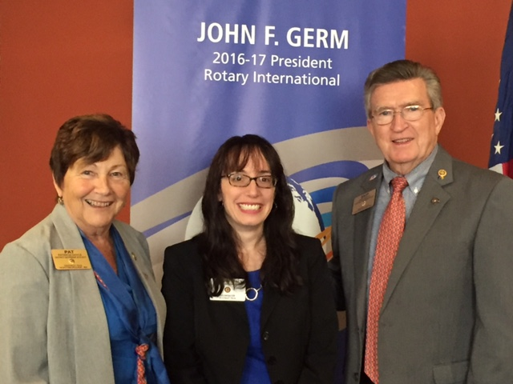

Watertown (Chartered 1925)

Shown left to right, are DG Pat Doyle and Watertown President Lilia (Wood) Weisfeldt.

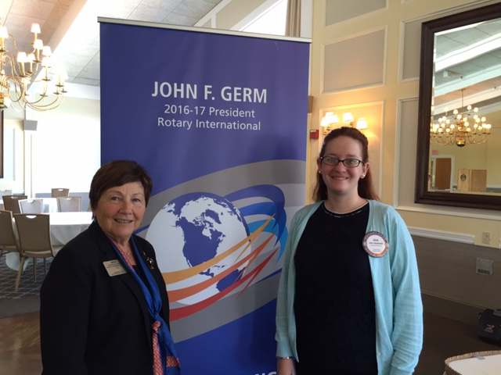

Westborough Holds Outing

On September 11, the Rotary Club of Westborough gathered at the home of Rotarian Shelby Marshall, Gail Hanson and daughter Grayson for a late afternoon of wacky fun, fellowship, fabulous food and perfect weather. Homage was paid to the events and heroes of 9/11. It was a perfect New England event.

To read the Westborough newsletter, click here.

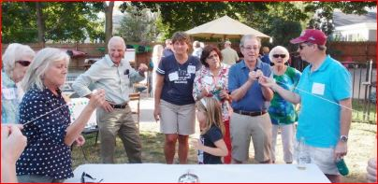

Planning Underway for 2017-2018

Pat Doyle and Skip Doyle's year as district governors has just started, but planning is already underway for next year! District Governor Elect Karin Gaffney met recently with the 2017-2018 district leadership team to start planning, and the first pre-Presidents Elect Training Seminar (pre-PETS) session for next year's club presidents begins next week!

Shown, left to right are William Domings, District Foundation Chair Sanjay Deshpande, District Governor Nominee Steven Sager, Immediate Past District Governor Jim Fusco, David Fitzgerald, Lilia Wood, Karin Gaffney, Lindsey Dean, Diana Nestrova, Ronald Bott, Steve Kirk, Assistant Governors Coordinator Pam Anastasi and District Secretary Michelle Gasbarro.

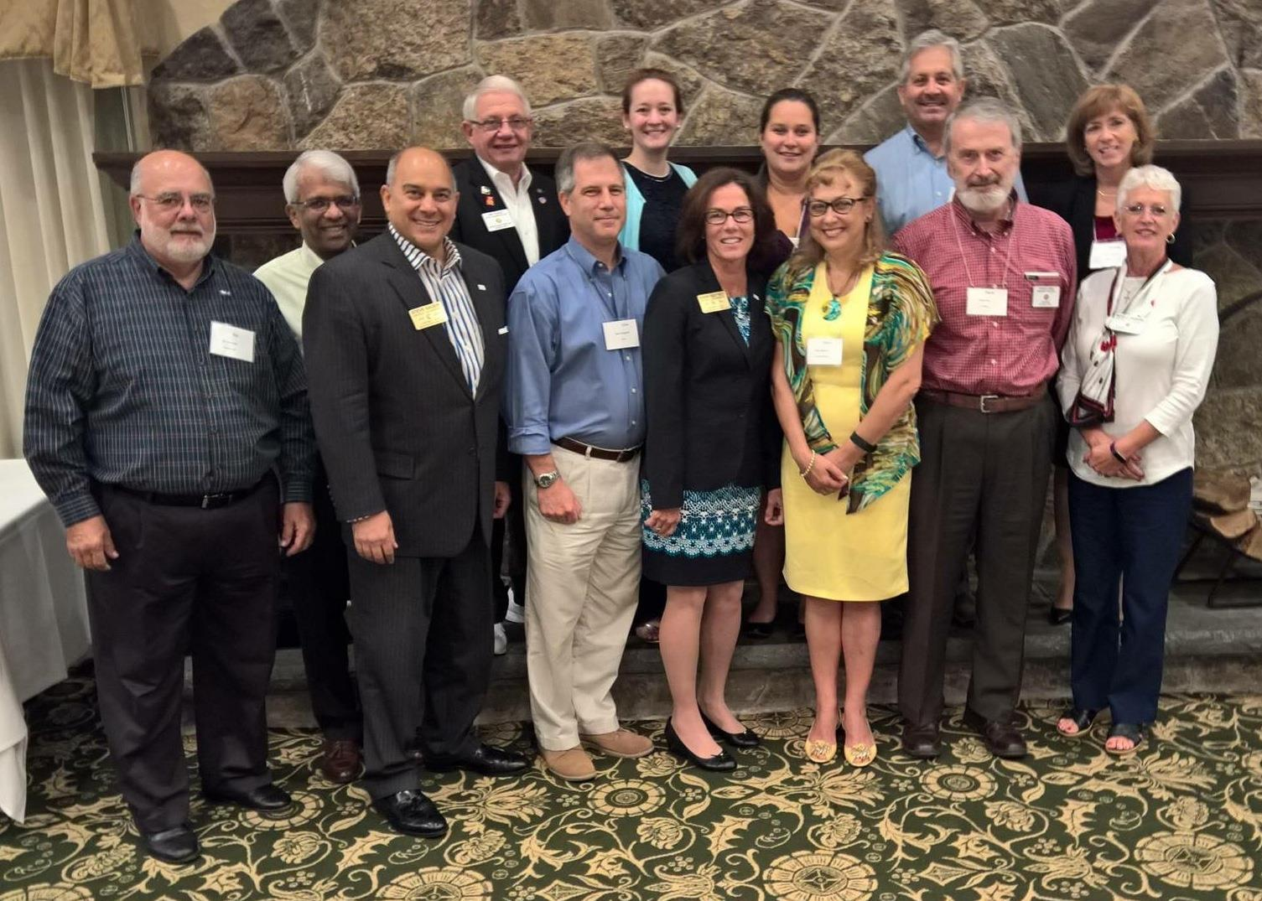

Rotary Alumni: Where Are They Now?

Congratulations to Honore Johnson (shown), a former Youth Exchange student, on being selected to be a Fulbright Scholar. She graduated from Cornell University in May 2016. While at Cornell, she was a member of the Rotaract Club. Honore's studies will be in the area of conflict resolution in Taiwan.

READ MORE

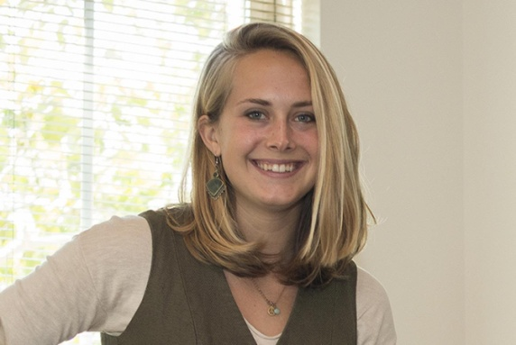

Marlborough Partners With Local Groups On Mental-Health Crisis Intervention
The partnering organizations invite all members of the community to attend and join the conversation.food and beverages served.., with 5:30 p.mNetworking will start at Marlborough. , 82 Brigham St. Employment Options, at 6:00 to 8:00 p.m., 2016 from September 29on Thursday, Many Hands, Many Partnerships, have partnered to conduct an event on mental-health crisis intervention, National Alliance on Mental Illness and the MetroWest chapter of the Employment Options ,Rotary Club of MarlboroughThe 
Many Hands, Many Partnerships will be a community dialogue on how we can better work together to help individuals and families in a mental-health crisis get the support they need. It takes a community to manage a mental-health crisis. All too often, we rely entirely on the police to manage such a crisis. Although our local police departments play a valuable role in a crisis, emergency first-responders, mental-health clinicians, individuals with lived experience, and family members all play equally valuable roles.

The event will include a feature presentation and panel discussion. Audience questions and participation will be encouraged. Feature presenter, Chief Craig Davis of the Ashland Police Department, will speak on “Crisis Diversion and Linkages.” The topic of the panel will be “Crisis Intervention to Crisis Management to Family Need and Support to Recovery.” Chief Davis will join Chief Mark Leonard of the Marlborough Police Department and John Deronck of Emergency Services Advocates in the panel discussion.
The Many Hands, Many Partnerships event is part of a community mental-health-awareness campaign to draw attention to the needs of those with mental illness, change negative perceptions, and promote recovery and healthy communities. The partners’ objectives include finding innovative community-based solutions to mental-health needs, with a focus on helping young people, and developing clear steps for communities to address their mental-health needs in a way that complements existing local activities.

For more information on the Many Hands, Many Partnerships event, visit marlboroughrotary.org, employmentoptions.org, or namimetrowest.org
To register in advance, call 508-251-9595 or email namimetroWest@namimetrowest.org.

Rotary Leadership Institute of Northeast America Annual Meeting

The Rotary Leadership Institute is a multi-district, grassroots leadership-development program of member districts organized into regional divisions in various parts of the world. RLI is not an official program of Rotary International and is not under its control. For more information, click here.

Shown, is Past District Governor Ed King of Northborough Rotary presenting the Registrar's Report.

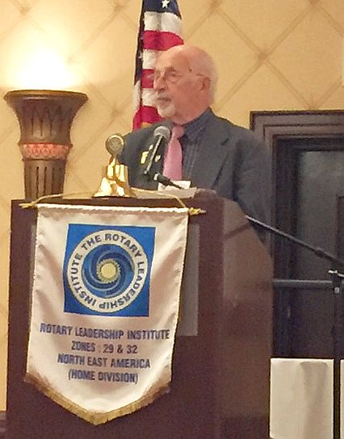

Next Nashoba Valley Rotary, Bolton Local Repair Café On September 24

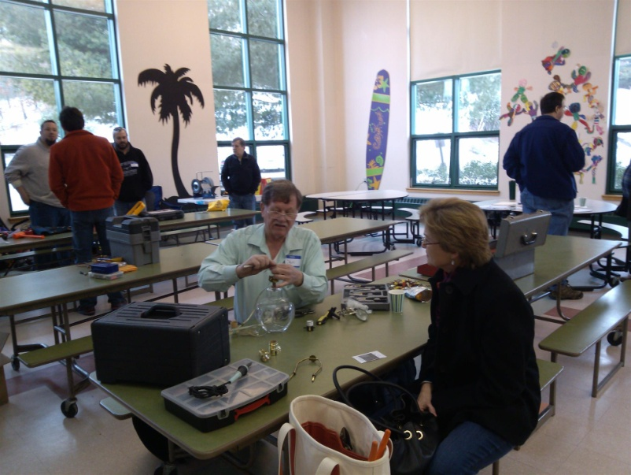What do you do with a broken toaster or lamp? Or with a shirt or blouse with a seam that is ripped out? Toss it? No way! Bring them to the Bolton Repair Café. The Rotary Club of Nashoba Valley, with help from Bolton Local, is hosting the next Bolton Repair Café on Saturday,September 24 from 9:00 a.m. to 1:00 p.m. The event will be held in the cafeteria of the Florence Sawyer School, located at 100 Mechanic St. in Bolton. The school is located behind the Emerson School, which is on the same driveway/street.

Residents of Bolton and surrounding towns are invited to come and find out what a Repair Café is all about. At the Repair Café, sponsored by Nashoba Valley Rotary,everything centers on making repairs. Knowledgeable volunteers will help repair items such as clean, mendable clothing, lamps, small appliances, computers and other electronics, bikes, toys, outdoor power equipment, and jewelry. They can also sharpen knives, scissors, and garden tools. You only pay for needed parts. If you know what parts are needed, please get them ahead of time and bring them to the Repair Café to save time. Volunteers at the Repair Café will look at all items brought in and try to repair them. If the volunteers cannot repair something, they will offer suggestions about where you could go for repairs.

Unlike a “fix-it” shop, where people drop off items to be repaired and continue about their day, the Repair Café is meant to get people involved with the repair process and create connections with others in the community. People bringing in items for repair are asked to stay while your items are being fixed. You can just watch, help with the repair, fix the item yourself with help from volunteers, or just have a snack and visit with neighbors.

Promoting repairs will help reduce mountains of waste. According to organizer Ray Pfau, a Nashoba Valley Rotarian, “We throw away lots of things that often have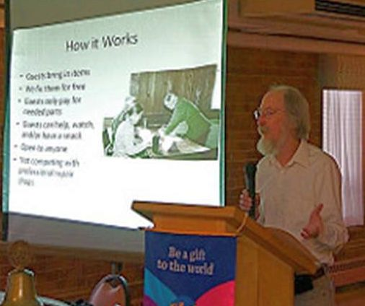 almost nothing wrong with them, things that could easily be used again after a simple repair. Unfortunately, many people have forgotten that they can fix things. Repair Café wants to change all that.” (Shown, right, is Ray Pfau addressing a recent Worcester Rotary meeting. Click here to view additional photos of that event by Worcester Rotarian Rich Prager.)

Repair Café is also meant to put neighbors in touch with each other in a new way. Neighbors may discover that a lot of know-how and practical skills can be found close to home. Pfau added, “If you repair a bike, a CD player, or a pair of trousers with previously unfamiliar neighbors, you look at them in a different light the next time you see them. Jointly making repairs can lead to connections in the community.” Making repairs can also save money and resources.

The Bolton Repair Café is sponsored by Nashoba Valley Rotary with support from Bolton Local and the Repair Café Foundation. The Foundation has been organizing Repair Cafés since 2010 in the Netherlands and has provided support since January 2011 to local groups in and outside the Netherlands wanting to start their own Repair Cafés.

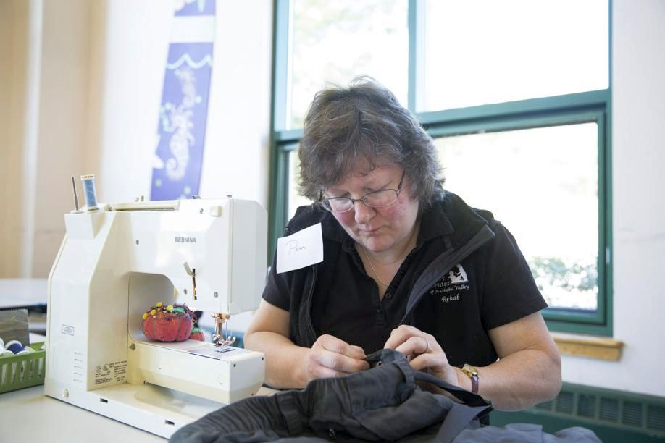Click here for a recent Boston Globe profile of the Bolton Repair Cafe.
For more information, contact Ray Pfau at 978-779-5545 or ray.pfau@alum.mit.edu, or visit www.nashobarotary.org.

Pat and Skip Doyle Installed As '16-'17 DGs

District 7910's 2016 Rotary Youth Leadership Awards were held on June 24 through 26 at Fitchburg State University, ending with the installation of longtime RYLA supporters Pat and Skip Doyle as District Governors for 2016-2017. The three-day RYLA event was attended by 188 sophomores. To learn more about RYLA, visit ryla7910.org.

Click on the image, to view a video of the installation of Pat and Skip Doyle as '16-'17 DGs

District Leadership Meeting A Huge Success

How HUGE? So HUGE that another is planned for October 17!

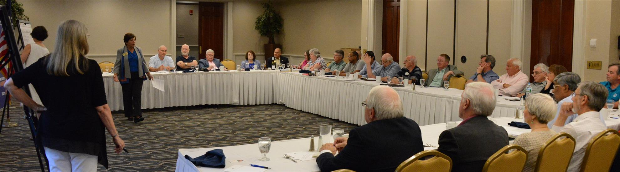
District Governors Pat and Skip Doyle held their Leadership Meeting on July 19 at the DoubleTree Hotel in Leominster. This is an annual event for which DGs bring their District leaders and committee chairs together to review the goals for the new Rotary year.

This, year the event was presented in a facilitated format. The results will be consolidated and sent to all attendees so that the District Goals for each committee can be set.

District Banners Available

Our district banners are available for your to use when you have an upcoming event or fundraiser.

If you want to reserve one of the banners, please contact PR Chair Laura Spear at laura@spear.net.

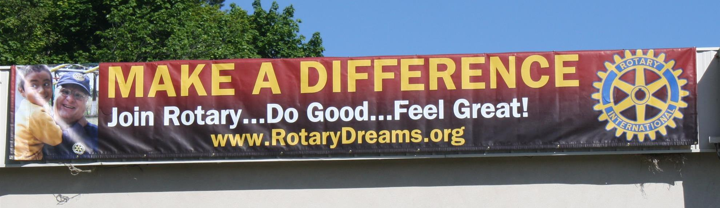

On To Atlanta In 2017

Planning to attend? Contact District Chair Steve Glines.


More than 43,000 attendees left the Rotary International Convention in South Korea inspired to end polio for good, to celebrate The Rotary Foundation's centennial, and to champion changes that will help Rotary appeal to a broader audience.
On the last day, RI President K.R. “Ravi” Ravindran shared a personal story of his mother’s triumph over polio.

To read the story, click here.

To register for the 2017 RI Convention in Atlanta, click here

MAJOR DISTRICT & CLUB HAPPENINGS: SUMMER & FALL
Today, September 19: Wachusett Area Rotary - '24th Annual Golf Tournament,' Fitchburg

To download the event flyer, click here.


Tonight, September 19: Shrewsbury Rotary - 'Amanda Graves: On Being A Polio Survivor'

Don't miss this presentation! Amanda (shown, below) is the newest member of the District 7910 Polio Committee, chaired by Carl Good III.

READ MORE

To read the press release, click here

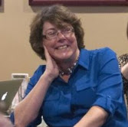

Tuesday, September 27: Bedford, Billerica, Lowell, Newton and Shrewsbury Rotary - 'Governor Baker - Featured Speaker at Rotary'

5:00-9:00 p.m., DoubleTree Bedford Glen Hotel, Bedford

To RSVP, click here

Thursday, September 29: Marlborough Rotary - 'Many Hands, Many Partnerships'

To download the event flyer, click here.

Saturday October 1: Ayer Rotary - Senior BBQ, Bob Eisengrein Community Center, Devens

To download the flyer, click here.

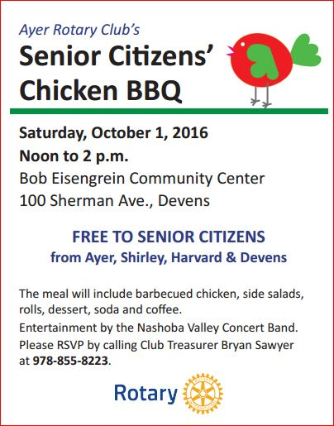

Wednesday, October 5: Boston Rotaract Club - 'Women in Rotary'

To buy tickets, click here



Friday, October 14: Montachusett Area Rotary - 'Comedy Night,' Knights of Columbus, Leominster

For tickets and information, contact Club President Jennifer Peck at montachusettarearotary@gmail.com.



SUBMIT MAJOR CLUB HAPPENINGS


Send flyers of your club's major events and activities, in either JPEG or PDF format, to Immediate Past District Governor/Newsletter Editor Jim Fusco
at jim.fusco2@gmail.com.

