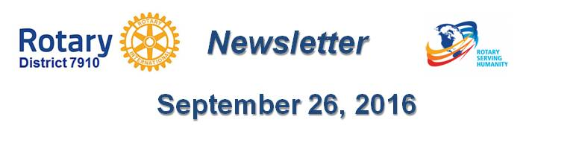

Dear $NICK_NAME$,

It is our pleasure to share with you the September 26 issue of Rotary District 7910 Newsletter.

For the complete issue, click here.

To explore past issues, click here.

Highlights of September 26 issue:

Governor's Message: - Clinton, Nashoba Valley, Sturbridge were our destinations last week - By Pat and Skip Doyle

Our Presidents Speak: Q&A with Otto Prohaska of Sturbridge

Interact Action: District Interact Teen and Advisor Training Seminar is a huge success - By Bob Anthony

Bandey Hefler Report: District 7910 travelers have safely arrived at Heathrow Airport - By Victor Tom

District Governor-Elect Report - Why should I go to the Rotary International Convention? By Karin Gaffney

Rotary Leadership Institute: Just 19 days in Boxborough! - By Doug Detweiler

PolioPlus Update: October an important month for Foundation, PolioPlus
- By Carl Good III

Speakers Bureau: Do you need a speaker for your club? By Steve Levitsky

Membership Corner: Rotary club objectives - By Tom Sturiale

Membership Materials on Sale: Order now!

Foundation Note: Club qualification status for foundation grants - By Sanjay Deshpande

PR Tips: Make your press releases newsworthy! - By Laura Spear

Treasurer's Report: Message about your dues - By Jack Hoell

District Charity Fund: How does DCF operate? - By Al Bowers

Communications Link: Seeking club photo, video albums - By Steve Jones-D'Agostino

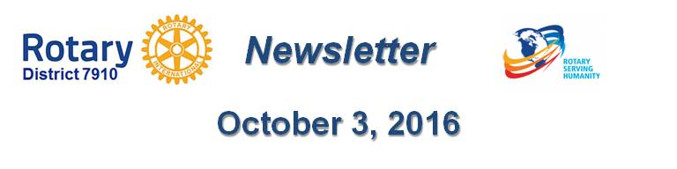Our next newsletter will come out on Monday, October 3. The submission deadline is this Friday, September 30. Text content must be submitted in Word format. Image content must be submitted in either JPEG or PDF format. Send your content submissions to Immediate Past District Governor/Newsletter Editor Jim Fusco at jim.fusco2@gmail.com.

Governors Pat & Skip

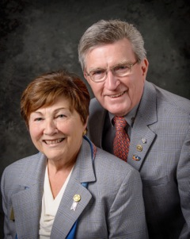Pat and Skip Doyle
2016-2017 Governors
Rotary District 7910
pwdoyle2@verizon.net
skipdoyle2@verizon.net

