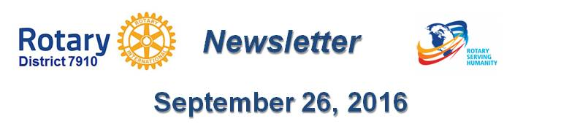

Click here for the complete issue

Or, click on each of these issue highlights:

Governor's Message: - Clinton, Nashoba Valley, Sturbridge were our destinations last week - By Pat and Skip Doyle

Our Presidents Speak: Q&A with Otto Prohaska of Sturbridge

Interact Action: District Interact Teen and Advisor Training Seminar is a huge success - By Bob Anthony

District Governor-Elect Report - Why should I go to the Rotary International Convention? By Karin Gaffney

Rotary Leadership Institute: Just 19 days in Boxborough! - By Doug Detweiler

Bandey Hefler Report: District 7910 travelers have safely arrived at Heathrow Airport - By Victor Tom

PolioPlus Update: October an important month for Foundation, PolioPlus
- By Carl Good III

Speakers Bureau: Do you need a speaker for your club? By Steve Levitsky

Membership Corner: Rotary club objectives - By Tom Sturiale

Membership Materials on Sale: Order now!

Foundation Note: Club qualification status for foundation grants - By Sanjay Deshpande

PR Tips: Make your press releases newsworthy! - By Laura Spear

Treasurer's Report: Message about your dues - By Jack Hoell

District Charity Fund: How does DCF operate? - By Al Bowers

Communications Link: Seeking club photo, video albums - By Steve Jones-D'Agostino

