GOVERNOR'S MESSAGE

Clinton, nashoba valley, Sturbridge were our destinations last week
By Pat and Skip Doyle
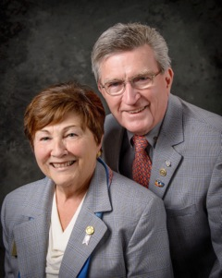
Last week, we visited two seasoned clubs, Clinton and Sturbridge, and the newest club in the district, Nashoba Valley. Those of you whose clubs we have already visited and have heard our talk will appreciate the fact that while each of the three clubs is unique, Nashoba Valley most mirrors Rotary International President John Germ's remark that we have entered into historic times. Again, we thank these clubs for their hospitality and attention to our message.

Nomination Process 101
As a retired Social Studies teacher, Pat is very disturbed with the current lack of knowledge exhibited by voters concerning our election process. She feels this should not be the case for Rotarians in District 7910 when it comes to our process for choosing a District Governor. This has led us to develop a crash course: Nomination Process 101 District 7910.

An invitation is sent by August 15 each year to all clubs in the district to propose qualified candidates for District Governor Nominee, for 2018-2019. The invitation will outline the procedures to follow, the qualifications required and the necessary form to fill out. The deadlinefor receiving these nominations is October 15.

Regarding District Governor for '19-'20, all applicants must have served as a club president and have been in Rotary for a minimum of seven years.

The District Nominating Committee shall schedule and conduct interviews of the candidates proposed by the clubs. The committee may nominate additional candidates it feels would also fulfill the requirements. The committee submits its selection to the governor no later than December 1.

Further guidelines can be found on page 177 of the District Directory or in the District Resolutions.

It is a fundamental principle in Rotary that the best-qualified candidate should be selected for service in Rotary’s elective offices. Therefore, any effort to influence the selection process in either a positive or negative manner by campaigning, canvassing, electioneering or otherwise is prohibited under the Rotary International Bylaws.

District Governor and Trustee Nomination Time
Remember that even though the Nominating Committee can only choose one District Governor each year, all Past Presidents are eligible to be considered. We have met so many qualified Past Presidents as we visited Clubs, and as we say any one of you could be District Governor. Give it a try. The application deadline is this October 15.

More than likely, all of you are just as tired as we are about elections, voting and candidates. But this reminder is for all Rotarians. Now is the time for Clubs to nominate candidates for the very important positions of District Governor and Trustee. Please review the nomination details and nomination forms, below. We hope to hear from many Clubs because there are so many potential candidates among our members.

- Nomination Details
- Nominating Form Supplemental Statement
- District Governor Nomination Form
- Trustee Nominating Form
Always remember, you can call us with questions at 508-393-9031.

District Governors Pat and Skip Doyle may be reached at pwdoyle2@verizon.net and skipdoyle2@verizon.net, respectively.

Click here to submit content for the October 3 issue to Immediate Past District Governor/Newsletter Editor Jim Fusco.

Click here for past issues.

WELCOME, NEW ROTARIANS
Please join us in welcoming these new Rotarians to clubs in our District (alphabetical by last name):
- Ryan Donovan, Southborough
- Alan Herzog, Marlborough

CLUB MEMBERSHIP GROWTH, ’16-‘17
We share with you the results of club membership growth in our District during Rotary 2016-2017, which began July 1.

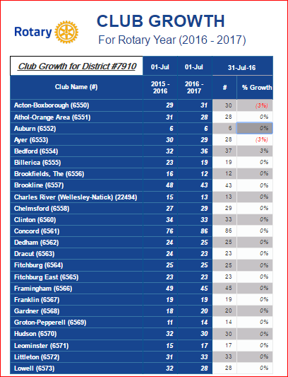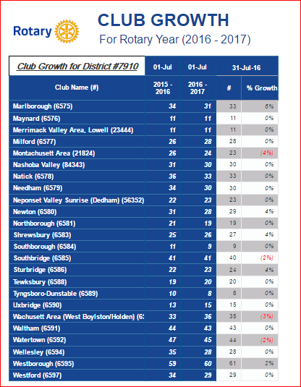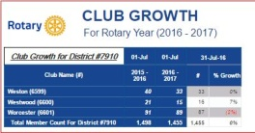

READ MORE

This is a unique opportunity for Rotarians and friends to discuss partnering on humanitarian projects affecting our local communities.

OUR PRESIDENTS SPEAK
Otto Prohaska, Sturbridge

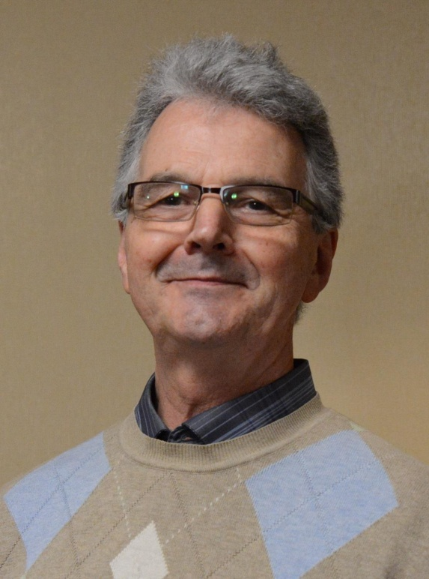
Please tell us what factors helped you decide to join Rotary.

The reason for my being an excited and active Rotarian is that Rotary is a very effective and efficient organization with focus on local services, as well as international ones, our members’ hearts are in the right place, and our goals are exactly where the needs are.

READ MORE

DISTRICT & CLUB ROUNDS
District Interact Teen and Advisor Training Seminar A Huge Success
Nearly 50 participants from 14 Rotary communities took part in a District Interact Teen and Advisor Training Seminar, which was held on Saturday, September 17 at the Sheraton Hotel in Needham.

Bandey Hefler Report

District 7910 travelers have safely arrived at Heathrow Airport in London for their Bandey Hefler visit.

READ MORE

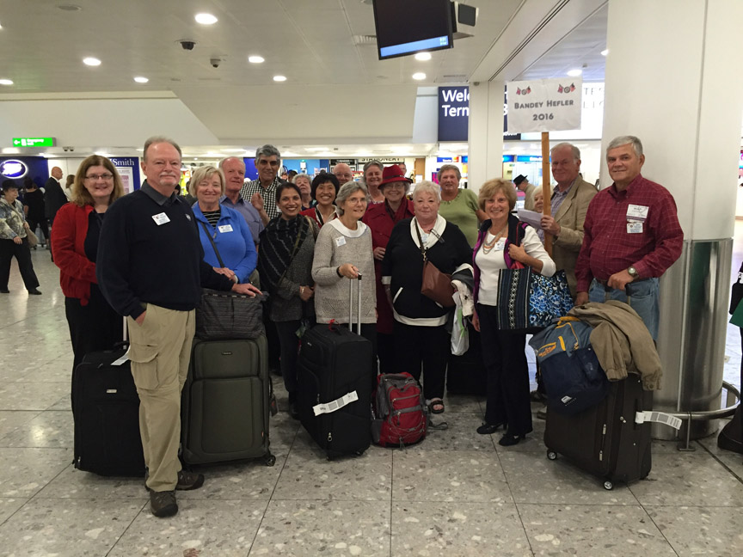

Sturbridge Participates in Day of Caring

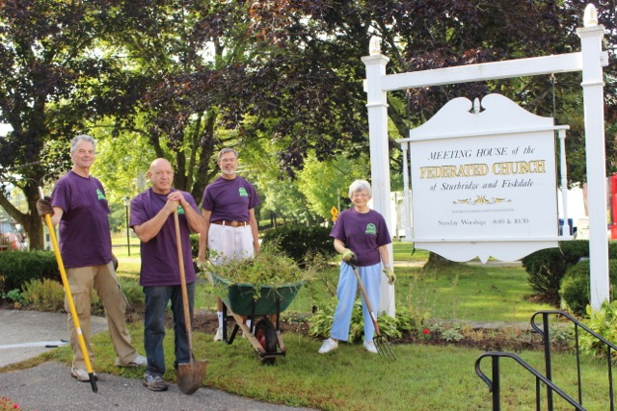

For the seventh year, Sturbridge Rotary has participated in United Way's annual Day of Caring. Nine club members were part of the 130 volunteers working at 14 project sites. This is yet another good example of '"service above Self" as Sturbridge Rotary members volunteer in their community.

Shown in the photo on the left are Sturbridge President Otto Prohaska (far left), an unidentified Sturbridge Rotarians (second from left), and Sturbridge Rotarians Klaus Hachfeld (second from right) and Glenys Hachfeld (far right).

Shown in the photo below are several more Sturbridge Rotarians who participated in a Day of Caring food drive.

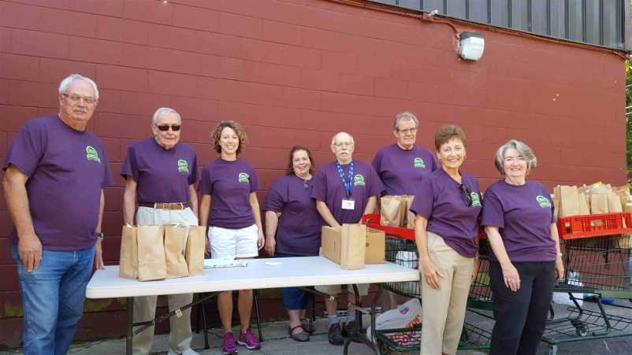

Westborough Sponsors Down Syndrome Buddy Walk

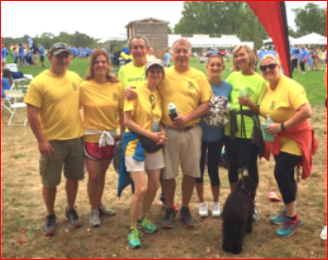

One of Westborough Rotary's giving requests was to be a sponsor of the Down Syndrome Buddy Walk and Harvest Festival, which was held on Sunday, September 18. A group of Rotarians (shown here) participated in the walk and had a great time supporting a wonderful cause.

District Polio Team Visits Lowell Rotary

Carl Good III, chair of the District Polio Committee, and his polio team continue to visit clubs. Recently, he visited Lowell Rotary to spread the polio message. He learned that Lowell has the largest artist colony in the U.S. and that the Lowell club promised to discuss a polio event at their next board meeting. Thank you, Lowell!

If you would to join the polio team, just let Carl know at carlgood@yahoo.com or 978-273-7880.

Carl Good III (left) posing with Lowell President Maureen Couture.

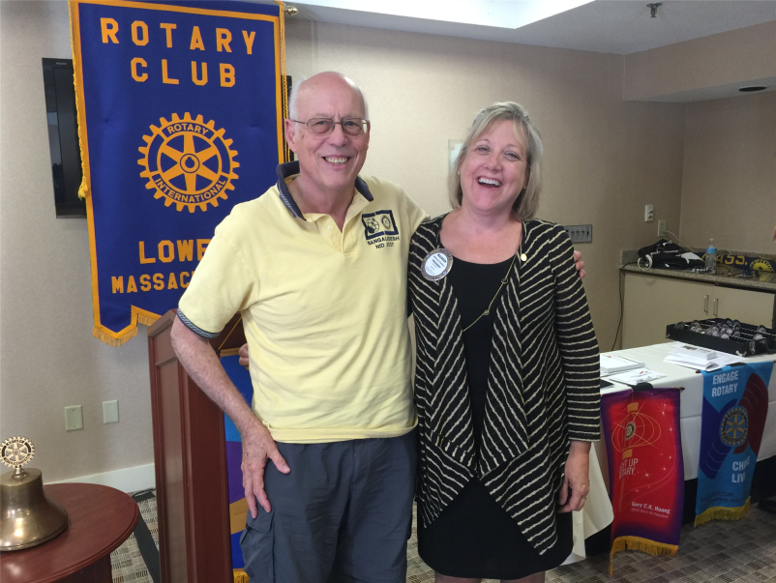

Nashoba Valley Sponsors Razia's Ray Of Hope Event On October 27 - 'Celebrate 500 Tour' Features CNN Hero Razia Jan
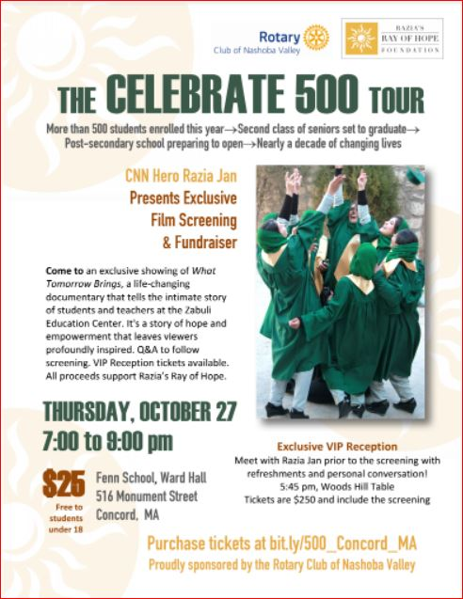Nashoba Valley Rotary is proud to sponsor an exclusive showing of What Tomorrow Brings, a life-changing documentary that tells the intimate story of students and teachers at the Zabuli Education Center. It's a story of hope and empowerment that leaves viewers profoundly inspired.

This local premiere of the What Tomorrow Brings event to benefit Razia’s Ray of Hope will be on Thursday, October 27 from 7:00 to 9:00 p.m. at the Ward Hall of the Fenn School, located at 6 Monument St. in Concord. All proceeds support Razia’s Ray of Hope.

A Q&A session will follow screening. The fee is $25 per person - free to students under age 18.

VIP Reception tickets are available for $250, and include refreshments and a personal conversation with Razia Jan at 5:45 p.m. at the Woods Hill Table.

To purchase tickets, click here.

READ MORE

District Governors' Visits Last Week

Sturbridge (chartered 1972)

Shown, left to right, are Sturbridge President Otto Prohaska and District Governors Pat and Skip Doyle.

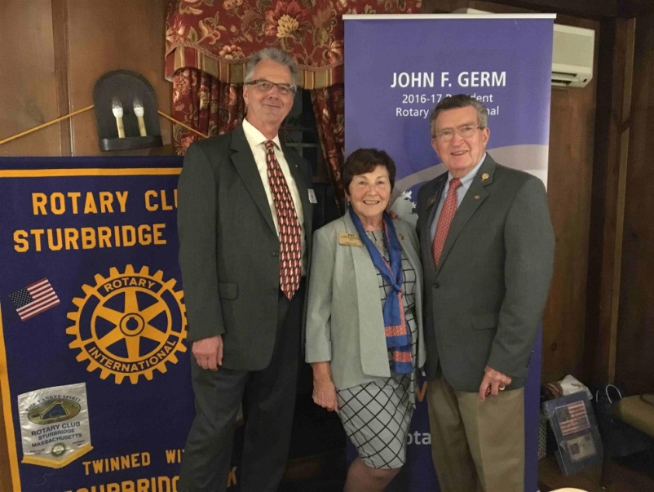

Nashoba Valley (chartered 2012)

Shown,left to right, are DGs Skip and Pat Doyle, Nashoba Valley President Chris Spear and his wife, Nashoba Valley Rotarian Laura Spear, who chairs the District PR Committee.

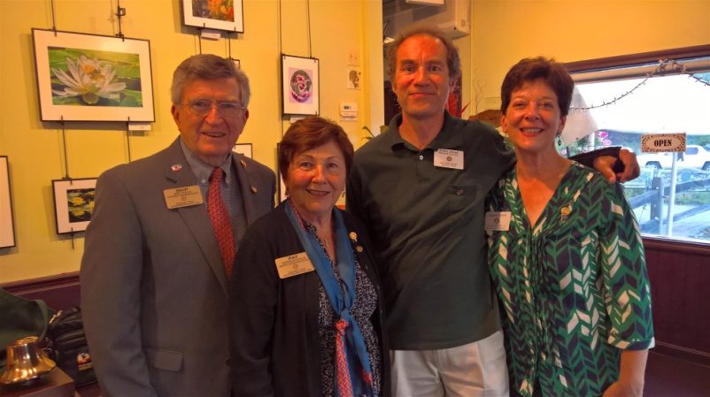

President Elects Start Their Pre-PETS Training

District Governor-Elect Karin Gaffney recently kicked off the training for presidents-elect at Concord Academy. Karin is shown motivating the PEs.

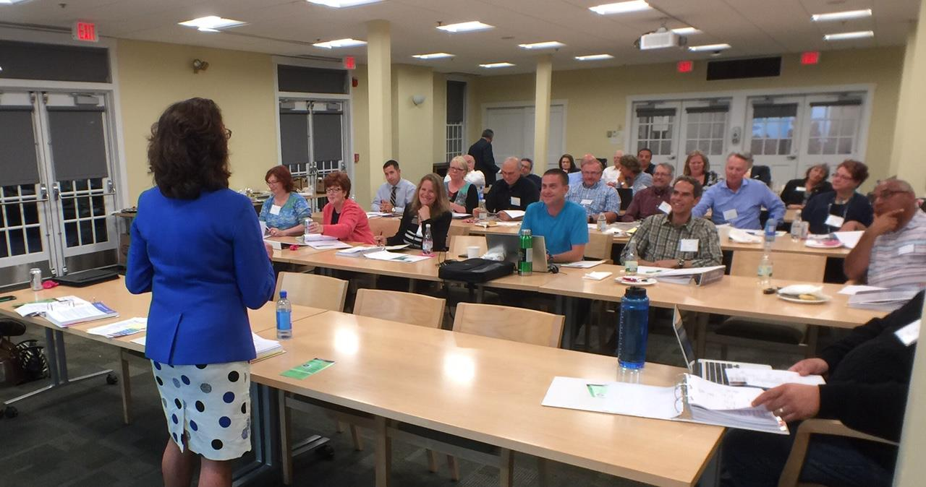

Rotary Alumni: Where Are They Now?

Congratulation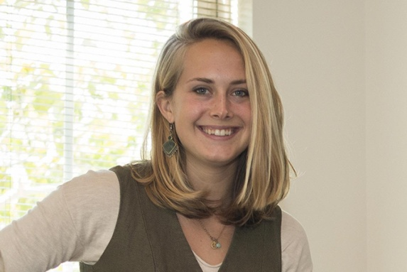s to Honore Johnson (shown), a former Youth Exchange student, on being selected to be a Fulbright Scholar. She graduated from Cornell University in May 2016. While at Cornell, she was a member of the Rotaract Club. Honore's studies will be in the area of conflict resolution in Taiwan.

READ MORE

Marlborough Partners With Local Groups On Mental-Health Crisis Intervention

The Rotary 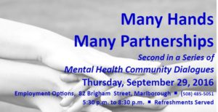Club of Marlborough,Employment Options and the MetroWest chapter of the National Alliance on Mental Illness have partnered to conduct an event on mental-health crisis intervention, Many Hands, Many Partnerships, this Thursday, September 29 from 6:00 to 8:00 p.m. at Employment Options, located at 82 Brigham St. in Marlborough. Networking will start at 5:30 p.m., with food and beverages served. The partnering organizations invite all members of the community to attend and join the conversation.
Many Hands, Many Partnerships will be a community dialogue on how we can better work together to help individuals and families in a mental-health crisis get the support they need. It takes a community to manage a mental-health crisis. All too often, we rely entirely on the police to manage such a crisis. Although our local police departments play a valuable role in a crisis, emergency first-responders, mental-health clinicians, individuals with lived experience, and family members all play equally valuable roles.

The event will include a feature presentation and panel discussion. Audience questions and participation will be encouraged. Feature presenter, Chief Craig Davis of the Ashland Police Department, will speak on “Crisis Diversion and Linkages.” The topic of the panel will be “Crisis Intervention to Crisis Management to Family Need and Support to Recovery.” Chief Davis will join Chief Mark Leonard of the Marlborough Police Department and John Deronck of Emergency Services Advocates in the panel discussion.

The Many Hands, Many Partnerships event is part of a community mental-health-awareness campaign to draw attention to the needs of those with mental illness, change negative perceptions, and promote recovery and healthy communities. The partners’ objectives include finding innovative community-based solutions to mental-health needs, with a focus on helping young people, and developing clear steps for communities to address their mental-health needs in a way that complements existing local activities.

For more information on the Many Hands, Many Partnerships event, visit marlboroughrotary.org, employmentoptions.org, or namimetrowest.org
To register in advance, call 508-251-9595 or email namimetroWest@namimetrowest.org.

Pat and Skip Doyle Installed As '16-'17 DGs

District 7910's 2016 Rotary Youth Leadership Awards were held on June 24 through 26 at Fitchburg State University, ending with the installation of longtime RYLA supporters Pat and Skip Doyle as District Governors for 2016-2017. The three-day RYLA event was attended by 188 sophomores. To learn more about RYLA, visit ryla7910.org.

Click on the image, to view a video of the installation of Pat and Skip Doyle as '16-'17 DGs

District Leadership Meeting A Huge Success

How HUGE? So HUGE that another is planned for October 17!

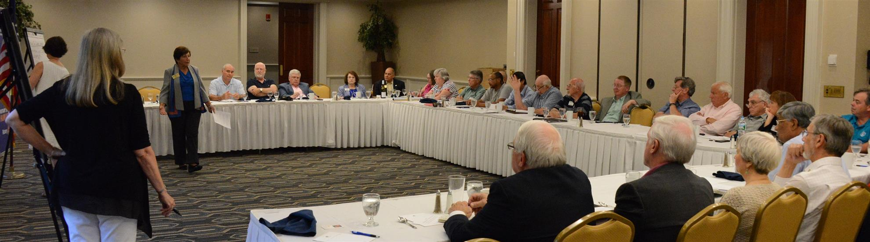
District Governors Pat and Skip Doyle held their Leadership Meeting on July 19 at the DoubleTree Hotel in Leominster. This is an annual event for which DGs bring their District leaders and committee chairs together to review the goals for the new Rotary year.

This, year the event was presented in a facilitated format. The results will be consolidated and sent to all attendees so that the District Goals for each committee can be set.

District Banners Available

Our district banners are available for your to use when you have an upcoming event or fundraiser.

If you want to reserve one of the banners, please contact PR Chair Laura Spear at laura@spear.net.

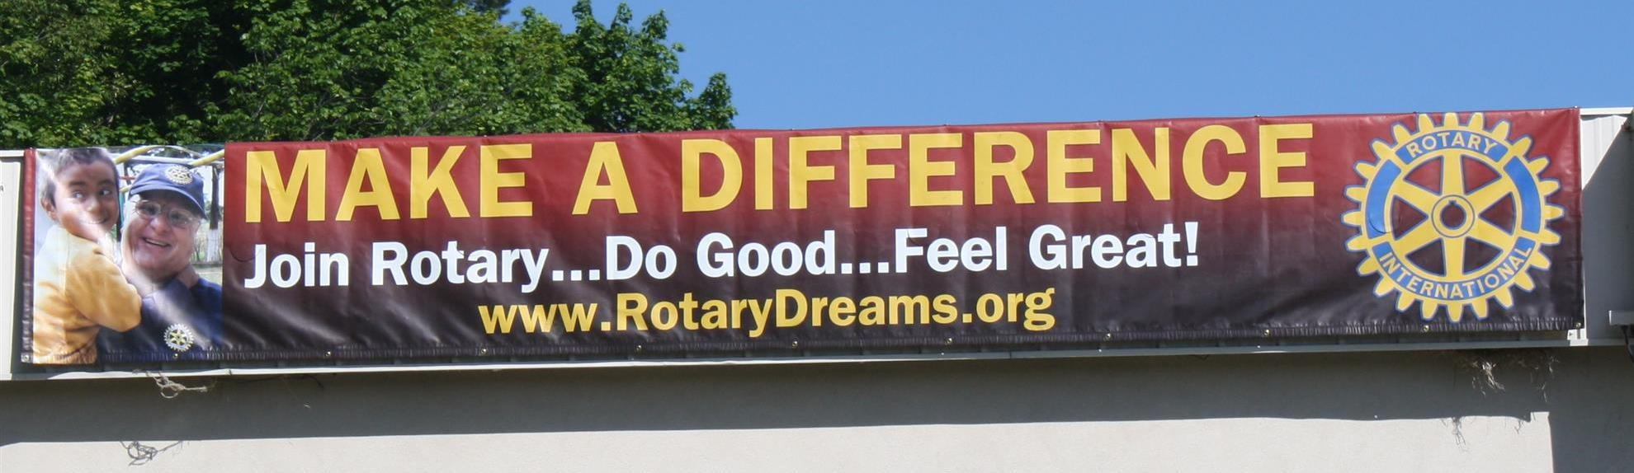

On To Atlanta In 2017

Planning to attend? Contact District Chair Steve Glines.

More than 43,000 attendees left the Rotary International Convention in South Korea inspired to end polio for good, to celebrate The Rotary Foundation's centennial, and to champion changes that will help Rotary appeal to a broader audience.
On the last day, RI President K.R. “Ravi” Ravindran shared a personal story of his mother’s triumph over polio.

To read the story, click here.

To register for the 2017 RI Convention in Atlanta, click here

MAJOR DISTRICT & CLUB HAPPENINGS: FALl
Tuesday, September 27: Bedford, Billerica, Lowell, Newton and Shrewsbury Rotary - 'Governor Baker - Featured Speaker at Rotary'

5:00-9:00 p.m., DoubleTree Bedford Glen Hotel, Bedford

To RSVP, click here

To view a 4-minute video by Concord Rotarian Steve Kirk titled "District 7910 Welcomes Governor Charlie Baker," click here

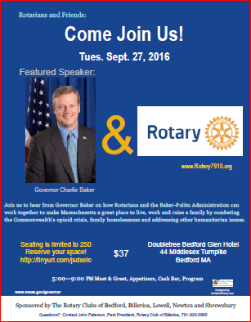

Thursday, September 29: Marlborough Rotary - 'Many Hands, Many Partnerships'

To download the event flyer, click here.

Saturday October 1: Ayer Rotary - 'Senior BBQ,' Bob Eisengrein Community Center, Devens

To download the flyer, click here.

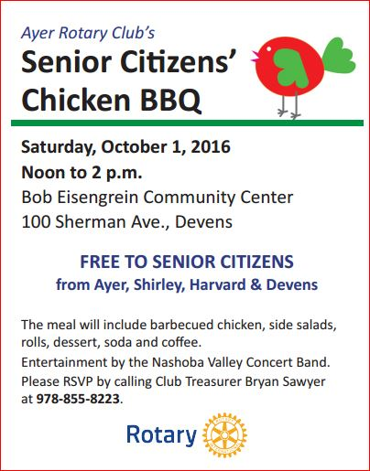

Wednesday, October 5: Boston Rotaract - 'Women in Rotary'

To buy tickets, click here.

To hear a 29-minute radio interview by Auburn Rotarian Steve Jones-D'Agostino with Boston Rotaract President Amy Collinsworth, District 7930 Governor Sheryl Meehan and D7930 Governor-Elect David Gardner, which aired this Sunday, September 25 on 90.5 WICN, click here.

Friday, October 14: Montachusett Area Rotary - 'Comedy Night,' Knights of Columbus, Leominster

For tickets and information, contact Club President Jennifer Peck at montachusettarearotary@gmail.com.

Saturday October 15: Franklin Rotary in conjunction with Simon Properties - 'Chalkfest,' Wrentham Outlets, Wrentham

READ MORE

Saturday, October 29: Sturbridge Rotary - 'Antique Appraisal Show'

To download the event flyer, click here

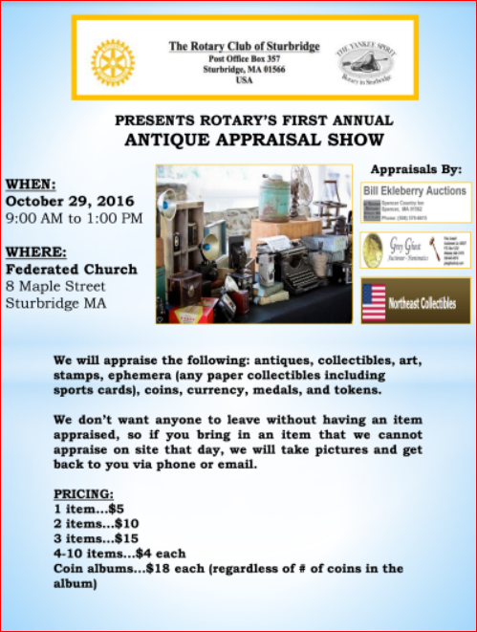

Monday, December 5: Sturbridge - 'Lottery Ticket Raffle'

To download the event flyer, click here.

SUBMIT MAJOR CLUB HAPPENINGS

Send flyers of your club's major events and activities, in either JPEG or PDF format, to Immediate Past District Governor/Newsletter Editor Jim Fusco
at jim.fusco2@gmail.com.

