COMMITTEE REPORTS
Why Should I Go to the Rotary International Convention?

By Karin Gaffney
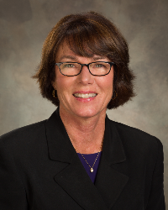

Here is why you should attend - in the words of your fellow District 7910 Rotarian Steve Glines (shown right), an assistant governor from Littleton Rotary, who attended his first RI Convention this past May in Seoul, Korea:
"Imagine a District Conference on steroids," Steve states. "Instead of a single club proudly displaying a poster setup of their contributions to ShelterBox, ShelterBox is there with a booth occupying several hundred square feet (or meters, if you prefer)."
READ MORE

Rotary Leadership Institute in Just 19 Days in Boxborough!

By Doug Detweiler

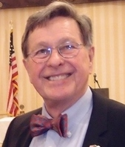

The Rotary Leadership Institute believes in course sessions with as much discussion and participation as possible.

READ MORE

PolioPlus Update: October An Important Month For Foundation, PolioPlus

By Carl Good III

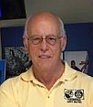

October is an important month for both The Rotary Foundation and PolioPlus.

READ MORE

Membership Corner: Rotary Club Objectives
By Tom Sturiale
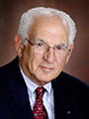

How do Rotary clubs find their way in this confusing and multi-faceted world?
READ MORE

Membership Materials on Sale: Order Now!
To order, click here

Foundation Note: Club Qualification Status for Foundation Grants
By Sanjay Deshpande
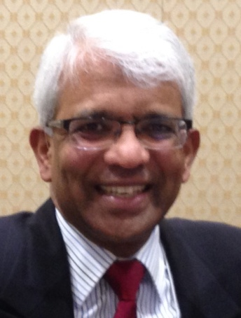

District 7910 adopted three qualification criteria that its clubs must satisfy in Rotary Year 2016-2017 for being eligible for participation in Foundation grants, which include District Grants (DG) and Global Grants (GG).
READ MORE

PR Tips: Make Your Press Releases Newsworthy!
By Laura Spear
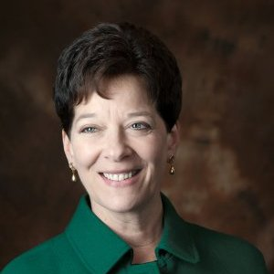

From Network for Good: “For a non-profit announcement to be considered newsworthy it must have a broad, general interest to the target audience.
READ MORE

Treasurer's Report: Message About Your Dues

By Jack Hoell
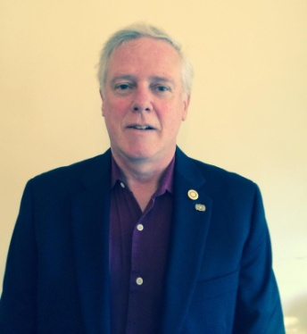

The Rotary International dues bills were e-mailed to the 51 clubs in our District on July 22 and the District dues bills were e-mailed to clubs on July 26.
READ MORE

Speakers Bureau: Do You Need A Speaker For Your Club?

By Steve Levitsky

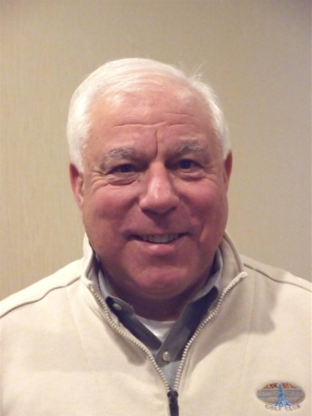

We have many suggestions for you. Here are just a few:
- Rwandan genocide: Carine Boggis
- Elevator-pitch tips: Andy Winig
- Positive-results hypnosis: Bob Martel
- Differentiation and game-changing simplicity: Stephen Melanson
VIEW MORE

District Charity Fund: How Does DCF Operate?
By Al Bowers

The District Charity Fund is a 501(c)3 charitable, non-profit that can be used by the Rotary clubs in District 7910.
READ MORE

Communications Link: Seeking Club Photo, Video Albums
By Steve Jones-D'Agostino
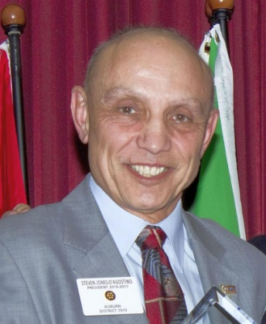

Does your District committee or Club have Rotary-related photo and/or video albums that you'd like to share with other Rotarians?
READ MORE

Bandey-Hefler: Having a great time in England!
By Victor Tom
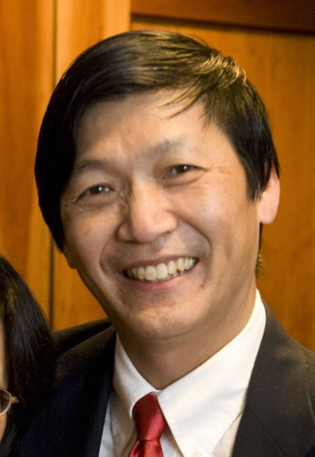

We landed safely on the morning of September 20.
READ MORE

SUBMIT CONTENT
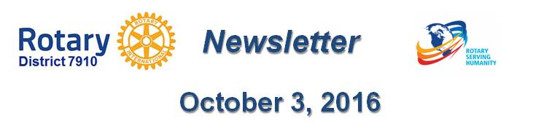To submit content for consideration for the Monday, October 3 issue of Rotary District 7910 Newsletter, please e-mail it to Immediate Past District Governor and Newsletter Editor Jim Fusco at jim.fusco2@gmail.com.

The submission deadline for that issue is Friday, September 30. All text must be in Word format. All images must be in either JPEG or PDF format. Please identify the people, left to right, who are shown in your photos, including their first and last name as well as their club or other title.

PAST ISSUES
To view past issues of the weekly Rotary District 7910 Newsletter, click here
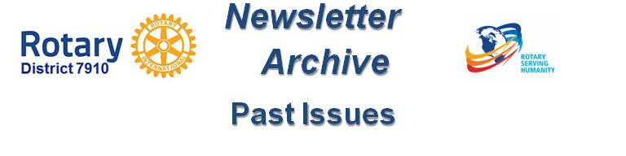

DISTRICT 7910 ONLINE
Visit our website
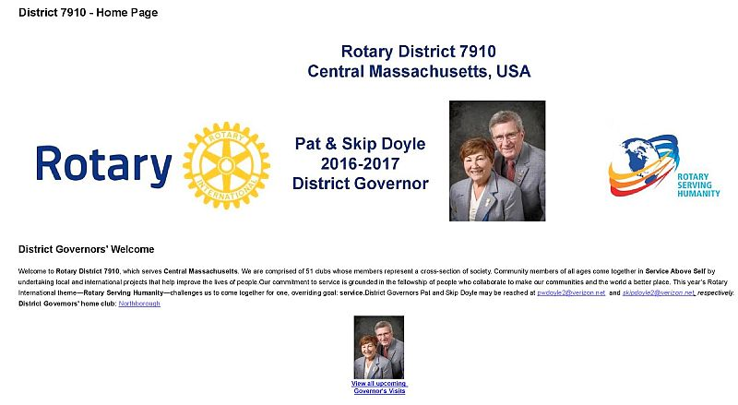

'Like' and share us on Facebook
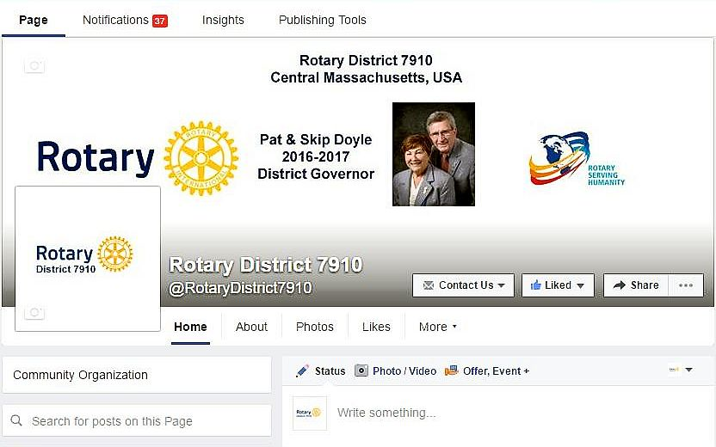

Watch our videos on YouTube

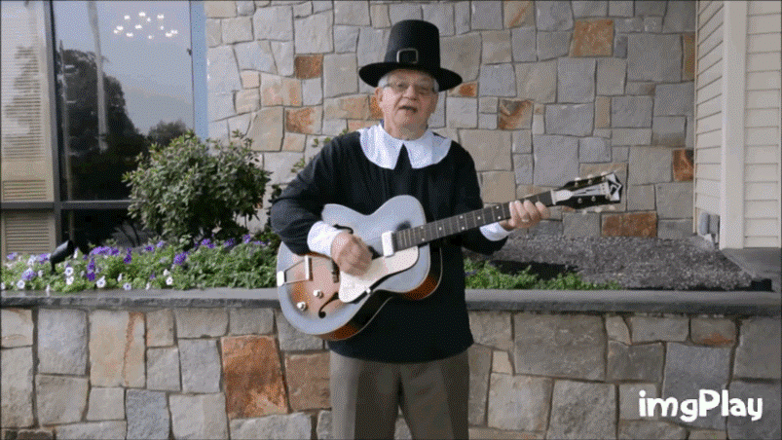

View our photos on Google Photos (since May 2015) and ClubRunner (before May 2015)

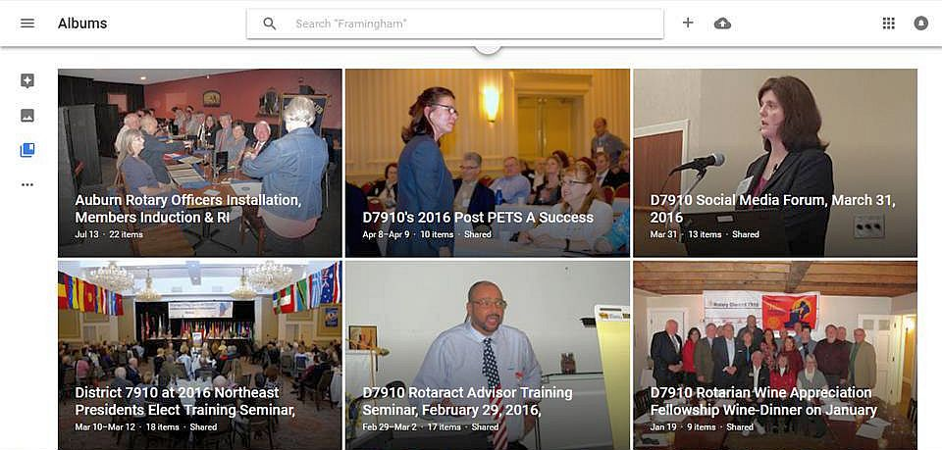

CONTACT US
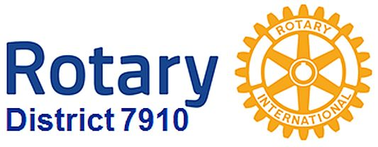
Immediate Past District Governor and Newsletter Editor Jim Fusco
​jim.fusco2@gmail.com
District Webmaster Steve Jones-D'Agostino
​srdagostino@icloud.com

© Copyright 2016-2017 - Rotary District 7910, Central Massachusetts, USA

