Rotary Leadership Institute on October 15 in Boxborough
By Doug Detweiler
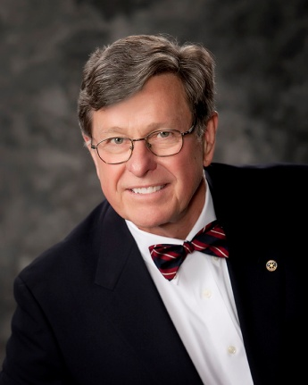
Why do we need a Leadership Institute?
Rotary needs a constant influx of leadership as club officers, etc., since they change every year. It is difficult at the club level to learn enough about the exciting world of Rotary with its 1.2 million members in 163 countries. Furthermore, leadership skills in voluntary organizations are often different from business-leadership skills. It is important that club leaders have every opportunity for education because the success or failure of our clubs depends in large part on the quality of their leaders.

What are the teaching methods?

The Institute believes in course sessions with as much discussion/participation as possible. Discussion breakout sessions are limited to approximately 10 to 15 persons. Lectures are strictly limited. Course methods include discussion groups, role-playing, problem-solving workshops, creating projects and audiovisual presentations. Everyone participates during one of the Institute's sessions. A course workbook containing an Institute Manual, session-program agendas, faculty biographies and course outlines and materials, is provided to each attendee.

Who are the faculty?
The Institute for their teaching abilities carefully selects the faculties. They are drawn from all areas of the member districts and occasionally from outside of the member districts. Many are present and past Rotary International directors, present and past district governors, successful past presidents and those with experience in special areas. Each new faculty member must attend an initial full-day training program and various reorientation programs periodically. The results of evaluations help the Institute to improve the course content and instruction.

Who should be nominated to attend the Institute courses?
The Institute recommends that candidates should have those qualities that mark them as potential club leaders - not necessarily future presidents. They should be at least three to four years away from a possible presidency or other high-leadership post. They should certainly have a strong interest in Rotary and be ready to be exposed to the larger world of Rotary. The Institute requests each club to nominate one or two Rotarians each year.

What are the costs?
The current course fees are $95 per registrant per day. (It's $75 at selected low-cost sites). The fees include breakfast, lunch, coffee breaks and considerable materials given to participants. Course fees also pay for meeting space, audio-visual equipment and promotional costs. We recommend that clubs pay the fees for their nominees.

Should our club participate?
If your club cares about its future, it would want the best leadership possible. This is an outstanding opportunity for each club to improve the Rotary knowledge of its key people and to be exposed to new ideas of leadership. The exchange of ideas with other experienced Rotarians alone makes the courses worthwhile.

To download the RLINEA brochure, click here.

To register to attend RLI on Saturday, October 15 from 7:30 a.m. to 3:30 p.m. in Boxborough, click here.

How do I register at other locations? Click here, to find out.

Past District Governor Doug Detweiler, chair of the District Rotary Leadership Institute Committee, may be reached at rotary@detweiler.org.

Return to September 26 Newsletter

View past issues
Visit our website
'Like' our Facebook page

