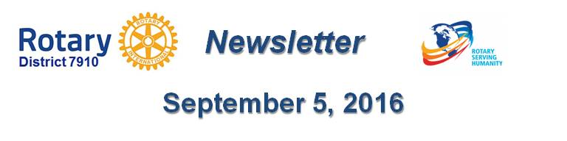

Dear Steven,

It is our pleasure to share with you the September 5 issue of Rotary District 7910 Newsletter.

To read this issue, click here.

To explore past issues, click here.

Here are the highlights of the September 5 issue:

Earthquake In Italy: A letter from Rotary International General Secretary John Hewko

Governor's Message: Last Week, We Made Five Visits - By Pat and Skip Doyle

Club Membership Growth: Club Goals For 2016-2017

Our Presidents Speak: Q&A With Kelly Hill Of Waltham

RI Conference Testimonial: Share Your Experience With Us - By Karin Gaffney

Membership Corner: Corporate Memberships In Rotary - By Tom Sturiale

Membership Materials on Sale: Order Now!

Foundation Note: Six '16-'17 Global Grant Proposals Under Review By Grants Subcommittee - By Sanjay Deshpande

PR Tips: Pictures – Show Something Awesome! - By Laura Spear

Treasurer's Report: Message about your dues - By Jack Hoell

District Charity Fund: How Does DCF Operate? - By Al Bowers

PolioPlus Update: District Polio Committee - By Carl Good III

Communications Link: Seeking club photo, video albums - By Steve Jones-D'Agostino

Bandey-Hefler Update: Preparing for trip to England - Plane leaves in just 14 days - By Victor Tom

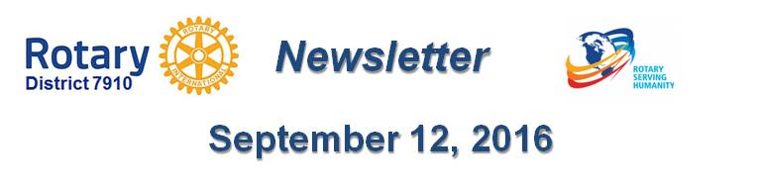
Our next newsletter will come out on Monday, September 12.The submission deadline is this Friday, September 9. Text content must be submitted in Word format. Image content must be submitted ineither JPEG or PDF format. Send your content submissions to Immediate Past District Governor/Newsletter Editor Jim Fusco at jim.fusco2@gmail.com.

Governors Pat & Skip

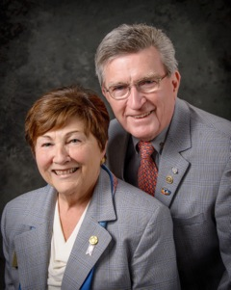
Pat and Skip Doyle
2016-2017 Governors
Rotary District 7910
pwdoyle2@verizon.net
skipdoyle2@verizon.net
