EARTHQUAKE IN ITALY
We want to share a letter from Rotary International General Secretary John Hewko:
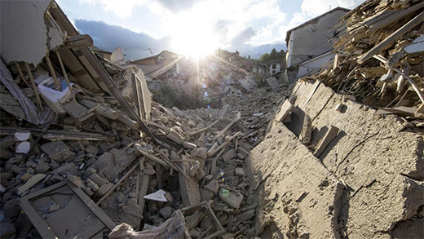
Dear Senior Leaders,
Rotary members worldwide stand together with the people of Italy, showing an outpouring of support.

READ MORE

For a related ShelterBox article, click here.

SUBMIT EVENTS
You may submit event information per the District 7910 Promotional Guidelines. If your club does not use ClubRunner, please send your event information to Rotary District 7910 Newsletter. And make sure to add the e-mail address of Immediate Past Governor/Newsletter Editor Jim Fusco, jim.fusco2@gmail.com, to your club's distribution list.

DISTRICT EVENTS

SEPTEMBER 5-27
RC Milford Governor's Visit

Tuesday, September 6

RC Fitchburg East Governor's Visit

Tuesday, September 6

RC Wellesley Governor's Visit

Wednesday, September 7

RC Brookfields Governor's Visit

Thursday, September 8

RC Gardner Governor's Visit

Thursday, September 8

RC Leominster Governor's Visit

Monday, September 12

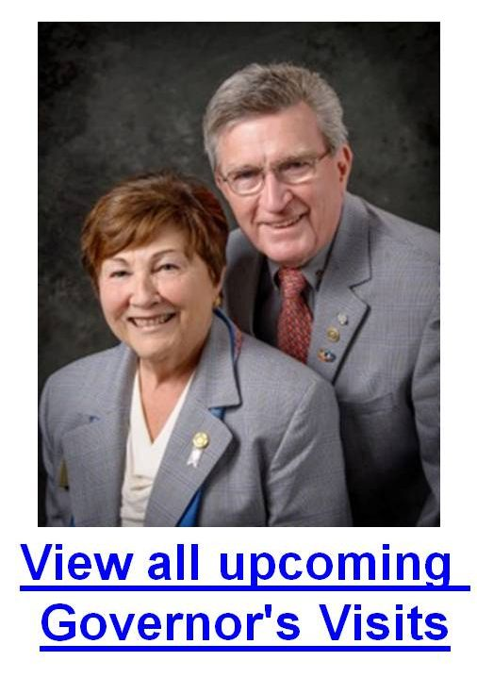

Vision at Athol-Orange

Monday, September 12

5:00-9:00 p.m.

Foundation Committee Meeting

Wednesday, September 14

6:30-8:30 p.m.

Holiday Inn, Boxborough

District Interact Teen and Advisor Training

Saturday, September 17

8:00 a.m.-2:30 p.m.

Sheraton Needham Hotel, Needham

Bandey Hefler Departs for UK

Monday, September 19

Presidents Elect Training

Monday, September 19

5:15–8:00 p.m.

Ransome Room (Math & Arts Center) of Concord Academy, Concord

Assistant Governors Meeting - Live

Wednesday, September 21

6:30-9:00 p.m.

Zone Institute for Zones 24 & 32

Monday, September 26-Friday, September 30

Winnipeg, Canada

Governor Baker: Featured Speaker at Rotary

Participating Clubs: Bedford, Billerica, Lowell, Newton and Shrewsbury

Tuesday, September 27

5:00-9:00 p.m.

DoubleTree Bedford Glen Hotel, Bedford

Opioid Epidemic Awareness Event by Newton

Thursday, October 6

7:00-9:00 p.m.

North High School, Newton

VIEW THESE PLUS MORE UPCOMING DISTRICT EVENTS - INCLUDING ALL GOVERNOR'S VISITS

RI SPOTLIGHT
Dean Rohrs: '16-'17 RI Director for Zones 24 & 32
New: Her September newsletter is here
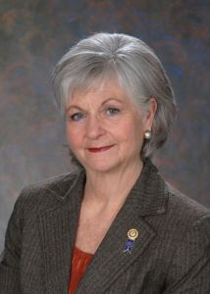

District 7910 is one of 20 Districts in Zone 32 and Dean Rohrs is the RI Director for Zones 24 & 32. We want you to be aware that she publishes a newsletter each month titled "Beyond Borders" To read her September newsletter, click here

Sam Owori Selected As 2018-2019 Rotary International President

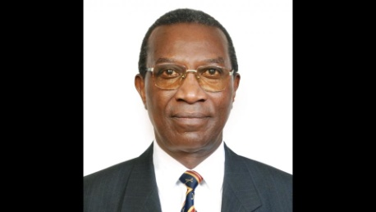

Sam Owon is a Ugandan businessman and a member of the Rotary Club of Kampala.

READ MORE

Still Time To Register For Zone Institute
Starting Wednesday, September 28

For information, click here

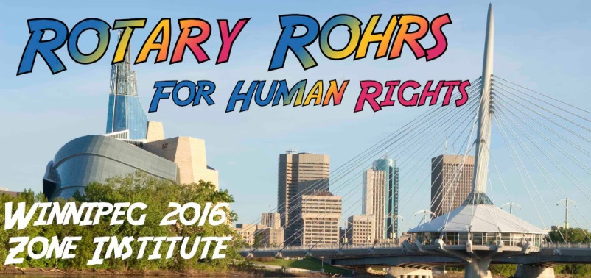

Meet The '16-'17 RI President: John Germ
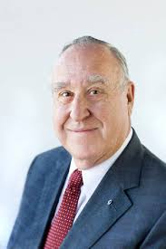

For his Membership Message, click here

From the July 2016 issue of The Rotarian

Just before John Germ dropped by, Rick Youngblood took a deep breath. “You want to match his energy,” he says, “but he makes it hard to keep up.” Youngblood is the president and CEO of Blood Assurance, a regional blood bank in Chattanooga, Tennessee that Germ helped found in 1972.

READ MORE

Read a profile of John Germ

Visit the President’s page

Great Video: Meet Your President

Young Women In Peru Learn To See A Future In Themselves
In Peru, women suffer higher rates of poverty and unemployment than men. About 50 percent of Peruvian women in the Sacred Valley region, which lies outside Cusco, will suffer severe physical or sexual partner abuse during their lifetimes. In 2012, members of the Rotary Club of Boulder’s New Generations pilot satellite club came up with a plan to address all of those problems by concentrating on empowering local women – specifically in their ability to make and act upon their decisions. READ MORE

Rotaract Projects Create Sustainable Change On A Global Scale
Nearly 140 Rotaractors and guests from across East Africa teamed up to help survivors of genocide plant and harvest their own kitchen gardens. The healthy fruits and vegetables help the residents maintain a balanced diet and provides them a sustainable, reliable food source. READ MORE

Campaign To End Polio: What you don't know
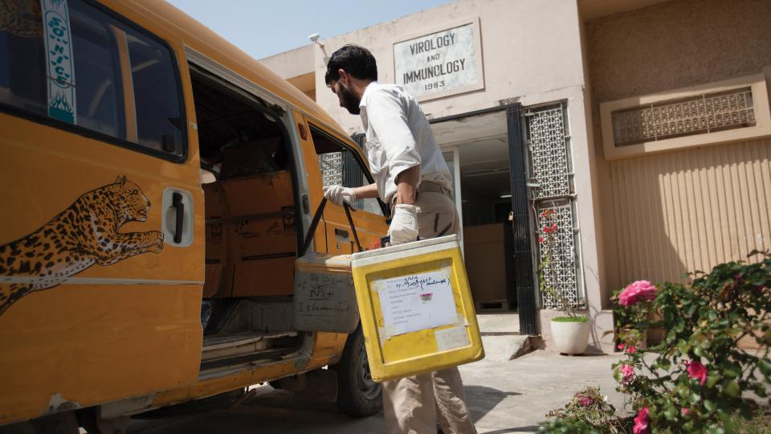
When was the last time there was polio in Europe? If you guessed 2002, the year the region was certified polio-free, you were wrong. The last time polio affected a child in Europe was last summer. In 2015, two Ukrainian children were diagnosed with paralytic polio. Given the way the disease manifests itself, that means many more were likely infected and didn’t show symptoms. At least one Western news outlet deemed the outbreak “crazy” – but the reality is that no place on Earth is safe from polio until the disease is eradicated everywhere. READ MORE

Water & Sanitation Rotarian Action Group: June Newsletter

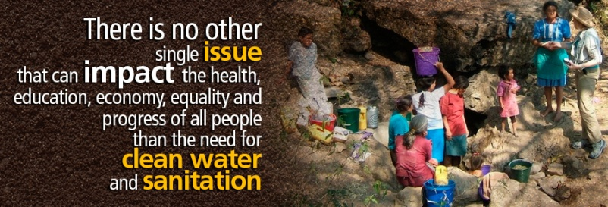For the latest WASRAGNewsletter, click here.

What Millennials Love About Rotary
Millennials, an ethnically diverse, fiercely independent generation of digital natives, are doing more than just snapping selfies—they’re looking for a way to make a difference in their communities. For Rotary, the Millennial era could mean an influx of young, energetic members. READ MORE

Get Ready For Your District Rotary Foundation Seminar
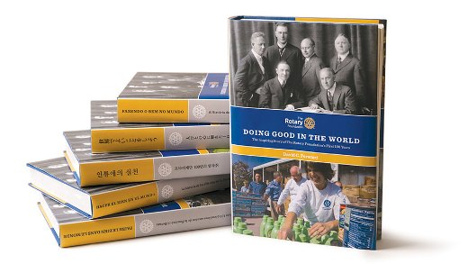
The Rotary Foundation is celebrating its 100th year of Doing Good in the World. Take the opportunity to strengthen your district and clubs during your district Rotary Foundation seminar by using resources from centennial.rotary.org.
Go to the Promotional resources tab to download the following Centennial Promotional Kit materials:
- Ideas and activities for clubs
- Doing Good in the World promotional flier
- Doing Good in the World bookmark
- Sample press release
- Centennial letterhead
- Centennial PowerPoint template
- History of the Rotary Foundation PowerPoint
- Centennial postcard
Let others know about these materials they can use to promote the Foundation in their clubs and communities.

Membership Materials on Sale: Order Now!

To order, click here

New Tools For Membership Tool Belt
Looking to enhance your club membership experience? Do you want to find opportunities for growth in your club? Club and district leaders now have a set of updated Membership Assessment Tools (formerly Club Assessment Tools) to help them strengthen club membership and add value to your club membership experience, so that more people will join and fewer members will leave.

For your convenience, you can download the entire publication, or just the individual assessments that are most relevant to your club.
The individual assessments, which walk users through evaluation and development of an action plan, include: READ MORE

A How-To Membership Leads Video
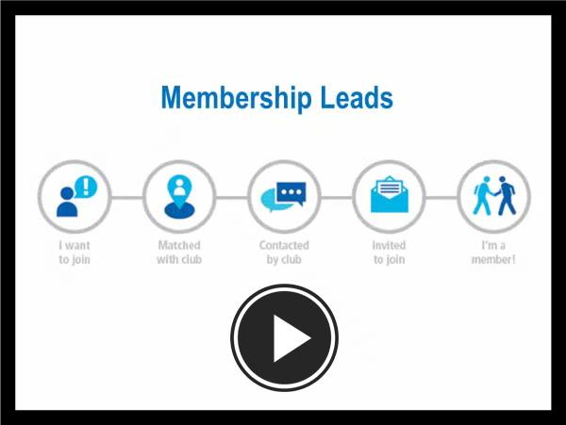
Click here for a new video that helps district and club leaders make the most of the recently enhanced Membership Leads resource. It shows how to track a prospective member from the initial membership-leads submission all the way to connection with a local club. It also outlines the role of club and district leaders in the redesigned process, highlighting how their participation will help strengthen membership, and features the new Rotary resources available to support them. Join the conversation in the Membership Best Practices discussion group to tell us how you’re using the new Membership Leads resource to grow and diversify membership.

RI Membership Resource Guide
To download in PDF format, click here
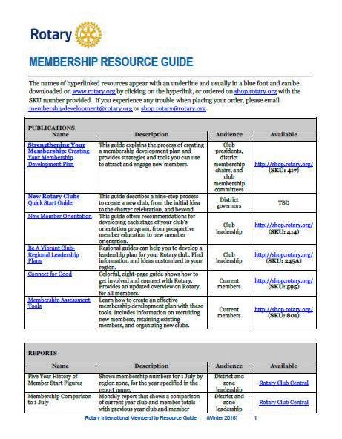

RI Makes Changes In 'Brand Center' Online Tool
We hope that you've found Rotary International’s Brand Center a useful tool to create customized logos and brochures - and to tell Rotary's story in a consistent and engaging way.

Rotary Global Rewards: Sign Up Today!
Click here for more information

Click here to e-mail District ChairJudy Merrimam

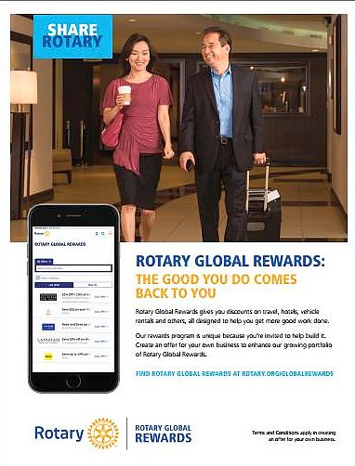Have you tried Rotary Global Rewards — Rotary International’s new member-benefit program that offers discounts on travel, hotels, dining, entertainment and more? Rotary Global Rewards will make your Rotary membership even more rewarding.

'16-'17 Rotary Theme: 'Rotary Serving Humanity'
To download the image in JPEG format, click here.

Check Out 'Rotary Voices' Blog
Check out Rotary Voices, the official blog of Rotary International. This blog features stories by and about Rotary members, Rotary program

