GOVERNOR'S MESSAGE
Last Week, We Made Five Visits

By Pat and Skip Doyle
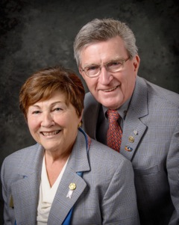
Last week, we were welcomed into the meetings of five Rotary clubs as we spoke of the changes and challenges facing Rotary and District 7910 in 2016-2017.

READ MORE

Click here to submit content for the September 12 issue to Immediate Past District Governor/Newsletter Editor Jim Fusco.

Click here for past issues.

WELCOME, NEW ROTARIANS!
- Shiks Dhiyani, Framingham

Club Membership Growth, ’16-‘17
Once a month, we will share with you the results of Club membership growth in our District during Rotary 2016-2017, which began July 1.

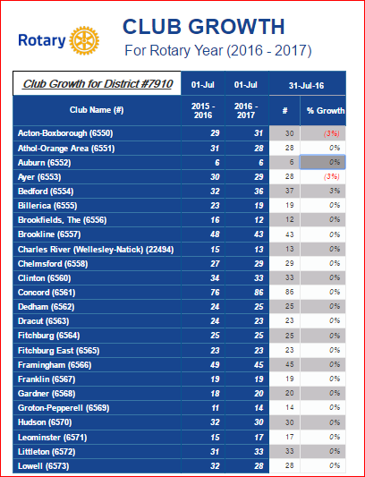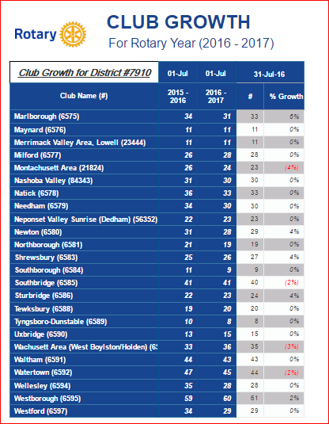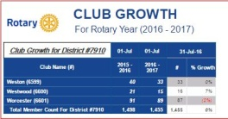

READ MORE

Our Presidents Speak
Kelly Hill, Waltham

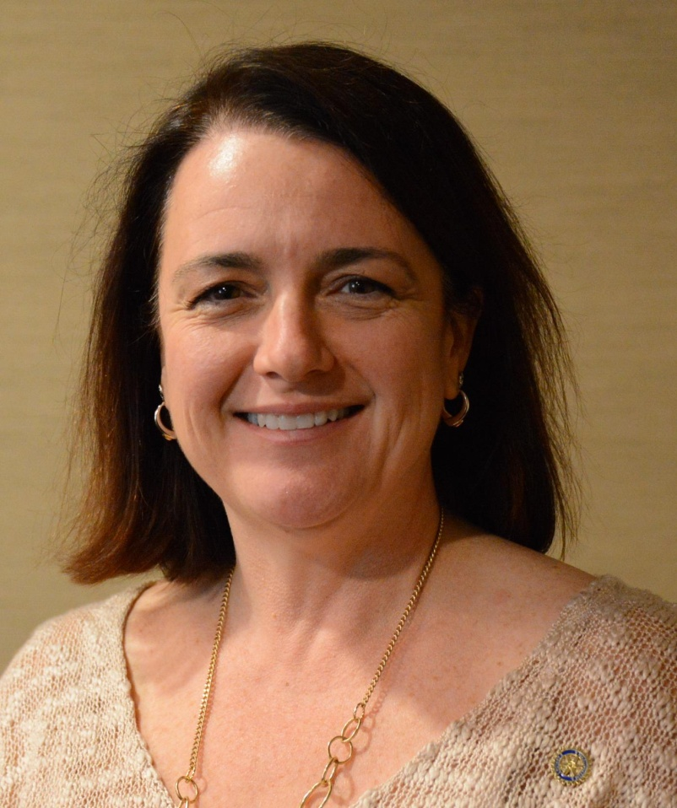

Please tell us what factors helped you decide to join Rotary.

I decided to join Rotary for several reasons. The deciding factor for me was that I was witnessing all the good work the Waltham Rotarians were doing.

READ MORE

DISTRICT & CLUB ROUNDS
District Governors' Visits Last Week

Acton-Boxborough (Chartered 1962)

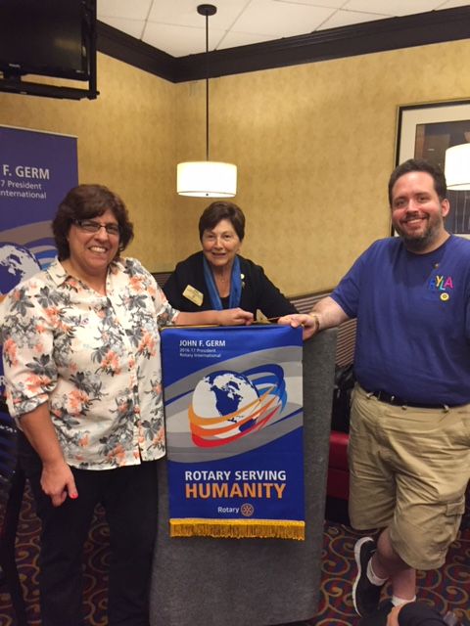

Ayer (Chartered 1956)

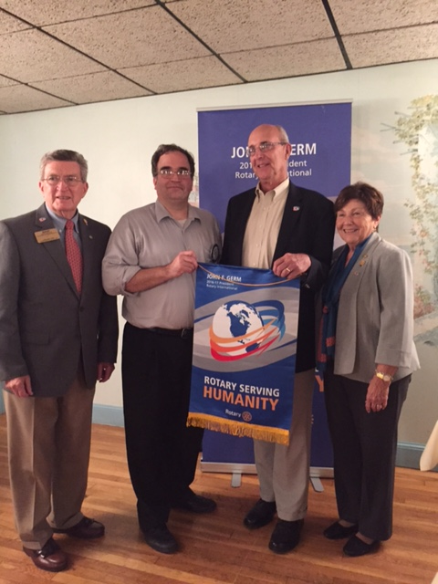

Southborough (Chartered 1960)

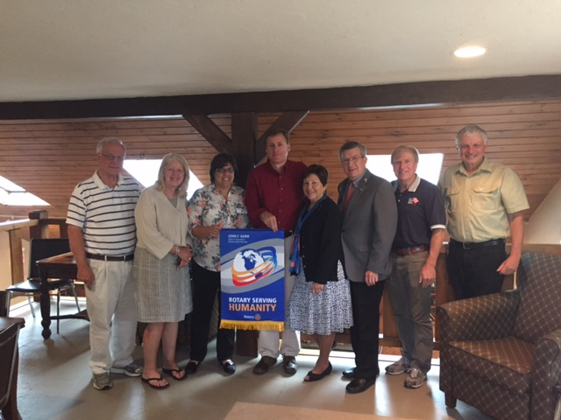

Rotary Alumni: Where Are They Now?

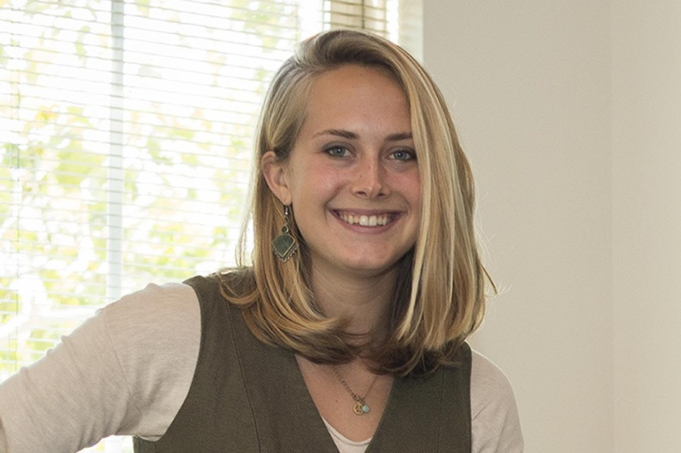
Congratulations to Honore Johnson (shown), a former Youth Exchange student, on being selected to be a Fulbright Scholar. She graduated from Cornell University in May 2016. While at Cornell, she was a member of the Rotaract Club. Honore's studies will be in the area of conflict resolution in Taiwan.

READ MORE

Paul Dumouchel Inducted As Newest Needham Member

Shown, left to right: Paul Dumouchel and District Governors Pat and Skip Doyle

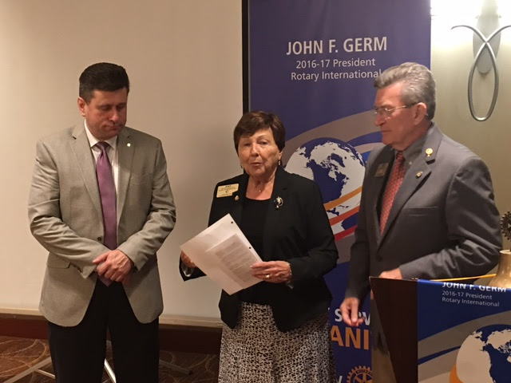

Shiks Dhiyani Inducted As Newest Framingham Member

Shown, left to right: District Governors Skip and Pat Doyle, Shiks Dhiyani, Framingham President Lindsey Morris, and Assistant Governor Steve Sager

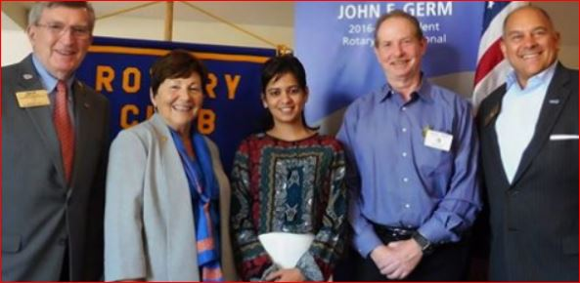

Brad Morse Inducted As Newest Westborough Member

Shown, left to right: District Governors Skip and Pat Doyle and Brad Morse

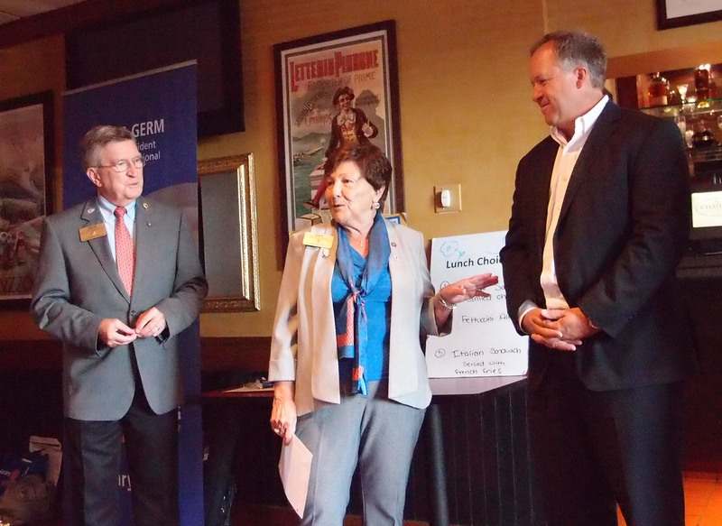

Newton Rotarian Bert Martinson, 106, Visited by Newton Rotarians

Some members of the Rotary Club of Newton visited our oldest member, Bert Martinson, for dinner last week. Bert is 106 and has been a Rotarian since 1940! Thanks to Jim Means for arranging the occasion.

Shown, are Bert Martinson and his girlfriend, Ellie Shuman

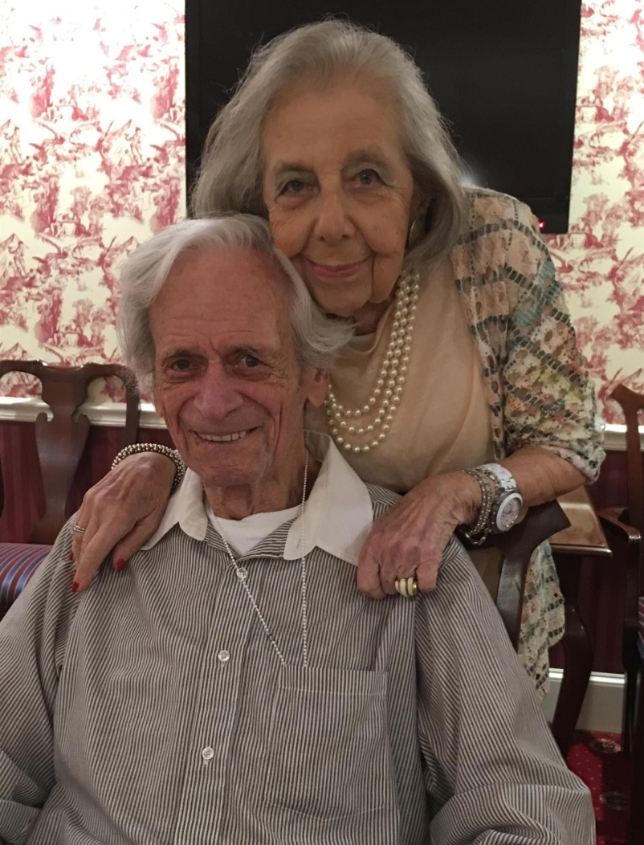

Shown, left to right, are Newton Rotarians Bill Lowry, Debbie Bowen, Linda Means, Dick Bowen and Bert Martinson, Bert's girlfriend Ellie Shuman, and Newton Rotarian Helen Lowry. Not pictured (and taking the photo) is Newton Rotarian Chris Chu.

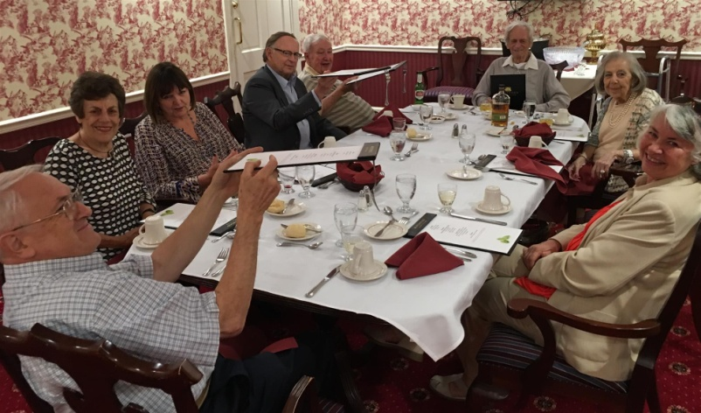

District Public Relations Committee Holds Quarterly Meeting

Shown, left to right: June Grace (Concord), Ron Trembly (Southbridge), Elliott Rittenberg (Westborough), Jason Camuti (Westborough), Peter Colgan (Bedford), Linda Cargiuolo (Bedford), Paul Johnson (Newton), District Governors Pat and Skip Doyle, Frank Doherty (Worcester), Elmond Hendrickson (Brookline), Peggie Thorsen (Marlborough), an unidentified Rotarian, Immediate Past District Governor Jim Fusco (Montachusett Area), photo by Steve Kirk (Concord). Also in attendance and not shown: Chair Laura Spear (Nashoba Valley, Chris Spear (Nashoba Valley), and Steve Jones-D'Agostino (Auburn).

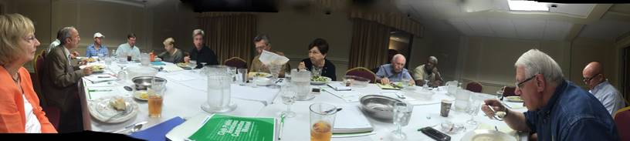

Shrewsbury Update On Haiti Battery Grant

This past Rotary year, the Rotary Club of Shrewsbury partnered with a Rotary club in Minnesota to provide improvements to the maternity center of Heartline Ministries in Haiti. Our part of the project was to provide funds—along with a District Matching Grant—to purchase an inverter and batteries for the center’s power system.

Elizabeth Thompson, of the Heartline Foundation, reports, "... The generator, batteries, and inverter were purchased and installed earlier this spring, making a significant difference for the staff and women served at the maternity center. Because electrical power from Port au Prince is only on for several hours a day and never reliable, having these backup power sources has made a tremendous difference in the quality of care provided to women - especially, in the middle of the night, when women often labor and give birth. The kitchen renovation is also complete, and the bathroom construction is nearly completion.”

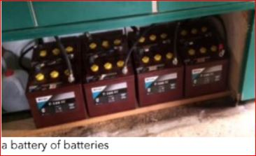

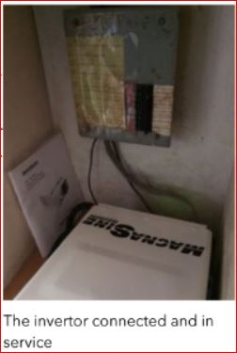

Sturbridge Golf Tournament a Huge Success

Meet the Winners, left to right: Austin Jenkins, Dave Tetzel, Howard Mosher, and Joe Mahaney.

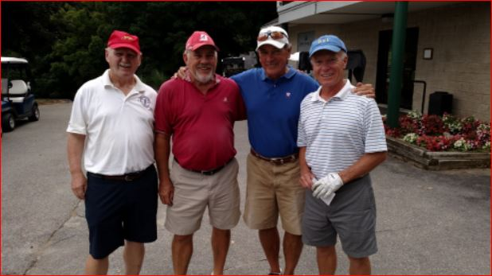

Leominster Helps Send Message Of Thanks, Support To Leominster Police

August 26 Sentinel & Enterprise article by Peter Jasinski:
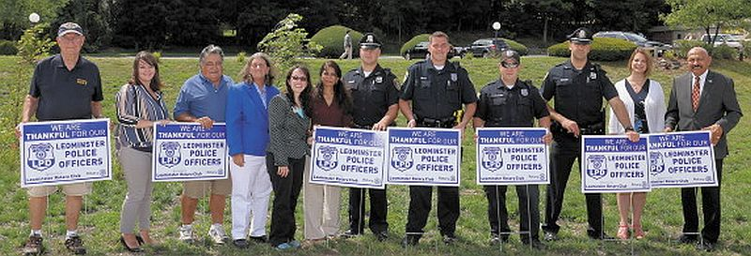Political yard signs have popped up along roads across the country this year, but the newest ones coming to Leominster won't have anything to do with candidates running for office.
The Leominster Rotary Club kicked off a campaign of their own on Thursday to show their support for local police.
With some of the signs, from left, are Rotary members Frank Ardinger, Nikki Paglieroni, John Souza, past President Claire Freda, current President Jennifer Stacy and Bharti Bhakta, with Police Officers Michael Booth, Eric Craig, John Bouchard and Billy Taylor, and Rotary members Mary Dean and Victor Bhakta. Photo/John Love
READ MORE

Marlborough Rotary Partners With Local Groups On Mental-Health Crisis Intervention

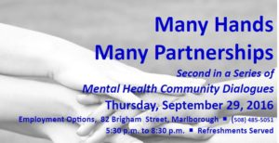The Rotary Club of Marlborough, Employment Options and the MetroWest chapter of the National Alliance on Mental Illness have partnered to conduct an event on mental-health crisis intervention, Many Hands, Many Partnerships, on Thursday, September 29, 2016 from 6:00 to 8:00 p.m. at Employment Options, 82 Brigham St., Marlborough. Networking will start at 5:30 p.m., with food and beverages served. The partnering organizations invite all members of the community to attend and join the conversation.
Many Hands, Many Partnerships will be a community dialogue on how we can better work together to help individuals and families in a mental-health crisis get the support they need. It takes a community to manage a mental-health crisis. All too often, we rely entirely on the police to manage such a crisis. Although our local police departments play a valuable role in a crisis, emergency first-responders, mental-health clinicians, individuals with lived experience, and family members all play equally valuable roles.
The event will include a feature presentation and panel discussion. Audience questions and participation will be encouraged. Feature presenter, Chief Craig Davis of the Ashland Police Department, will speak on “Crisis Diversion and Linkages.” The topic of the panel will be “Crisis Intervention to Crisis Management to Family Need and Support to Recovery.” Chief Davis will join Chief Mark Leonard of the Marlborough Police Department and John Deronck of Emergency Services Advocates in the panel discussion.

The Many Hands, Many Partnerships event is part of a community mental-health-awareness campaign to draw attention to the needs of those with mental illness, change negative perceptions, and promote recovery and healthy communities. The partners’ objectives include finding innovative community-based solutions to mental-health needs, with a focus on helping young people, and developing clear steps for communities to address their mental-health needs in a way that complements existing local activities.

For more information on the Many Hands, Many Partnerships event, visit marlboroughrotary.org, employmentoptions.org, or namimetrowest.org
To register in advance, call 508-251-9595 or email namimetroWest@namimetrowest.org.

Rotary Leadership Institute of Northeast America Annual Meeting

The Rotary Leadership Institute is a multi-district, grassroots leadership-development program of member districts organized into regional divisions in various parts of the world. RLI is not an official program of Rotary International and is not under its control. For more information, click here.

Shown: Past District Governor Ed King of Northborough Rotary presents the Registrar's Report.

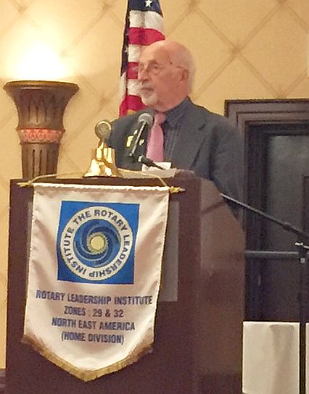

Next Nashoba Valley Rotary, Bolton Local Repair Café On September 24

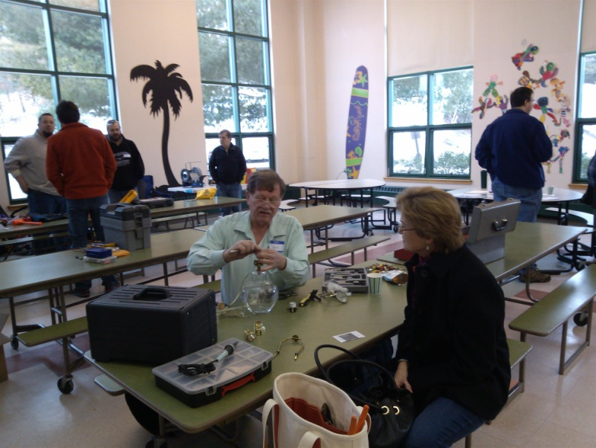What do you do with a broken toaster or lamp? Or with a shirt or blouse with a seam that is ripped out? Toss it? No way! Bring them to the Bolton Repair Café. The Rotary Club of Nashoba Valley, with help from Bolton Local, is hosting the next Bolton Repair Café on Saturday, September 24 from 9:00 a.m. to 1:00 p.m. The event will be held in the cafeteria of the Florence Sawyer School, located at 100 Mechanic St. in Bolton. The school is located behind the Emerson School, which is on the same driveway/street.

Residents of Bolton and surrounding towns are invited to come and find out what a Repair Café is all about. At the Repair Café, sponsored by Nashoba Valley Rotary, everything centers on making repairs. Knowledgeable volunteers will help repair items such as clean, mendable clothing, lamps, small appliances, computers and other electronics, bikes, toys, outdoor power equipment, and jewelry. They can also sharpen knives, scissors, and garden tools. You only pay for needed parts. If you know what parts are needed, please get them ahead of time and bring them to the Repair Café to save time. Volunteers at the Repair Café will look at all items brought in and try to repair them. If the volunteers cannot repair something, they will offer suggestions about where you could go for repairs.

Unlike a “fix-it” shop, where people drop off items to be repaired and continue about their day, the Repair Café is meant to get people involved with the repair process and create connections with others in the community. People bringing in items for repair are asked to stay while your items are being fixed. You can just watch, help with the repair, fix the item yourself with help from volunteers, or just have a snack and visit with neighbors.

Promoting repairs will help reduce mountains of waste. According to organizer Ray Pfau, a Nashoba Valley Rotarian, “We throw away lots of things that often have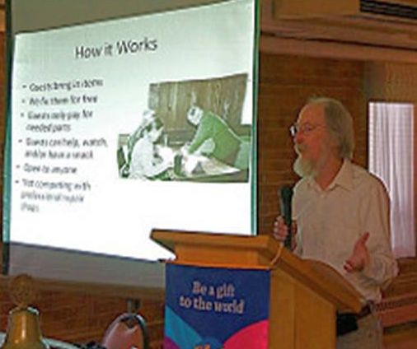 almost nothing wrong with them, things that could easily be used again after a simple repair. Unfortunately, many people have forgotten that they can fix things. Repair Café wants to change all that.” (Shown, right, is Ray Pfau addressing a recent Worcester Rotary meeting. Click here to view additional photos of that event by Worcester Rotarian Rich Prager.)

Repair Café is also meant to put neighbors in touch with each other in a new way. Neighbors may discover that a lot of know-how and practical skills can be found close to home. Pfau added, “If you repair a bike, a CD player, or a pair of trousers with previously unfamiliar neighbors, you look at them in a different light the next time you see them. Jointly making repairs can lead to connections in the community.” Making repairs can also save money and resources.

The Bolton Repair Café is sponsored by Nashoba Valley Rotary with support from Bolton Local and the Repair Café Foundation. The Foundation has been organizing Repair Cafés since 2010 in the Netherlands and has provided support since January 2011 to local groups in and outside the Netherlands wanting to start their own Repair Cafés.

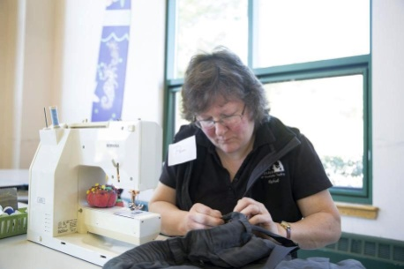Click here for a recent Boston Globe profile of the Bolton Repair Cafe.

For more information, contact Ray Pfau at 978-779-5545 or ray.pfau@alum.mit.edu, or visit www.nashobarotary.org.

Pat and Skip Doyle Installed As 2016-2017 District Governors

District 7910's 2016 Rotary Youth Leadership Awards were held on June 24 through 26 at Fitchburg State University, ending with the installation of longtime RYLA supporters Pat and Skip Doyle as district governors for 2016-2017. The three-day RYLA event was attended by 188 sophomores. To learn more about RYLA, visit http://www.ryla7910.org.

Click on the image, to view a video of the installation of Pat and Skip Doyle as '16-'17 DGs

Hudson And Nashoba Valley's Food And Brewfest Gets Excellent Coverage

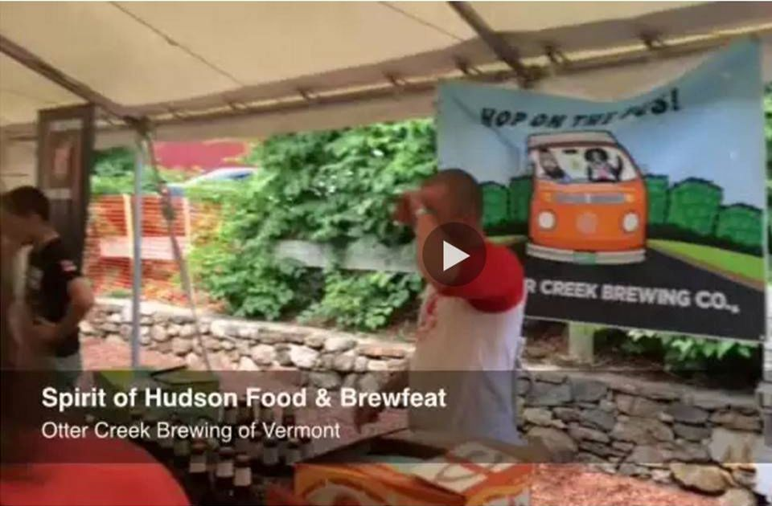

Kudos to the Hudson and Nashoba Valley Rotary clubs for excellent coverage by the MetroWest Daily News of their 2016 Spirit of Hudson Food and Brewfest on August 13 in Hudson.

To read the MDN article, click here.

To view the 50-second MDN video, click here.

To view event photos by Hudson Rotarian Cheryl Rosen, click here.

Westborough Rotary Heralds Successful Triathlon

The Rotary Club of Westborough has produced a Special Rotary Club of 2016 Westborough Sprint Triathlon Supplement. Produced by Club member Ron Goodenow, the supplement heralds the Club's very successful triathlon, including the day before the event, when Club members, Boy Scouts, Sun Multi Sport Events staff, and friends turning out to prepare the roads, trails, fields and beach for competition.

VIEW SUPPLEMENT
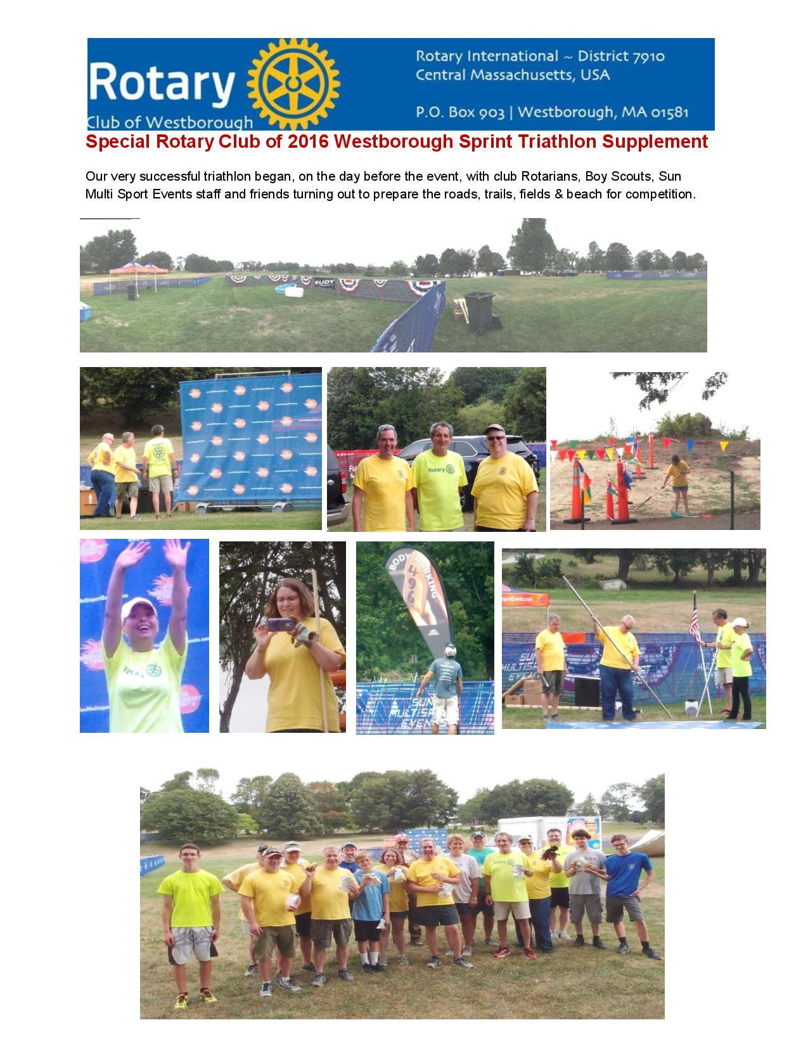

Westborough Inspired by Razia's Ray of Hope

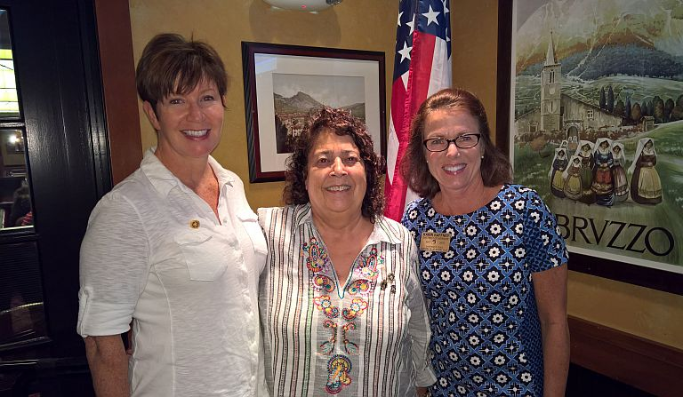

Westborough Rotarians recently had a very inspiring presentation by Razia Jan and Patty Quigley from Razia’s Ray of Hope. Several of the Westborough members stood up after and said it was one of the most inspiring speakers they had ever heard in Rotary.

Razia talked about the new college for young girls that they have built just outside Kabul, Afghanistan. Clubs in our District, led by Nashoba Valley, are working toward a possible Global Grant to provide equipment for a midwifery program at the college.

Razia has received the following Rotary International awards in the last 12 months:
- Service Above Self Award, 2016
- Global Woman of Action Award, 2015
Razia Jan (middle) and Patty Quigley (left) are shown posing with District Governor-Elect Karin Gaffney (right).

District Leadership Meeting Was A Huge Success

How HUGE? So HUGE that another is planned for October 17!

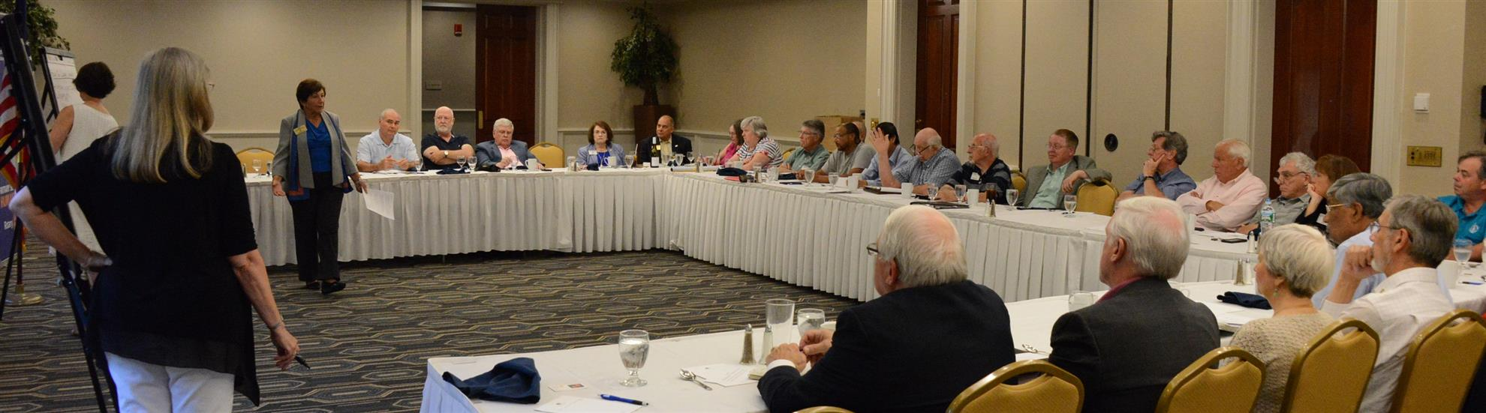
District Governors Pat and Skip Doyle held their Leadership Meeting on July 19 at the DoubleTree Hotel in Leominster. This is an annual event for which DGs bring their District leaders and committee chairs together to review the goals for the new Rotary year.

This, year the event was presented in a facilitated format. The results will be consolidated and sent to all attendees so that the District Goals for each committee can be set.

District Banners Available

Our district banners are available for your to use when you have an upcoming event or fundraiser.

If you want to reserve one of the banners, please contact PR Chair Laura Spear at laura@spear.net.

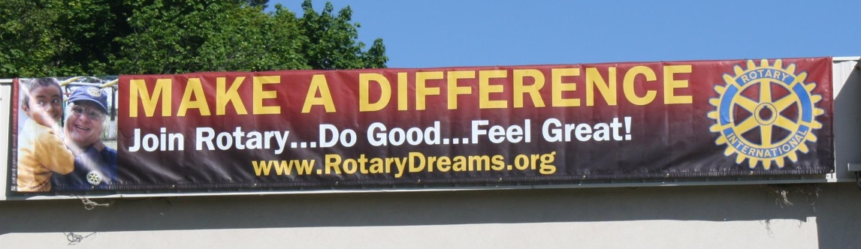

On To Atlanta In 2017

Planning to attend? Contact District Chair Steve Glines.

More than 43,000 attendees left the Rotary International Convention in South Korea inspired to end polio for good, to celebrate The Rotary Foundation's centennial, and to champion changes that will help Rotary appeal to a broader audience.

On the last day, RI President K.R. “Ravi” Ravindran shared a personal story of his mother’s triumph over polio.

To read the story, click here.

To register for the 2017 RI Convention in Atlanta, click here

Save The Dates: Rotary Golf Tournaments In Our District

Friday September 16: District 7910 Golf League - Monoosnock Country Club, Leominster. Click here for event flyer, in PDF format.

Friday September 16: Natick Rotary: 22nd Annual Golf Tournament - Juniper Hills. Click here for information.

Monday, September 19: Wachusett Area Rotary - 24th Annual Golf Tournament, Oak Hill Country Club, Fitchburg. Click here for Save The Date flyer, in PDF format Click here for Sponsorship Opportunities flyer, in PDF format.

MAJOR DISTRICT & CLUB HAPPENINGS: SUMMER & FALL
Friday, September 16: District 7910 - 'Golf Fellowship', Monoosnock Country Club, Leominster

Click here for event flyer, in PDF format

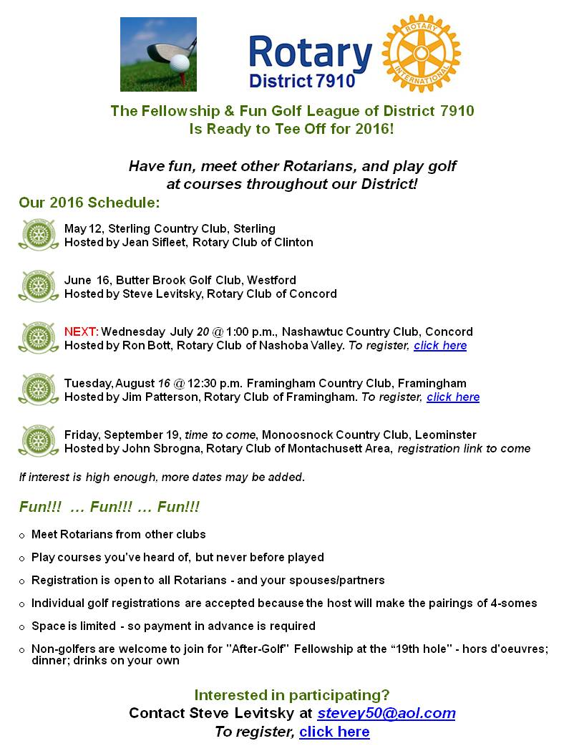

Saturday, September 17: District 7910 - 'Interact Teen and Advisor Training,' Needham

Click here for event flyer, in PDF format
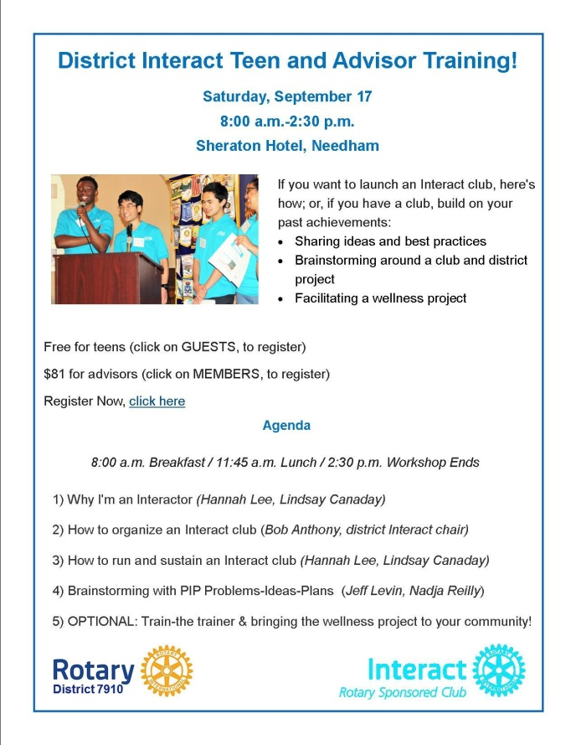

Sunday, September 18 - Northborough - 'Applefest Street Fair'

READ MORE

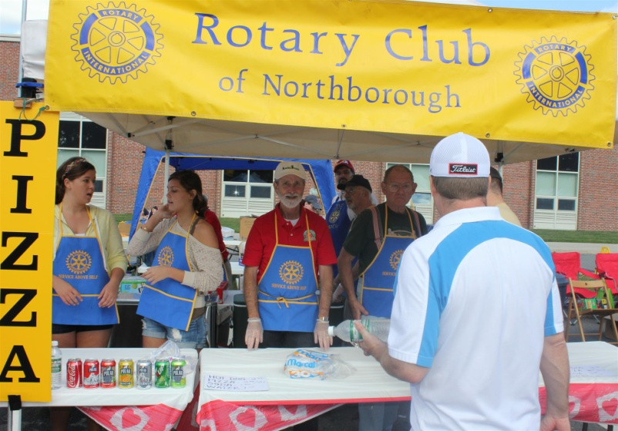

Monday, September 19: Wachusett Area Rotary - '24th Annual Golf Tournament,' Fitchburg

Click here for save-the-date flyer, in PDF format

Click here for sponsorship opportunities, in PDF format

Monday, September 19: Shrewsbury Rotary - 'Amanda Graves: On being a polio survivor'

Don't miss the presentation. Amanda (shown) is the newest member of the District 79010 Polio Team, chaired by Carl Good III. READ MORE

To read the press release, click here

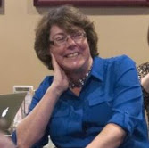

Tuesday, September 27: Bedford, Billerica, Lowell, Newton and Shrewsbury Rotary - 'Governor Baker - Featured Speaker at Rotary'

5:00-9:00 p.m., DoubleTree Bedford Glen Hotel, Bedford

Click here to RSVP

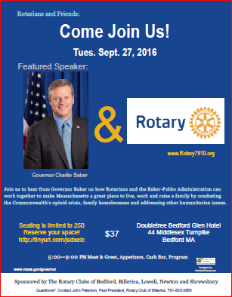

Thursday, September 29: Marlborough Rotary - 'Many Hands, Many Partnerships'

Click here to download event flyer, in PDF format

Friday, October 14: Montachusett Area Rotary - 'Comedy Night,' Knights of Columbus, Leominster

For tickets and information, contact Club President Jennifer Peck at montachusettarearotary@gmail.com

Submit Major Club Happenings

Send flyers of your club's major events and activities, in either JPEG or PDF format, to Immediate Past District Governor/Newsletter Editor Jim Fusco
at jim.fusco2@gmail.com.

