COMMITTEE REPORTS
RI Conference Testimonial: Share Your Experience With Us
By Karin Gaffney

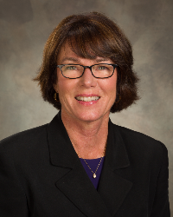

I'm looking for Rotary International Conference testimonials by members of Rotary clubs in our District to publish in this newsletter.

READ MORE

Membership Corner: Corporate Memberships In Rotary

By Tom Sturiale

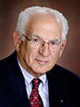

In our renewed zeal to broaden our membership, we are approaching large corporations and businesses to join our organization.

READ MORE

Membership Materials on Sale: Order Now!

To order, click here

Foundation Note: Six '16-'17 Global Grant Proposals Under Review By Grants Subcommittee
By Sanjay Deshpande

The District Grants Subcommittee under the leadership of Chair Jorge Yarzebski is taking up six Global Grant proposals for review in September for the allocation of $46,436 available in District Designated Funds for such grants in this 2016-2017 Rotary year.

READ MORE

PR Tips: Avoid cookie-cutter photos

By Laura Spear

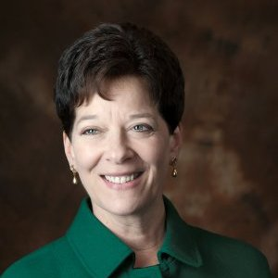

Don’t use a cookie-cutter picture of people shaking hands, standing in a row, or presenting a large check.

READ MORE

Treasurer's Report: Message about your dues

by Jack Hoell

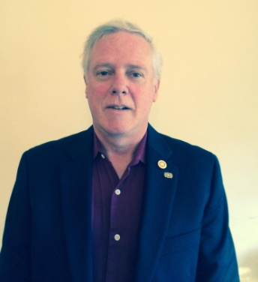

The Rotary International dues bills were e-mailed to the 51 clubs in our District on July 22 and the District dues bills were e-mailed to clubs on July 26.

READ MORE

District Charity Fund: How Does DCF Operate?

By Al Bowers

The District Charity Fund is a 501(c)3 charitable, non-profit that can be used by the Rotary clubs in District 7910.

READ MORE

PolioPlus Update: District Polio Committee

By Carl Good III

I want to let you know that the District Polio Committee been very active. Our committee now includes Chris Spear, Pam Anastasi, Phil Sandler and Amanda Graves.

READ MORE

Communications Link: Seeking club photo, video albums

By Steve Jones-D'Agostino

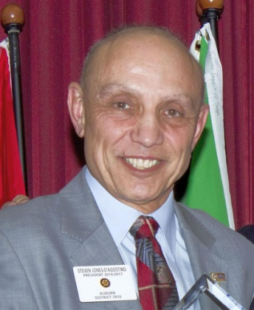

Does your District committee or Club have Rotary-related photo and/or video albums that you'd like to share with other Rotarians?

READ MORE

Bandey-Hefler Prepares For Trip To England: The Plane Leaves in Just 14 Days!

By Victor Tom

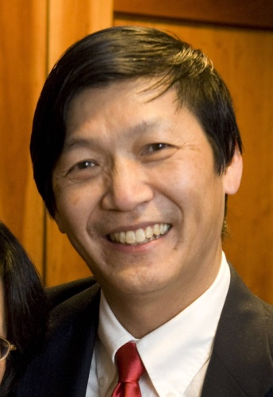

Our travelers are anxiously awaiting their two-week trip to England that begins on September 19.

READ MORE

SUBMIT CONTENT
To submit content for consideration for the Monday, September 12 issue of Rotary District 7910 Newsletter, please e-mail it to Immediate Past District Governor and Newsletter Editor Jim Fusco at jim.fusco2@gmail.com.

The submission deadline for that issue is Friday, September 9. All text must be in Word format. All images must be in either JPEG or PDF format. Please identify the people, left to right, who are shown in your photos, including their first and last name as well as their club or other title.

paST ISSUES
To view past issues of the weekly Rotary District 7910 Newsletter, click here

district 7910 oNLINE
Visit our website

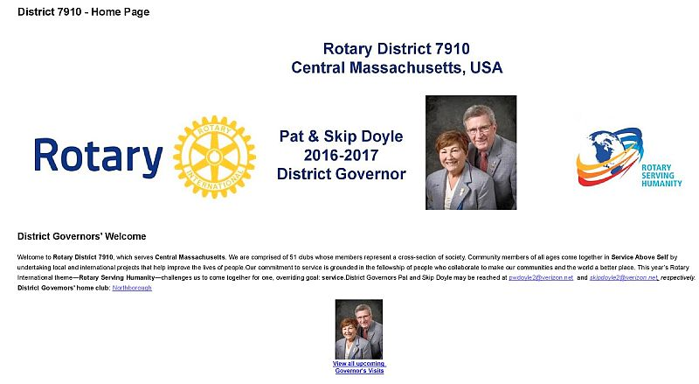

'Like' and share us on Facebook

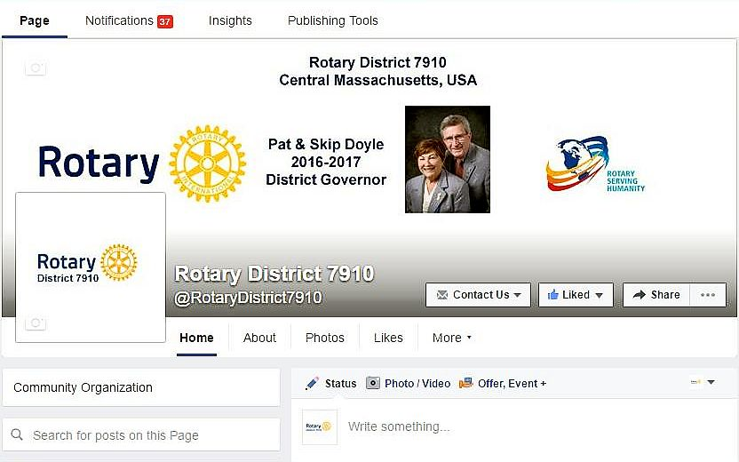

Watch our videos on YouTube

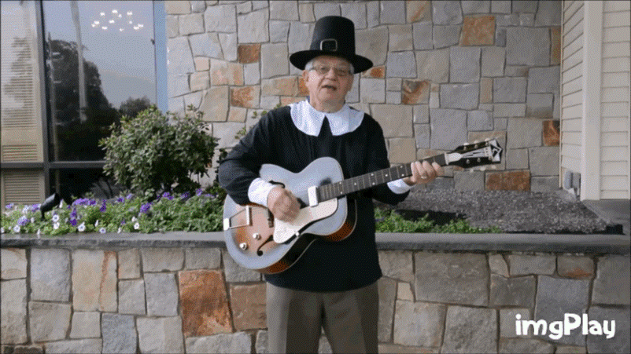

View our photos on Google Photos (since May 2015) and ClubRunner (before May 2015)

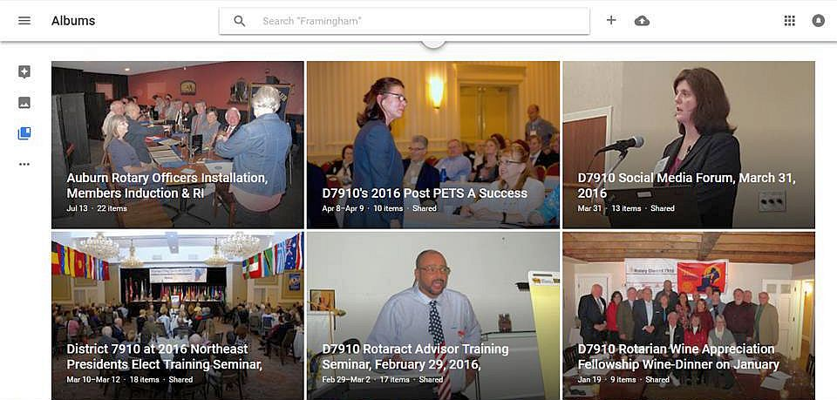

CONTACT US
Immediate Past District Governor and Newsletter Editor Jim Fusco
​jim.fusco2@gmail.com
District Webmaster Steve Jones-D'Agostino
​srdagostino@icloud.com

© Copyright 2016-2017 - Rotary District 7910, Central Massachusetts, USA

