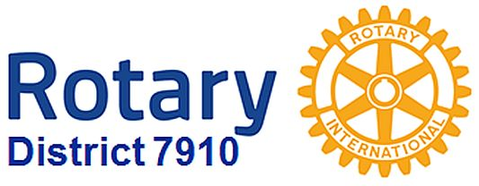

Looking for a good speaker?
By Steve Levitsky
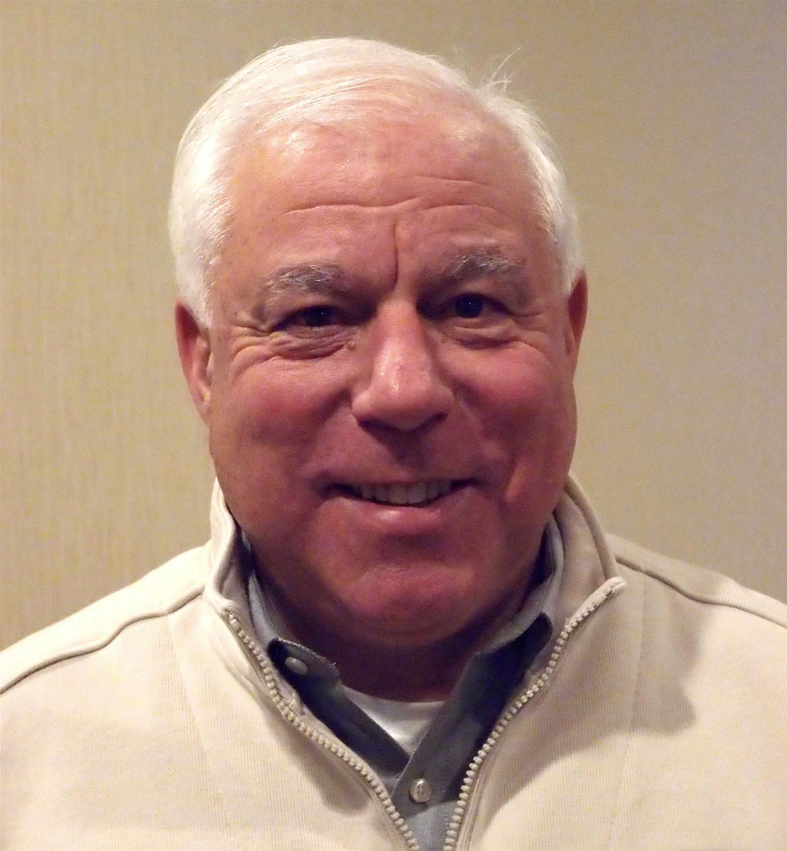It's not always easy to come up with ideas week after week. If you need an idea, here is some information on speakers who have recently addressed club in our district. The best part is that each speaker comes with a recommendation from one of our clubs, and has already indicated a willingness to present to other clubs.
Additionally, if you have enjoyed a presentation from someone who was spoken to your club, please consider sharing that information with me so that we can include that speaker here. Be sure to indicate whether or not that speaker has shown a willingness to present to additional clubs.
For more information, contact Steve Levitsky, chair of the District Speakers Bureau, at stevey50@aol.com or 978-337-4050.

RWANDAN GENOCIDE SPEAKER: CARINE BOGGIS
I recently had the pleasure of enjoying a speaker named Carine Boggis while attending a class at Harvard. She is a younger woman from Rwanda who at the age of eight experienced the genocide first hand.
Her story is powerful and she's a compelling speaker focusing on restorative justice. I believe at this time in our country when there's so much turmoil around diversity, her story needs to be told.
I'm reaching out to you to suggest you contact her and invite her to speak in your district and at your Rotary Club. She is in the Boston area – otherwise, I'd have her come to my club!
Recommended by: Corinne Cavanaugh
Member, Rotary Club of Seattle
Office: 206-802-9660
Cell: 425-232-9730

POSITIVE RESULTS HYPNOSIS: BOB MARTEL
Bob, who is a board-certified hypnotist at Positive Results Hypnosis in Holden, speaks on “Achieving Business Potential With Self-Hypnosis.”

What is hypnosis and why use it?

Hypnosis is a heightened sense of awareness. It is a habit change. An electric signal - a neuron in the brain - we become what we think about. We need to think differently to rewire the brain so that new thoughts take over the previous ones allowing the mind/body to work together. With hypnosis, you go into the future and pretend that by using a form of method acting with your imagination. Hypnosis is also used by advertisers who want to get into our heads in order to get us to buy their products.

Benefits of hypnosis in everyday life: By using auto suggestions, it can improve athletic accomplishments and academic performance. People can stop stuttering by going back in time to when it began. Hypnosis can help golfers with their game, and is used with Major League Baseball and the National Basketball Association.

Benefits of hypnosis in business: Hypnosis can stop procrastination, as it is a symptom of something they are afraid of. It can help with delegation, as that is usually due to being afraid to trust someone. It can reduce stress so you can stay calm, relaxed, in control and keep greater focus. Using hypnosis at work can mean happier employees being more productive with fewer sick days, and salespeople’s confidence going up leading to more sales.

Bob Martel can be reached at bobmartel@comcast.net or 508-481-8383. His website is www.positiveresultshypnosis.com.

Recommended by: Cheryl Rosen
Member, Hudson Rotary Club
Office: 508-791-9283
Cell: 508-615-0339

ELEVATOR-PITCH TIPS: ANDY WINIG
Andy Winig is not only a member of the Needham Rotary Club, but also an exceptional speaker on the art of the "elevator pitch" and presentations! His recommendations are spot-on for both general business use as well as promoting Rotary! To learn more, click here.
Recommended by: Karen Wetmore
Member, Needham Rotary Club
Assistant Governor, District 7910
Office: 781-444-8161
Cell: 339-223-0632

DIFFERENTIATION AND GAME-CHANGING SIMPLICITY: STEPHEN MELANSON
Stephen Melanson is president of Melanson Consulting, which was founded in 2004. He is a management consultant, trainer, speaker, Verbal Branding expert, and the originator of the only “business simplicity” platform of its kind. In the concept of Verbal Branding and the simplicity platform, he explains the short attention span of people below age 40, and how to get your message down to the absolute, most convincing basic that can be imparted in five seconds or less – the attention span of the under-40-year-old. As this is our primary target market for Rotary membership, the concept – and how to use it – is invaluable.

Melanson can be reached at 781-443-5051.

FEDERAL RESERVE BANK OF BOSTON: MARY BURKE
Mary Burke is a senior economist in the Research Department at the Federal Reserve Bank of Boston. She holds a Ph.D. in economics from Johns Hopkins University. Her primary research field is applied microeconomics, within which she has studied social-multiplier effects in the rise of obesity in the U.S., peer effects in education, and how individuals form inflation expectations, among other topics. Her research has been published in scholarly journals, including American Economic Review and Journal of Labor Economics. She also produces regular briefings on the New England economy for audiences both within and outside the Boston Fed.

Speaking arrangements may be made by contacting Darcy Saas at darcy.sass@bos.frb.org or 617-973-3177.

Mary spoke at the Rotary Club of Needham.

TANZANIA SCHOOL FOUNDATION - CHRISTINE LOTT
We began the School of St. Nicholas to educate disadvantaged children who could not afford school fees. We accept bright children born into chronic poverty. Most of our children live with their single mothers or grandmother in a one-room rented hut with no internal plumbing, electricity or toilets. It is through education that we will end the cycle of poverty for both them and their families in the years to come.

We are a group of professionals who volunteer our time, talent and treasures to ensure our mission continues with the heartfelt compassion it began with. The Foundation was founded in 2008 by Christine Lott, who had a dream. She wanted to change the world. Today, she lives that dream; changing lives one child at a time.

Christine is former vice president in middle-office operations at Goldman Sachs, a position she held for more than 25 years. In 2007, she traveled to Tanzania on a volunteer mission using her vacation time. While there, she made a promise that would change her life forever. In 2009, she took on the role of full-time director at The Tanzania School Foundation. She now lives in Tanzania six months of the year; the other six months, Christine lives in Stoughton. She may be contacted through the foundation's website at www.tanzaniaschoolfoundation.org.

MASSACHUSETTS LAW REFORM INSTITUTE: JEAN SIFLEET
Jean Sifleet, of the Rotary Club of Clinton, presented a program about the Massachusetts Law Reform Institute's Immigrant Family Community Education Program. MLRI is a non-profit organization that works for social justice and economic opportunity for low-income people. MLRI is a statewide organization that has been around for more than 45 years.

MLRI is a “systemic-advocacy organization,” – which means it works on achieving lasting outcomes through legal action, advocacy, coalition building and information sharing. So, rather than representing individual clients - such as a local Legal Aid office does - MLRI works on large-scale legal initiatives and reforms that address the root problems.

Jean is working with MLRI as a volunteer – and trying to better inform the business community of the issues. This is an informational program – no politics. Jean, who welcomes the opportunity to speak to other Rotary clubs, may be contacted at 508-361-0916.

BIKING ACROSS THE USA FOR THE PAN MASS CHALLENGE: CHRIS SPEAR
In 2015, Chris Spear, of the Nashoba Valley Rotary Club, biked from San Diego to Savannah to raise money for the Pan Mass Challenge and to challenge himself. With a group of cyclists, he rode more than 100 miles a day for a month, crossing the Sierra and Rocky mountains and the Arizona desert, following Route 66 through Oklahoma and the cotton fields of the South. He raised more than $9,000 for the Dana Farber Cancer Institute and every day saw new parts of the USA.

Chris, who is the 2016-2017 president-elect of the Nashoba Valley club, has been riding the Pan Mass Challenge since 1989, and is a verification engineer for Intel in Hudson. He has biked in 11 countries, is always looking forward to the next bike ride, and is willing to speak to other Rotary clubs. If interested, contact Chris at chrisbspear@gmail.com.

MAKE EACH DAY COUNT: TYKE CROWLEY
To learn more about Make Each Day Count, visit www.makeeachdaycount.com. You may contact Tyke, a motivational speaker who is recommended by the Rotary Club of Littleton, at 978-660-8130.

BOLTON REPAIR CAFE: RAY PFAU
Ray, a member of the Rotary Club of Nashoba Valley, is employed by the Oracle Corp. Repair Cafes encourage sustainability, save people money and avoid people throwing things away and buying new ones. You may contact Ray, who is recommended as a speaker by the Rotary Club of Hudson, at ray.pfau@oracle.com.

JEFF'S PLACE, CHILDREN'S BEREAVEMENT CENTER INC.
Located in Framingham, Jeff's Place facilitates healthy integration of loss for children, teens and their families by helping them feel connected with each other and less alone in their grief journey.

To arrange for a speaker, call 508-879-2800 or e-mail info@JeffsPlaceMetrowest.org.

HOW PRO ATHLETES LEAVE SPORTS AND ENJOY THE GAME OF LIFE: DAVE OSTROWSKY
Dave, who lives in Natick and grew up in Newton, is the author of Game Over or Game On? How Pro Athletes Leave Sports and Enjoy the Game of Life.

Dave, who is recommended by Rotary Club of Concord, may be reached at 508-651-0897.
Here are additional recommended speakers who addressed clubs in District 7910 during 2014.

DAN SHAUGHNESSY, SPORTSWRITER FOR THE BOSTON GLOBE
- ​Subject: Sports in the printed media
- Rotary Club Presentations To Date: Brookline & Newton (10/25/14)

SAJID BASEER SHAIKH, ROTARY CLUB OF LAHORE, PAKISTAN
- ​Subject: Polio in Pakistan
- Rotary Club Presentations To Date: Hudson (10/7/14)

DAN FENN, FORMER AIDE TO JFK
- ​Subject: President John F. Kennedy
- ​Rotary Club Presentations To Date: Marlborough (10/9/14)

BRAD STEVENS, HEAD COACH OF THE BOSTON CELTICS
- ​Subject: Basketball
- Rotary Club Presentations To Date: Wellesley (10/21/14)

JOANIE MAYHAN
- Subject: Paranormal: Flying Monkeys, Clowns, Snakes and Our Other Fears​
- ​Rotary Club Presentations To Date: Montachusett Area (10/30/14)

LINDSAY MORAND, GREAT NIECE OF E.B. WHITE, WHO WAS AUTHOR OF "CHARLOTTE'S WEB," AND PRESIDENT OF E.B. WHITE MEMORABILIA INC.
- Subject: Life history of E.B. White
- Rotary Club Presentations To Date: Montachusett Area (9/18/14); Fitchburg (9/23/14)
- Contact: 978-697-7951: Lindsay@EBWhiteNiece.com.

Got A Speaker?
If your club has enjoyed a high-quality speaker, consider sharing the speaker's information as follows:
- Name and title of the speaker
- Organization that the speaker represents
- Subject of the topic
- Is the speaker willing to present to other clubs?
Please send any recommendations to Assistant Governor Steve Levitsky, of the Rotary Club of Littleton, at stevey50@aol.com.

Questions? Please call Steve at 978-635-1525.

