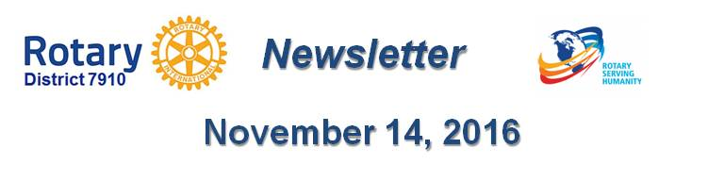

Wellesley Sixth-Graders Learn of Rotary Four-Way Test, Interact Global Grant Project

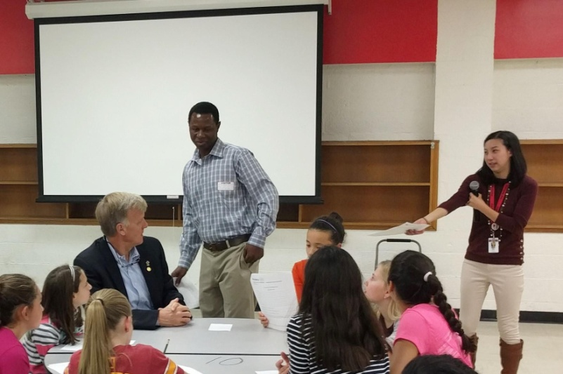About 80 students from the Wellesley Middle School used a lesson plan developed by English teacher Claire Lee (standing, right) to exercise the iconic Rotary tool for decision-making. The Grade 6 students were invited to list good and bad decisions they remembered and weigh them using the Rotary Four-Way Test (click here for Rotary Four-Way Test Worksheet for Grade 6). They were also invited to participate in a writing contest expanding on the same topic. John Adams (seated, left), Cynthia Sibold and Bob Anthony represented the Rotary Club of Wellesley in offering the writers judged to be the top three prizes valued at $400.

The students also heard from a guest visiting from India who is working on the Wellesley club’s Global Grant project there for Peer Leadership and Depression Prevention. Ramnath Subba Siddi (standing, middle) is a social worker and educator in Karntaka, India and is visiting Wellesley. He taught the middle school students that students everywhere want ideas on how to help a friend with worries.

Ramnath is available to visit Interact and Rotary clubs to speak briefly anytime before he departs on December 20. Please contact Bob Anthony at rwa1645@gmail.com to schedule a time or to discuss details.

The Peer Leadership and Depression Prevention project may be replicated by any club for implementation in the local community and beyond. Wellesley Interact teens are in their third year co-facilitating the program with school and community youth groups.

Wellesley and District 7910 Rotarians have implemented the program so far with schools and communities in Puerto Rico and India. Wellesley Rotary hopes other Interact clubs will expand it into additional countries.

Photo: Bob Anthony, Wellesley Rotary

Return to November 14 Newsletter

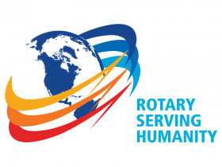
View past issues
Visit our website
'Like' our Facebook page
'Follow' us on Twitter

