30 Rotarians, Rotaractors Attend Multi-District Wine Fellowship Event
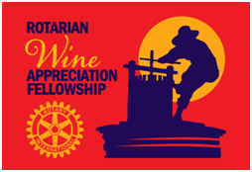District 7910 and 7930’s Rotarian Wine Appreciation Fellowship sponsored a Wine-Dinner on Monday, July 18 at La Morra Bicari Ristorante in Brookline Village. Thirty Rotarians and Rotaractors enjoy a delicious four-course meal with a total of four wine pairings. (Rotaractors under the legal drinking age were not served wine.) JIM TO MAKE CORRECTIONS

This was an open event, including both members and non-members of the D7910/7930 Rotarian Wine Appreciation Fellowship. We encouraged them to bring family, friends and co-workers who may be future Rotarians.

Planning is already underway for our next wine-dinner event, to be held sometime in October at a yet-to-be-chosen outdoor location.
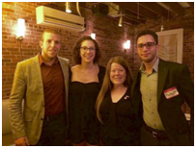A big, hearty thank-you to our new international Rotary friends, Burak Berk Douluay (far left) of Cyprus and Hicham Teghlaoui (far right) of The Netherlands, for joining us at the wine-dinner event. They are shown posing with District 7930 Rotaract Representative Mallory McCoy (second from left) Boston Rotaract President Amy Collinsworth (second from right).
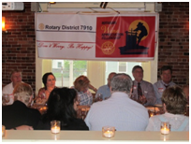In between courses, the more than two dozen Rotarians in attendance had an enlightening and energizing conversation with those Rotaractors, facilitated by Sturbridge Rotarian and Past District Governor Carl Kaliszewski (facing camera, second from right), who shared about their own commitments to "service above self."

The Rotaractors discussed the institutional, cultural and economic barriers in Rotary that influence young professionals from connecting with and becoming members of Rotary.

Following the July 18 wine-dinner event, Amy Collinsworth wrote to say that she is "looking forward to the continued conversation between Rotarians and Rotaractors in our districts. It was really wonderful to both feel and hear the support we have from everyone
To view additional photos of the July 18 wine-dinner event, click here.

For more information, contact Carl Gomes of the Rotary Club of Nashoba Valley at carlcgomes56@icloud.com or 508-450-3374, or Steve Jones-D’Agostino of the Rotary Club of Auburn at srdagostino@icloud.com or 508-930-8675. If you would like a short Fellowship presentation at your club meeting, please contact Carl or Steve.

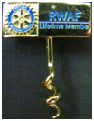To learn more about Rotarian Wine Appreciation Fellowships visit RotaryWine.net.

