Rotary District 7950 Public Image Grant Application 2026-2027

Rotary Club: ________________________________________________

Club President: ______________________________________________

Club Contact: ________________________________________________

Primary Club Contact Phone: ___________________________________

Primary Club Contact email: _____________________________________

Address for mailing reimbursement check: ____________________________

CLUB PUBLIC IMAGE GRANT OVERVIEW
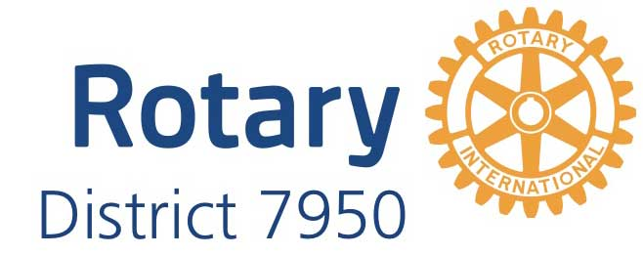
The purpose of this grant is to improve the public image of the Rotary clubs of District 7950. Categories for mini-grant approval are listed in the grant application. We encourage you to use pre-certified vendors that offer high quality and can consider vendors who understand the Rotary brand.

GUIDELINES
The grant is a reimbursement matching grant: 50% of expenses up to $150 for a total of $300.
Clubs cannot receive grant money up front but may submit receipts for payment prior to the
deadline, based on prior approval. Grant funds may be used to subsidize a larger quote.
All promotions, materials, and messaging must meet the Rotary International branding
standards and be PRE-APPROVED by a member of the Public Image Committee prior to
ordering. Brand standards, templates, and design help are available in the Brand Center:
https://brandcenter.rotary.org/

Do Not Use Google or Ai for logos or brand elements. If you need help, reach out to PI.
Brand Center includes templates and guidance for promotional materials. Qualifying materials/
promotions/messaging may be used to promote projects, membership, events, or general
information but should be aimed at increasing the visibility of your club and improving its public
image.

Recipients may be asked to share their materials/designs with other Rotary clubs.
We ask that all materials/promotions/messaging include a call to action. For example, an event
should include an invitation to visit a club’s social media and/or website or contact a club email
or call a specific member within your club to learn more.

Please try to use approved vendors that offer high quality and brand-compliant materials. You
can also get a one-time license for a local vendor.

REQUIREMENTS
You must submit with your application a sample of the design proposed for your grant item(s).
All designs must match Rotary Branding guidelines as defined in Brand Center. Grants WILL
NOT be approved without a pre-approved design. Approval for designs that meet branding
standards takes 3-5 business days. Other designs may take longer based on the time it takes
to meet Rotary International brand standards.

Once your design has been approved, your purchase must occur from September 1, 2026
through June 1, 2027.

Submit a photo of your finished product in action to the Public Image Committee with receipts
no later than June 1, 2026

INSTRUCTIONS FOR APPLICANTS

Please complete the following application. Incomplete applications will not be considered.
Please fit all information on the application and do not submit additional narrative. Submit this
application to the Public Image Committee along with a sample of your proposed material/
promotion/message to the Rotary District 7950 Public Image Committee:
d7950publicimage@gmail.com

CHECKLIST (You must complete all)

___ Our Club acknowledges that the total amount of the grant will match 50% of our costs up to
a maximum of $150.

___ Our Club’s Treasurer understands this is a reimbursement matching grant. We will submit
a copy of the project’s receipt(s) no later than June 1, 2026.

___ We have submitted our design for pre-approval to the Public Image Chair and understand
it will take 3-5 business days for review. Approvals may take more time if edits are needed for
brand compliance.

___ We have read the requirements stated in the overview and understand the timeline for
reimbursement.

QUESTIONS? Contact the District Public Image Committee: d7950publicimage@gmail.com

Public Image Grant Process
- Club identifies a promotional activity or deliverable, eligible for the grant process.
- Club completes the initial application.
- Club submits the application and proposed design to d7950publicimage@gmail.com.
- District 7950 Public Image Committee reviews the application and proposed design within 3 business days of receipt.
5. If edits are needed, the District 7950 Public Image Committee responds and works with the club on brand compliance.
6. Upon approval from the District 7950 Public Image Committee, the club purchases the public image items.

7.The club submits a photo of the final product, the invoice, and proof of payment to d7950publicimage@gmail.com.

8.The District Public Image Committee forwards the information to the District Treasurer for payment.

9. The District Treasurer issues a check to the club, a 50% match up to a maximum of $150.

