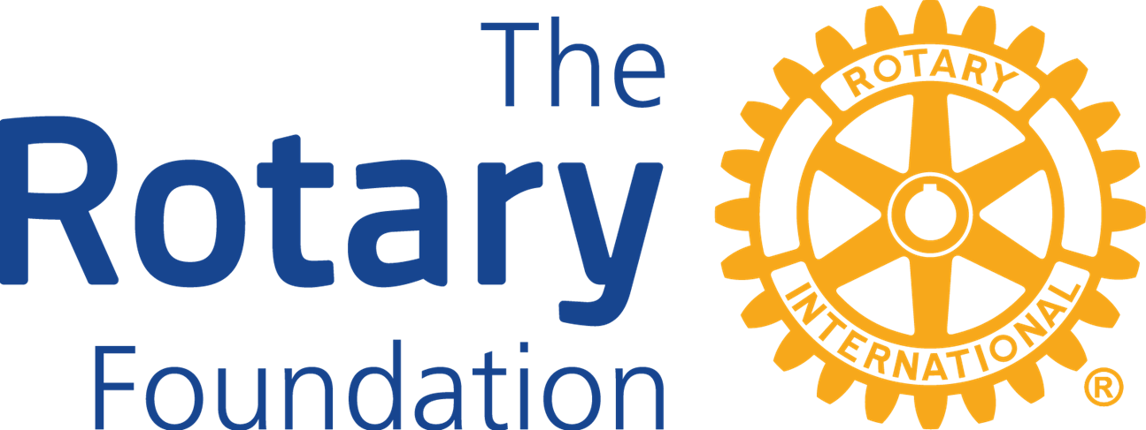 THE ROTARY FOUNDATION (TRF) DISTRICT 7950
DISTRICT GRANT APPLICATION
2026-2027

- Please answer ALL the questions. This is a word document. Download it, complete it in Word and save the doc with your club’s name as the file name. Email it to: foundation_committee@outlook.com Incomplete applications will be returned! Applicants may attach pages to this as needed.
- QUALIFICATIONS – Only clubs that have completed the qualification terms are eligible to apply for a District Grant, including Interact and Rotaract Grants. The qualifications are:
  - District and Rotary International Dues are paid.
  - At least one club member has attended a district grants qualification training.
  - A Memorandum of Understanding / District 7950 Addendum has been signed and submitted by the Club’s President and President Elect.
  - The President Elect has entered the Foundation Goals in Club Central.
- Applications must include a signed and dated Letter of Support from the organization (on the organization’s letterhead) who will benefit from the club’s project. No electronic signatures.
- A maximum of three (3) clubs may collaborate on one (1) project, and the application must be signed by each of the Presidents of the clubs involved for the application to be considered completed. ONLY the lead club should complete this application and coordinate the project. No electronic signatures.
- Grant requests will be reviewed by the District Grants Review Subcommittee on a rolling basis between
June 1, 2026, and August 15, 2026, or until all available funds have been allocated.
- Note that Projects that will be conducted in the geographical area of District 7950 will be given priority over request for project that will be conducted outside the district.
- Grant projects may not start until the club receives a written approval letter stating that their grant request has been approved. All receipts must be dated after the approval letter date and no later than May 31, 2027. Monies spent prior to the approval letter date will not be reimbursed.
- Completed grant applications can be sent to the District Grant Subcommittee Chair, by email to foundation_committee@outlook.com

This Grant application is being submitted by The Rotary Club of ________________________________X

Provide contact information for the Rotarian completing this application.
Name:
Address:
Phone:
Email:

- What is the name and contact information for the beneficiary?

- What is the purpose of this project? Provide a brief description.

- What is the total amount of District Funds your club/multi-clubs are seeking for this project? (This is only the amount that your club or all participating clubs are requesting from the district. Not the total project budget). AMOUNT OF FUNDS YOU ARE REQUESTING:
Rotary Clubs: Minimum Grant award is $250, and the Maximum is $1,500 per club.
Rotaract Clubs: Same as a Rotary Club
Interact Clubs: Minimum Grant award is $250, and the Maximum is $500 per club. If this is a
Interact project, please obtain a signature of the club president or advisor if the president is under 18 years of age.

4. Detail the total costs of the project:
a. What is the total cost of the project?
b. Club funds to be used.
c. District funds to be used.
d. If the project cost is greater than the District grant award request, how will you obtain the additional
funds?

If there is any possible conflict of interest regarding the project the club must notify the District Grants Subcommittee Chair as part of the grant application.

5. How will the money be spent? Please provide a budget of how you plan to spend the money.

PROJECT INCOME WORKSHEET:
Sources of Income | Amount
Amount of District Grant Funds Requested:
(Funds must be matched by the club dollar-to-dollar)
Club Funds
Other Funding Sources, i.e., Club Foundation: Rotarians; Non-Rotarians
Total Budgeted Income
PROJECT EXPENSES:
Expense Items (please be specific) | Cost
NOTE: Best practices are for vendors to be paid directly by the Rotary Club. The Name of
the Rotary Club should be listed as who will be billed for the item (not the
organization or beneficiary).
Total Budgeted Expenses:

Note: Your club is responsible for managing and maintaining all the financial records and receipts for the total amount of the project expenditure. Monetary donations to the beneficiary are not considered part of the expenses incurred for a project.

6. Needs Assessment and Project Impact:
a. How will this project meet the needs of the community?
b. How many people will benefit?

c. How many Club members will participate?
d. How will they help?

7. How will the public know that this is a Rotary sponsored project: i.e. how will it be promoted and publicized?

8. Funds donated to the Annual Fund of The Rotary Foundation (TRF) are used to provide funds for District Grants.
a. How much did your club and club members donate to the Annual Fund of The Rotary Foundation in the
year 2023-2024?

b. Has your Club included the Annual Giving Goal in Club Central for Rotary year 2026-2027? Yes No

c. How much has your club pledged on Club Central to support the annual fund in 2026-2027?

___________________________

9. Provide the names and contact information of the three Rotarians appointed by the President to oversee this project.

Club Foundation Chair email:_____________________________________

Grant Treasurer email:_____________________________________

Grant Project Chair email:_____________________________________

Note: Before submitting this application, please review the bullet points of required information listed on page one.

10. As President, I hereby affirm that the club’s board has voted to undertake this project as an activity of the club. I also affirm that all information in this District Grant Application is true and accurate, to the best of my knowledge:

2026-27 President’s Signature X DATE ____________

Email address_________________________ Telephone Number ____________________

Interact Advisor and or Rotaract President’s Signature DATE

Email address_________________________ Telephone Number ____________________

If additional clubs are collaborating on this project, please obtain signatures of the club presidents:
(Up to 3 clubs may collaborate on one project that used District Grant funds.)
Note: All participating clubs must be qualified before applying for a District Grant.

Rotary Club of:

PRESIDENT'S SIGNATURE DATE

Rotary Club of: __________________________________________

PRESIDENT’S SIGNATURE ______________________ DATE __________

Email the completed application with all the necessary documents to: foundation_committee@outlook.com

Reporting Requirements: A Progress Report is due by February 1, 2027, and the club must notify the District Foundation Grants Committee in email if the project goals and objectives need to be modified.

All projects must be completed by May 31, 2027; and the Final Report is due on or before June 15, 2027. This report form is located on the District website (www.rotary7950.com).
- Final Reports must include copies of all receipts and the club’s cancelled checks or club’s bank statements that relate to the project.
- All reports must be sent to foundation_committee@outlook.com

NOTE: The amount of the Grant awarded will only match the receipts submitted in the final report.

