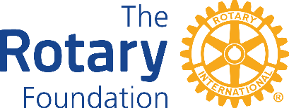

District 7950 Grant Intention Form
2026 - 2027

It is requested that clubs submit the District Grant Intention Form providing the Club name, contact information of the Rotarian completing the form, the intent or purpose of the grant and the amount of District Designated Funds requested.

The District Grant Committee is requesting this information to speed up Grant processing and provide for Fall projects, i.e., back-to-school, Thanksgiving, Winter homeless efforts, etc.

The Rotary Year for which the funds are required _____________________

1. Rotary Club of ______________________________________________

2. Name of person completing this form_____________________________

Email____________________________________ Phone_____________

3. Brief description of the intent or purpose of the grant:

4. Amount of District funds requesting: ____________

5. Club President’s Name _______________________

Signature_____________________________ Date __________

Email this form to: Foundation_Committee@outlook.com

