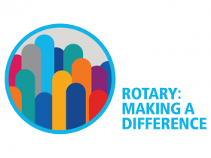
Rotary International District 7950
Rotary Foundation Dinner
Venus de Milo

Thursday, November 9, 2017

DINNER
$46.50 per person

Social Hour begins at 5:30 pm
Dinner at 7:00pm

Club Name:

Name Title Dinner Total Cost

GRAND TOTAL:

Please list everyone attending. Make checks payable to: Rotary District 7950.

You can also register online at www.rotary7950.com

A REGISTRATION MADE IS A REGISTRATION PAID.

EARLY REGISTRATION WOULD BE APPRECIATED. DEADLINE IS NOVEMBER 1, 2017.

MAIL TO: Valerie Perry 30 Wannamoisett Road, East Providence, RI 02914

