|  |  |
| --- | --- |
| *RotaryMBS_RGB* | **CLUB QUALIFICATION MEMORANDUM OF UNDERSTANDING FOR District 7950 Foundation, Inc. Participation** |

**CONTENTS**

1. General Statement
2. Club Qualification
3. Club Officer Responsibilities
4. Document Retention
5. Reporting Misuse of Funds
6. Authorization and Agreement

**1.General Statement**

The Rotary District 7950 Foundation, Inc. (hereinafter the “District Foundation”), has been created to help its’ clubs obtain tax-deductible donations, from individuals or organizations, which will increase the club’s fundraising capability and therefore the impact of their charitable works. The District Foundation is intended to be a conduit for donors seeking to make tax deductible donations to a District 7950 Rotary Club. All clubs in good standing, in the District, are eligible to utilize the services of the District Foundation.

The District Foundation must protect and retain its’ favored tax-exempt status for the benefit of all clubs. A member club acting outside of the guidelines noted could put the tax-exempt status of the District Foundation at risk. Any hint of scandal, misuse, or wrong-doing could cause the District Foundation to lose its’ tax-exempt status, which would hurt every club in the District. It would also damage public perception of Rotary in the community. As a result, the following rules have been developed. Any member club found to have violated the stated rules of use will be barred from future participation.

At the current time, there is no fee for participation. However, the Board of Directors reserves the right to institute a fee should it be absolutely necessary.

**2. Club Qualification**

To qualify to participate in the District Foundation, a club must agree to implement the stewardship requirements required by the District Foundation and agree that all monies will be used for charitable purposes, only.

1. Participating Member Clubs, in good standing, may interact with the Foundation to increase their charitable fundraising and impact. A member in good standing means both International and District dues are paid current, with no other club impediment.
2. Member clubs wishing to utilize the District Foundation must review the District Foundation by-laws, as well as sign this Memorandum of Understanding, agreeing to abide by the rules of the District Foundation.
3. Qualification may be suspended or revoked for misuse or mismanagement of funds or other unethical practices involving, but not limited to: fraud; forgery; membership falsification; gross negligence; endangerment of health, welfare, or safety of beneficiaries; ineligible contributions; use of funds for personal gain; undisclosed conflicts of interest; monopolization of donated funds by individuals; report falsification (should one be required); overpricing; acceptance of payments from beneficiaries; illegal activities; use of charitable funds for ineligible purposes.

**3. Club Officer Responsibilities**

The club officers hold primary responsibility for club qualification and the proper implementation of charitable gifts through the District Foundation.

Club officer responsibilities include:

1. Appointing at least one club member to implement, manage, and maintain club qualification
2. Ensuring that all funds transferred comply with stewardship measures and proper charitable funds management practices
3. Ensuring that all individuals involved in a funds transfer conduct their activities in a way that avoids any actual or perceived conflict of interest

**4. Club/District Foundation Financial/Recordkeeping Management (“Givebutter”)**

Participating clubs may use the District Foundation without using the Givebutter platform. For example, both in Rhode Island and Massachusetts, clubs may use the sales tax exemption certificate for legitimate fundraising expenses. Please remember that regular club meetings do not qualify for sales tax exemption. We still ask that the memorandum of understanding be signed to create a record of clubs using the exemption. Contact the Foundation Secretary for a copy of the certificate. The Memorandum of Understanding is an annual requirement.

1. Givebutter, a free to use charitable giving software, is currently the Recordkeeping instrument.
2. Each participating club has a unique account, within the District 501c3. Each club designates ‘Admins’ to interact with the Givebutter account. Givebutter also allows for ‘Editors’ and ‘Members’ within that club account. The club can run campaigns, (i.e. fundraisers). The Givebutter program is quite robust, clubs can run all kinds of campaigns.
3. Participating clubs set up a unique Charitable Giving or “Good Works” bank account, should they not already have one, to receive transferred funds, from which they in turn distribute their allocations.
4. The District Foundation Treasurer will transfer clubs’ donations to that Charitable Giving bank account at the conclusion of each campaign, providing that there is a current MOU on file.

**5. Document Retention**

The club must establish and maintain appropriate recordkeeping systems to preserve important documents related to charitable funds management. Retaining these documents supports transparency in funds management and assists in the preparation for any potential governmental audits or financial assessments. An original paper file and an electronic backup is recommended. These listed requirements are activities that clubs should do ordinarily.

1. Documents that must be maintained include, but are not limited to:
2. Bank information, including copies of past statements
3. Club qualification documents including a copy of the signed club Memorandum of Understanding (hereinafter the “MOU”)
4. Documented plans and procedures, including:
   * Club financial management plan
   * Procedure for storing documents and archives
   * A succession plan for the Club’s Givebutter account authorized signatures and the retention of information and documentation
5. Information related to charitable funds management.
6. Club records must be accessible and available to Rotarians in the club and must be provided at the request of the District Foundation, and/or District Governor.
7. Documents must be maintained for a minimum of seven years, or longer if required by local law.

**6. Reporting Misuse of Charitable Funds**

The club must report any suspected and real misuse or mismanagement of charitable funds to the district. This reporting fosters an environment in the club that does not tolerate the misuse of charitable funds.

1. **Authorization and Agreement**

This memorandum of understanding is an agreement between the Club and the District Foundation and acknowledges that both the Club and the District Foundation will undertake measures to ensure the proper implementation of pass-through charitable fund donations. By authorizing this document, the club agrees to comply with all conditions and requirements of this MOU.

The undersigned agree to comply with all conditions and requirements of the MOU and will notify the District Foundation of any changes or revisions to club policies and procedures related to these requirements.

**On behalf of the Rotary Club of** \_\_\_\_\_\_\_\_\_\_\_\_\_\_\_\_\_\_\_\_\_\_\_\_\_\_\_\_\_\_\_\_\_\_\_\_\_\_\_,

**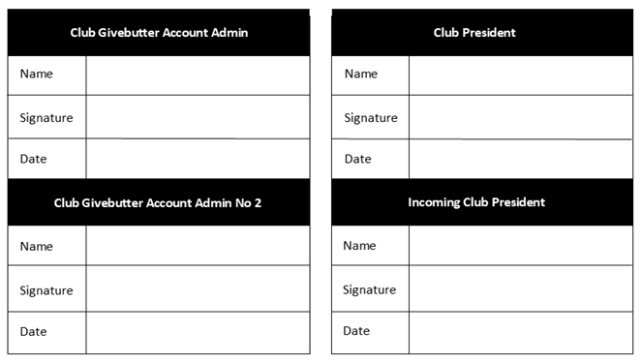**

**Rev. 1.25.23, 7.31.23, 3.05.24, 5.15.24**