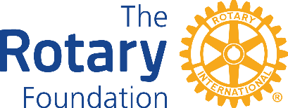

District 7950
Partner Global Grant Intention Form
2025 - 2026

It is requested that clubs submit the Partner Global Grant Intention Form providing the Club name, contact information of the Rotarian completing the form, the intent or purpose of the grant, the Club’s name and/or District number of who you will be partnering with, the Global Grant Number assigned by The Rotary Foundation and the amount of District 7950 Designated Funds requested.
(District DDF Funds will be matched to your contribution up to a maximum of $5,000 so long as there are funds available)
The District Grant Committee is requesting this information to ensure there are Grant funds available to fulfill this request.

The Rotary Year for which the funds are required _____________________

1. Rotary Club of ______________________________________________

2. Name of person completing this form_____________________________

Email____________________________________ Phone_____________

3. Club you are partnering with ______________________

4. District you are partnering with _____________________

5. Global Grant Number GG_________________________

6. Brief description of the intent or purpose of the grant:

7. Amount of District funds requesting: ____________

8. Club President’s Name _______________________

Signature_____________________________ Date __________________

Email this form to: Foundation_Committee@outlook.com

