FORM 3 Districts 9500 & 9520
Markets / Trading / Car Boot sales,
Swap meets/ Flea Markets RISK ASSESSMENT
Revision 2
DATE: 23/01/2019

Risk Assessment Checklist |  | NA | C
3.1.1 | Complete Form 1.  Name of the event:  Date: If this event is to be repeated with identical requirements list the dates on Form 1.
3.1.2 | One member must carry a mobile phone with current emergency Police, Fire and Ambulance numbers inserted. 1st Aid provisions in place. Firefighting equipment on site?
3.1.3 | Venue permission obtained, (Land owner, Government , Council, Sporting entity etc.) preferably written. Comply with any conditions/instructions attached.
3.1.4 | Comply with the Rotary National Insurance Program Stallholders insurance overview. (next page).Complete form and send to Rotary District Insurance Officer
3.1.5 | Stall holders must carry their own insurance and must produce a copy. (There are some dedicated Aon Market Trading insurances available) NB. The sale of used electrical goods is not permitted.
3.1.6 | Bouncy Castles, Trampolines, Pony Rides, Mechanised rides fairground rides etc. must carry their own insurance. Please do not get involved!
3.1.7 | Under Work Health and Safety Legislation (All states and Territories) we are obliged to: -  - Provide Safe work premises.  - Assess risks and implement control measures as required.  - Ensure safe use and handling of goods and substances  - Provide and maintain safe machinery and materials  - Assess workplace layout and provide safe systems of work  - Provide a suitable working environment and facilities  - Have insurance and in some cases workers compensation in the case of employees.  - IMPORTANT. Be aware of all/any additional hazards which may exist specific to the venue being used, (for example if the venue is beside a lake or on a boat eg.) Plan controls/ mitigation of hazards. Anticipate and prepare for the weather conditions.
3.1.8 | To satisfy the above (3.1.7) carry out a detailed inspection of the site and ask the appropriate questions. The legal obligations will vary according to circumstances and industry. In some cases, you may need to seek legal opinion as to what is applicable to your specific situation. Peter Tiffin is the contact. (page 8 of the Stallholders Insurance Overview)
3.1.9 | Ensure everyone involved that under WHS requirements they must::-  - Comply with instructions given for work health and safety.  - Use any provided personal protective equipment (PPE) and must be properly trained in how to use it.  - Not willfully or recklessly interfere with or misuse anything provided for WHS at the workplace  - Not willfully place others at risk and,  - Not willfully injure themselves.
3.1.10 | If your market stall obstructs the footpath, you may need to obtain a footpath usage or obstruction permit from your local council. This permit helps to protect public safety and ensures that the natural environment is cared for.  You can find out from the market organiser if they obtain this permit on your behalf, or if you'll need to obtain one yourself. If you do need to obtain the footpath usage/obstruction permit to hold a market stall, you can search the Australian Business License and Information Service (ABLIS) to find one relevant to your local council.
3.1.11 | The sale of alcohol requires a license and the selling of alcohol is restricted to persons over 18 years
Approval | Sign: Date:
Note: NA = Not applicable C = Complied with.
Contact details:
D9500 Vic Isbester vic@oxford.net.au D9520 Nigel Woolmer niwusa@yahoo.com

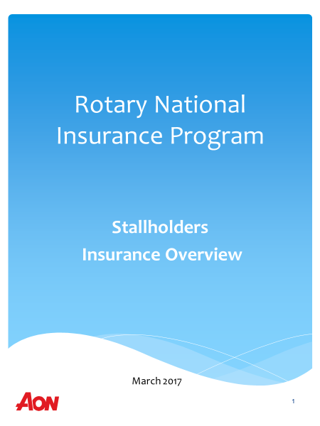

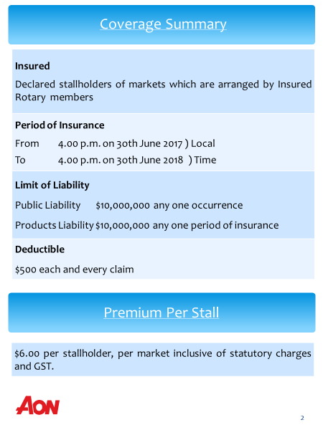

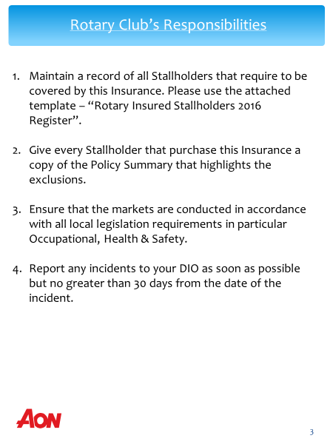
Work Health and Safety

