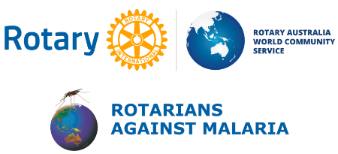
2019 RAM Annual Conference
24th & 25th August 2019
Ciloms Airport Lodge, Tullamarine,
Melbourne

Excellent speakers have been organised to update attendees on such topics as; global malaria statistics; malaria in pregnancy and the malaria vaccine PlasProtecT® research. Find out about civil societies’ roles in malaria elimination. Learn about the malaria elimination needs and achievements in our partner countries: Papua New Guinea, Solomon Islands, Vanuatu, Timor Leste and West Timor.

Pre-Conference Workshops - NEW this year, the RAM Conference offers two informative workshops on the Saturday morning (24th August)

Registration fees
Pre-Conference Workshop: $15 per workshop
Full Registration: $120 (includes Conference Dinner)
Extra Guest for Conference Dinner: $45.
Single Day: $60 (Saturday or Sunday). Conference dinner at additional cost of $45. Drinks not included.
Rotaractors: $30 for Saturday; $30 for Sunday. Conference Dinner $40. Drinks not included.

As well as hearing invited speakers on the Sunday morning, the Conference Program will include RAM’s General Meeting which will give you an opportunity to contribute to RAM’s annual plan for minimising the impact of malaria in our neighbouring countries. This Meeting also includes orientation for new Regional Coordinators and District Chairs.

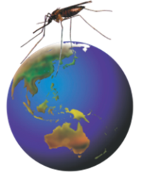
We look forward to welcoming you to our Conference.
Online registration, a more detailed flyer (that includes
accommodation details) and the Conference Program is now
open on our website www.ram.rawcs.com.au

Registration closes on August 12th RAM

