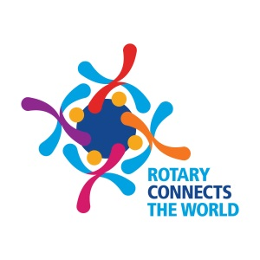

It only takes a minute to donate life!

DonateLife Week Sunday 28 July – Sunday 4 August 2019

If every registered organ and tissue donor found one person who wasn’t and encouraged them to register, we would double the number of potential donors on the Australian Organ Donor Register – this year Rotary is calling on all registered donors to find their plus one for DonateLife Week 2019.

Held every year, DonateLife Week is a key event that highlights the benefits that organ and tissue donation has for transplant recipients and their families in Australia. Rotary Clubs across Australia are supporting the DonateLife Week campaign by encouraging families to register and discuss their organ and tissue donation decisions to help save more lives.

“Organ and tissue donation is the ultimate gift. You can save and improve the lives of many people as an organ and tissue donor,” said [XXXXX, President of the Rotary Club of XXX].

“While many Australians agree with donation, only one in three has registered on the Australian Organ Donor Register. Registration is so important because it leaves your family in no doubt of your decision to save lives as an organ and tissue donor,” said [XXXXXX].

We want everyone to talk about organ and tissue donation. Your family needs to know your wishes to be a donor and we also encourage you to chat to ‘a plus one’ – a colleague, neighbour, teammate or other relatives and encourage them to register too.

“With 1,400 Australians currently on a waiting list for a life-saving transplant and a further 11,000 on dialysis, we’re asking people in our community to make their decision count and join the Australian Organ Donor Register. It’s so quick and easy to register online at donatelife.gov.au and it’s a decision that can save lives,” said [XXXXXX].

Organ and Tissue Authority CEO, Lucinda Barry explains, “Registering at donatelife.gov.au to be an organ and tissue donor, takes less than a minute. Registering to be a donor is important because it leaves your family in no doubt of your decision to be an organ and tissue donor.”

“And if every registered donor found one person who wasn’t and encouraged them to register, we could double the number of potential donors. Grab your “plus one” and register today. A plus one can be a friend, neighbour, colleague or other relatives.” Said Ms. Barry.

DonateLife Week is Australia’s national awareness week to promote organ and tissue donation and is led by the Organ and Tissue Authority.

To register your donation decision on the Australian Organ Donor Register, visit www.donatelife.gov.au

For more information, contact the Rotary Club of…………………………… at................................. phone…………….
Australia

