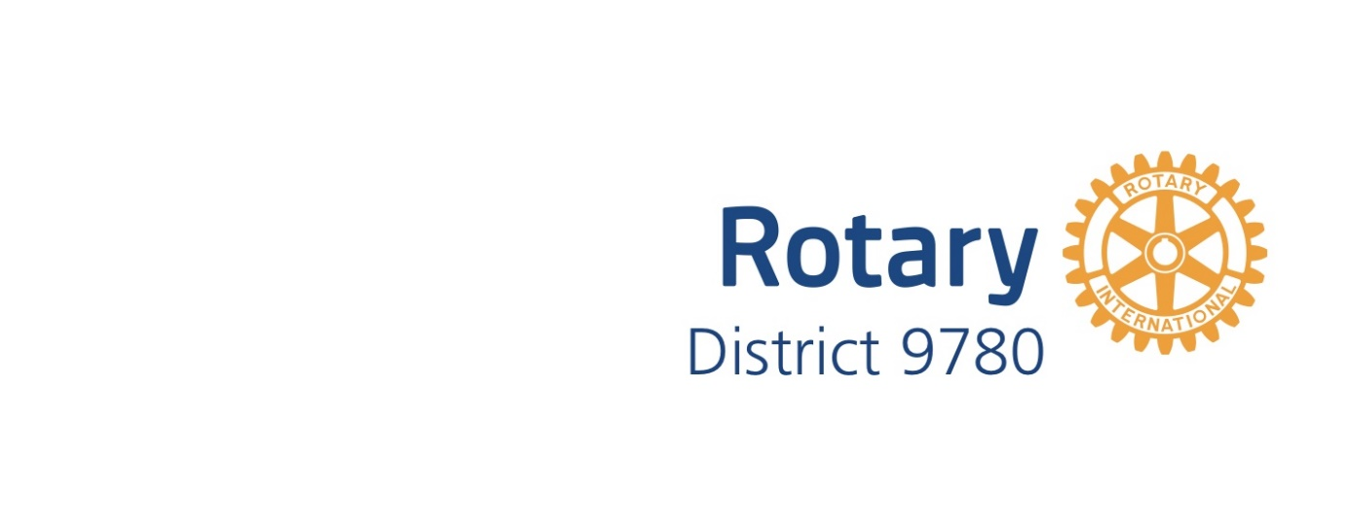

District 9780 EnviroClub Awards

Application Form – Bronze Award
A Bronze Award is the first of three levels of recognition of your club’s environmental achievements. The District 9780 Sustainable Communities Committee will review your application on the basis of criteria at the appropriate level for the Award. The Committee will then make a recommendation to the District Governor who will make the final decision as to whether your club receives this level of Award. Refer to the EnviroClub Awards Information Pack for further details about requirements and assessment criteria. Please complete all sections below.
Rotary Club Name

Rotary Year

Name of Club Environment Officer
Club ES Committee formed | - YES  - No
Signature of Club Environment Officer
Name and signature of Club President
Date

Summarise your club’s submission for a BRONZE Award below
- Current environmental activities, projects and events by the club or individuals?

- Planned environmental activities?

For official use only
Date received

Date considered by District Sustainable Communities Committee
Committee’s observations and recommendations
Date approved by District Governor
Initials of District Governor
Date Award presented to club

