A Legacy to Mary Elliott
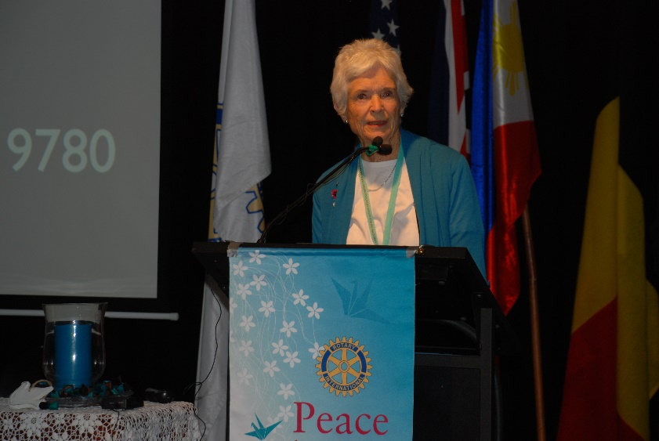
Mary Elliott made her mark on the community with her dedication & commitment to Rotary & all the community Projects, and She was a passionate promotor of the Organ Donor Awareness program, Chair of the District Committee & very active in community campaigns & support to transplant recipients
Mary Elliott was a model of the Rotary motto of Service above Self.
The Torquay Rotary Club will continue Mary’s work through the development of the Mary Elliott legacy –
PP Maggie Isom Chair the District Committee says “ How wonderful that we can continue Mary's amazing work creating awareness about organ and tissue donation”

Your Club can support Donate Life week in many ways
- At your Rotary Club – ask Members to talk to their families/ friends & register
https://donatelife.gov.au/register-donor-today
- Promote Donate Life Week at your local hospital
- at the schools in your area
- in your workplace
- in local media
- in your community
- on social media
check out the resources https://donatelife.gov.au/resources/donatelife-week

Contact Maggie on marg.isom@gmail.com or 0412713102

