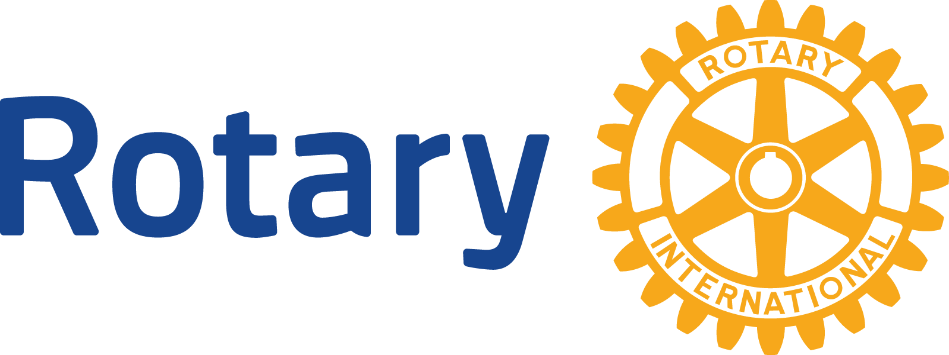

ENGLISH (EN)

# GLOBAL GRANTS COMMUNITY ASSESSMENT RESULTS

#### Use this form to report community assessment findings to The Rotary Foundation when you apply for a global grant.

Assessing the strengths, weaknesses, needs, and assets of the community you plan to help is an essential first step in designing an effective and sustainable global grant project. See [Community Assessment Tools](https://my.rotary.org/en/document/community-assessment-tools) for full instructions and helpful tips.

This form will help you report the results of your community assessment, and it’s required when you apply for any humanitarian or vocational training team grant. Complete a separate form for each beneficiary community (e.g., school, health care system, or village), using information that is both current and specific to each community. Remember, you can’t use global grant funds to cover the cost of doing an assessment, but you can use district grant funds.

Beneficiary community or institution

Rehabilitation and Mobility Treatment Centres in Western Pacific Islands, and ultimately the patients they service, with special emphasis on prevention of diabetic limb amputation and improved outcomes in the treatment of amputees with mobility devices.

Groups in the community that would receive a clear, direct, and immediate benefit from the project

Nursing and medical personnel, physiotherapists, prosthetic and orthotic clinicians and technicians, occupational therapists and other allied health professionals. The development of these health professionals, and the services they provide, would ultimately benefit all the patients they treat.

Beneficiaries’ demographic information, if relevant to the project

The centres with mobility device services in the Western Pacific include:

Papua New Guinea, Marshall Islands, Kiribati, Solomon Islands, Vanuatu, Fiji, Samoa and Tonga. All centres offer very basic services and there are enormous needs for development and capacity building throughout the Pacific region.

Who conducted the assessment? (check all that apply)

Host sponsor members

International sponsor members

A cooperating organization

University

Hospital

Local government

Other :Delegates attending the Pacific Rehabilitation and Mobilty Conference included representatives from all of the above categories

Assessment dates

2-5 April 2019 : Pacific Rehabilitation and Mobility Conference

3 April 2019 (evening): Discussions with the Rotary Club of Fiji

6 April 2019: Additional discussions with possible partners and trainers

What methods did you use? (check all that apply)

Survey

Community meeting

Interview

Focus group

Asset inventory

Community mapping

Other : Attended presentations on current policies, needs assessments, reports and programs as well as workshops, meetings and discussions at every level

Who from the community participated in the assessment?

Representatives from all countries in the specified area included nursing and medical personnel, physiotherapists, prosthetic and orthotic clinicians and technicians, occupational therapists and other allied health professionals, as well as university and government officials. Discussions were also held with other cooperating organisations and sponsors. Two patients with amputated limbs were also consulted.

List the community needs you identified that your project would address.

1.Continuing professional development in line with existing strategies, and development of capacity in the rehabilitation services of the Western Pacific

2. Building on the work already being done by partnering with those who have the local knowledge and expertise

3. Support regional networking and peer-to-peer mentoring

List any needs you identified that your project would not address.

1. The needs are many and the resources very limited. Our project can only focus on one area at this stage - that of staff development.

2. The lack of funds, services and equipment will not be addressed.

3. Many patients in rural areas have no access to services. This might be slightly improved with more training of field workers but will not be the major focus of our project.

List the community’s assets, or strengths.

1. Those who have been trained (often very basic training) are handling extreme case loads and sometimes doing three or more job descriptions in poor conditions without adequate materials or equipment.

2. Some trained professionals are working without salary as the health department budget sometimes will not stretch to paying their salaries. This shows real commitment and dedication.

3. Services rely greatly on charities for funding and equipment but are very keen to develop their own departments and staff

Considering the needs and assets you listed, explain how you determined the project’s primary goal.

Motivation Australia has done absolutely wonderful work in this area and has developed a very impressive plan for Continuing Professional Development (CPD). We decided that if Rotary partners with them we could help build on the existing framework in the most inclusive way to develop a CPD Mentoring Partnership Program which is truly driven by the local needs.

How would your project’s activities accomplish this goal?

We plan to develop a mentoring CPD program with Motivation Australia, and possibly other organisations, which has clear objectives, as defined by the local needs analysis already completed. This should ideally be an on-going program but our global grant will focus on a 1-3 year plan. Once the training plan is approved, by all partners, qualified trainers will be recruited and provided with orientation on Pacific needs and standards. The training will be deployed on a needs basis as assessed locally (dependent on funding). Our global grant funds will be allocated to paying the travel and accommodation costs of the training team/s.

What challenges have prevented the community from accomplishing the project’s goals?

Lack of funds

Lack of expertise and education

These communities live in poverty without resources to even pay salaries to those who have qualified in training such as prosthetics and orthotics

The incidence of diabetic foot disease and lower limb amputation is astronomical due to many reasons including poverty, poor diet, lack of education, genetics, very poor primary health care etc.

Isolation of small communities makes CPD nearly impossible to provide without the support of NGO Motivation Australia

How is the community addressing these challenges now?

The few trained staff are working very hard, in poorly resourced centres, and are reaching out for help to improve their own skills and those whom they develop. There is an impressive will to become self-sufficient but lack of funds makes it impossible.

Why are the project’s activities the best way to meet this community need?

The development of capacity in existing rudimentary repatriation health systems can build on focused workers, and build on the early links established by Motivation Australia. By the provision of mentoring, education and support for these small departments, we can help them provide a 21st century service to otherwise permanently incapacitated individuals.

There is a good focus on equity and equality in the Pacific which came across very clearly!