RI 2023 International Convention 27- 31May 2023 Oct 2022
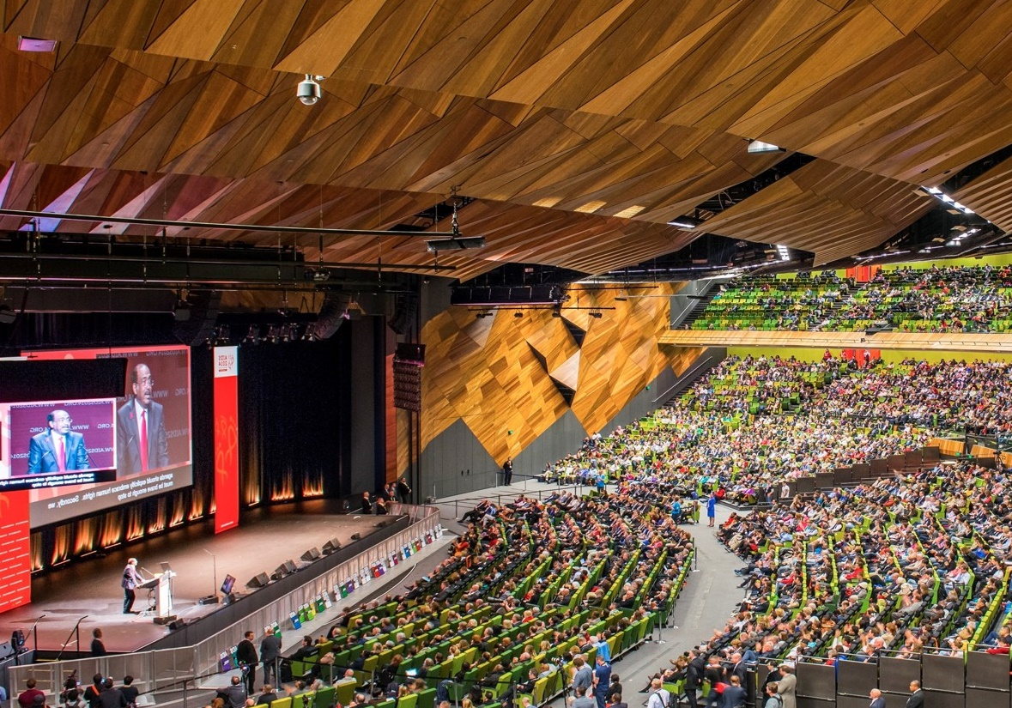
RICON 2023 - Exciting Volunteer Opportunities!!

The Host Organising Committee (HOC) is looking for Volunteers to assist with the running of the Rotary International Convention in May 2023 (RICON23) in Melbourne. Volunteers are required to primarily assist as Welcome Marshalls at the main convention sites ( Melbourne Convention and Entertainment Centre and Rod Laver Arena ) as well as at HOC Events, Major Block Hotels, Tullamarine Airport and Southern Cross Station. Volunteers shall also be first-hand providers of information and advice to delegates on a variety of aspects of RICON23.

So, Why Volunteer for RICON23?

- Volunteering is what we do as Rotarians – to assist in the largest RI event is an opportunity to be an Ambassador for Rotary and our Zone.
- Provide a friendly face and smile to delegates attending from all over the world – to demonstrate we are a Zone of welcoming Rotary Members and Non Members.
- Demonstrate our impact of embracing Diversity, Equity and Inclusion by having a diverse workforce of Volunteers. Volunteering is also open to Non Rotary Members – we encourage family and friends and potential members to attend and volunteer.
- An opportunity to see and witness first-hand the big picture of Rotary.
- Connecting with thousands of like-minded people – and the opportunity to develop friendships outside of your Club, District and Zone.
- Most shifts are for four hours – a time frame that allows you to assist but also spend plenty of time visiting other aspects and events during RICON23.
- You do not have to register for the Convention to volunteer, provided you choose a shift outside the Convention venues. However, by registering as a delegate to attend RICON23 you can also share the load by volunteering for a shift at the two main Convention venues.

How Do I Volunteer?

- It’s easy – just visit the HOC website https://rotarymelbourne2023.org
- The website provides details on how to register as a volunteer on the Volunteer tab. You shall eventually be able to select your job and shift as a volunteer as the program develops.

Opportunities for Clubs

- Clubs have the opportunity to Volunteer as a block – by registering individually and then selecting the desired job and shifts with your fellow club members to book out that volunteer block. Why not use Volunteering at RICON23 as replacement for your weekly club meeting for the time of the Convention: May 25th – May 31st 2023 ?
- Use Volunteering at RICON23 as a fellowship activity. You can work with your club members – or pair with a neighbouring club – at a job and shift of your choosing.
- Why not attend some of the HOC Events as a club fellowship activity – or for clubs close to the event venues, volunteer as a club for a specific HOC Event.

Attending RICON 2023

- Delegate registration is open via the MyRotary tab at www.rotary.org This shall enable you to attend RICON23 and volunteer inside the main convention venues.
- There is an opportunity to Volunteer outside the main Convention venues if you are not a registered delegate for RICON23. For example, Volunteers are required to welcome delegates at the Opening and Closing ceremonies outside Rod Laver Arena – a major venue and maximum impact to act as a Welcome Volunteer.
- Registration is available for the entire Convention program or for attendance just on the Saturday May 27th to visit the House Of Friendship.

So What Do I do Now to Assist?

Please visit rotarymelbourne2023.org and register as a Volunteer. This is a major event for Zone 8, and by working together we can embrace the opportunity to showcase Rotary.

For any specific information or assistance, please contact either Stephen or Jane by email

Stephen Lamont Jane Pennington
Director of Services and Volunteers Volunteer Registration Coordinator RICON23
Host Organising Committee – RICON23 Jane.Pennington@rotary9800.org
stephenlamont9780@gmail.com

