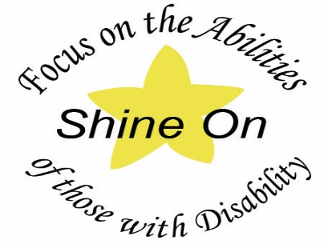

Districts: 9780, 9790, 9800, 9810, 9820

Rotary International Southern Districts
SHINE ON RECOGNITION EVENT
2022-23
will be held on
Saturday, 14th May, 2023
from 1pm to 4pm

to recognise and celebrate the volunteer
community work of anyone with a disability

VENUE: The Templestowe Baptist Church Hall,
Anderson Creek Rd, Doncaster East, 3109

Send Completed Forms & Documents Via Email to

EMAIL: lara.barrett.secretary@gmail.com
ENQUIRIES: to the Secretary, Lara Barrett
MOBILE: 0416 262 615

CLOSING DATE for Nominations: 1st January 2023

