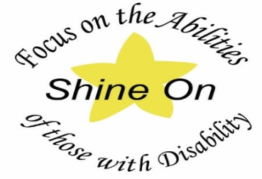
‘Shine On Recognition Event’
What is it?
- This event is to recognise outstanding service, to the local and wider communities, by persons with any disability – chronic, physical, intellectual or a mental health disorder.
- The Event is comprised of two levels, Certificates of Commendation and Awards Trophies.
- There are two age brackets, 15-25 years and over 25 years, and can be for any field of endeavour.

The Committee: The Rotary Districts of D9780, D9790, D9800, D9810 & D9820 each have two representatives chosen by the District Vocational Chairpersons. The committee organizes the rotation of the Awards Ceremony around the districts, seeks sponsorship and funding. The Committee Members disseminate materials to the Clubs and to District Assemblies, as well as promoting the Awards to the wider community, through radio and other media.

Nominations: Anyone can nominate a person, who has: a permanent injury; a mental health disorder; an intellectual and/or physical disability, and contributes to their community by doing Volunteer Work.
- A Rotarian must then assist the nominee to complete the Nomination Form and sign off on behalf of their club.
- The Nomination Form can be accessed through your District website, Facebook or contact Lara Barrett: details below.
- Places to start looking for your candidate are Local Disability Support Services, Advocacy Services or place a short advertisement in your local paper.

Selection: The three-member selection panel is composed of people from medical, paramedical, disability services or prominent persons with a disability. They are given the selection criteria and determine if a Nominee stands out sufficiently to receive a Trophy as well as a citation to recognise their Community Work.

Awards Recognition Event: Nominees and their families & friends are invited to the ceremony, where a Guest Speaker/s is invited as well as local Mayor, state and federal MP’s, media and a professional Photographer attends. Every Nominee is recognized and presentations are made by District Governors. Each nominee receives a certificate and/or trophy and afternoon tea is provided.

ENQUIRIES: Contact: Lara Barrett: M: 0416262615 Email: lara.barrett.secretary@gmail.com

FACEBOOK – Shine On SD
Supported by the Bendigo Bank .

