Reversing a member termination within ClubRunner
Occasionally the situation may arise where a member has been terminated from their club and would like to have their membership reinstated. However due to restrictions within the RI Integration system, once a member has been terminated this cannot be directly undone.
Instead the individual should be restored as a member of the club, along with a new updated Club Join Date.
- Login to your Club or District website member area
- Navigate to the inactive members list, where you will find the member’s inactive member record.
- Visit the member’s profile and access the Rotary tab to note the following information:
  - Date Joined Club
  - Termination Date
- Once you have noted down this information, navigate back to the inactive members list page.
- Back on the inactive members list page, click the "Change Status" link. For more information on how to re-instate an inactive/terminated member, please see click here
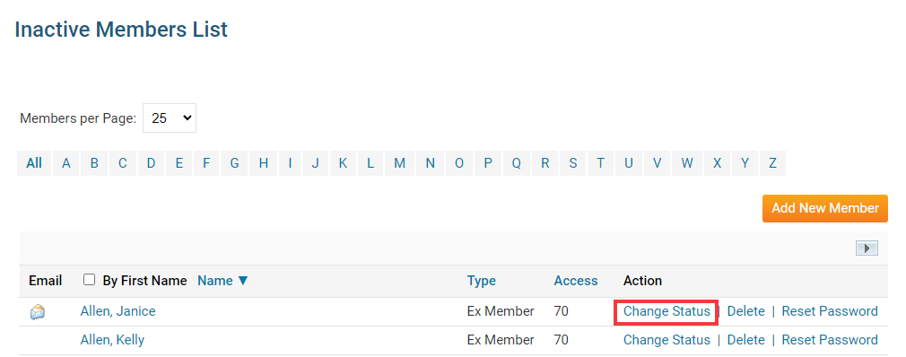
- After clicking Change Status you will be prompted with three options. Select "Activate Membership".
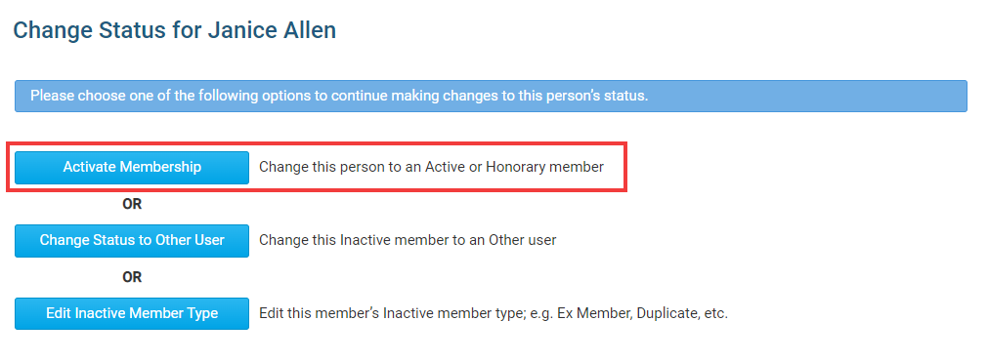
- Within the Activate Membership page, update the Date Joined Club field to a date later than the date the member had originally been terminated from the club. For example if the member was terminated on November 26th 2021, a date of November 27th 2021 or later should be entered.
Note: The date entered here is temporary and will be updated to the member’s original club join date at a later step. Should a date prior to the termination date be entered, their membership will be unable to be re-activated with Rotary.
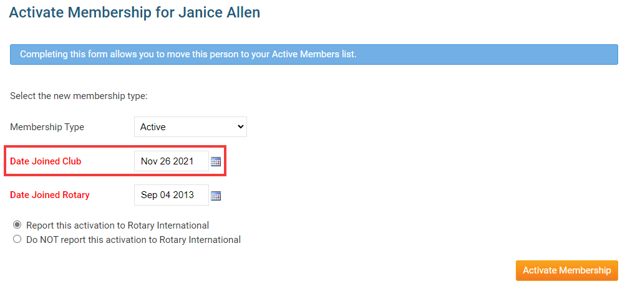
- Click on the Activate Membership button to finalize this change and re-activate their membership. Once this has been done, the user’s membership will be synchronized over to Rotary as a new member of the club, using the entered club join date.
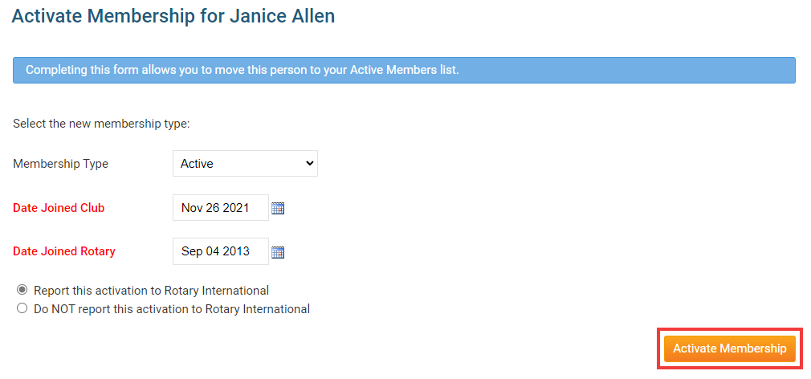
- To correct this club join date within ClubRunner, navigate to the member’s profile and click their "Rotary" tab. From here you can edit the member’s Club Join Date to the original date that was listed in their profile previously. Please see click here for more information on how to edit a member’s profile.
- Due to restrictions with the RI Integration system, ClubRunner is unable to synchronize a member’s join dates with Rotary. To proceed, please email the Rotary Data Corrections team who will be able to update the member’s club join dates on Rotary’s end as well.
  - Rotary Data Corrections - data@rotary.org
- When reaching out to the Data Corrections team, you may provide them with the following information to assist in completing this update:
  - Your name and club
  - Member Name
  - Member Rotary ID
  - Correct Club Join Date

