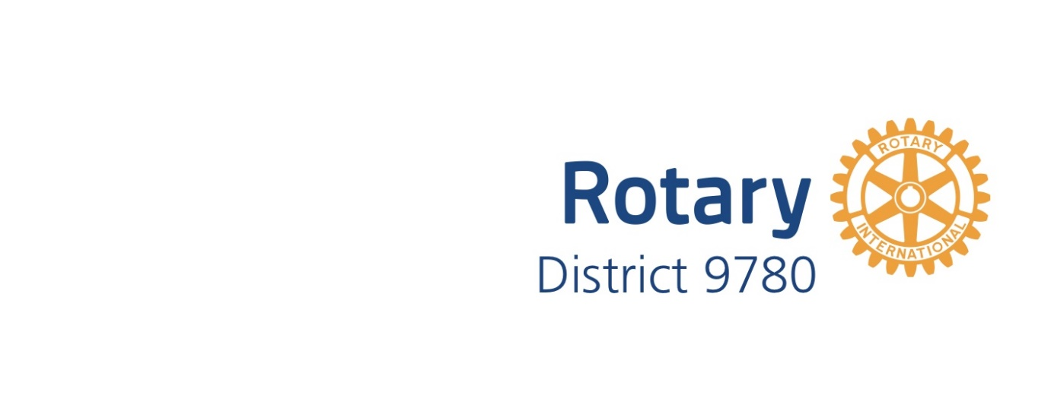

District 9780 EnviroClub Awards

Application Form – Bronze Award
A Bronze Award is the first of three levels of recognition of your club’s environmental achievements. The District 9780 Environment Committee will review your application on the basis of criteria at the appropriate level for the Award. The Committee will then make a recommendation to the District Governor who will make the final decision as to whether your club receives this level of Award. Refer to the EnviroClub Awards Information Pack on the District 9780 website for further details about requirements and assessment criteria.
Please be aware that photographs and details of your environmental projects may be used by the District 9780 to showcase your project to the wider Rotary community. To avoid any copyright infringements please ensure that you have the permission of the original photographer to use their images.
Please complete all sections below and attach photographs of your projects to the application when submitting.
Rotary Club Name

Rotary Year

Name of Club Environment Officer
Club ES Committee formed (include month/year) | - YES  - No
Consent for Rotary to use photographs and project details in promotions. | (Please write yes or no in this box)
Signature of Club Environment Officer
Name and signature of Club President
Date

Summarise your club’s submission for a BRONZE Award below
- Please list current environmental activities, projects and events by the club or individuals? Please include month/year projects commenced and/or completed.

- Please list planned environmental activities.

For official use only
Date received

Date considered by District 9780 Environment Committee
Committee’s observations and recommendations
Date approved by District Governor
Initials of District Governor
Date Award presented to club

