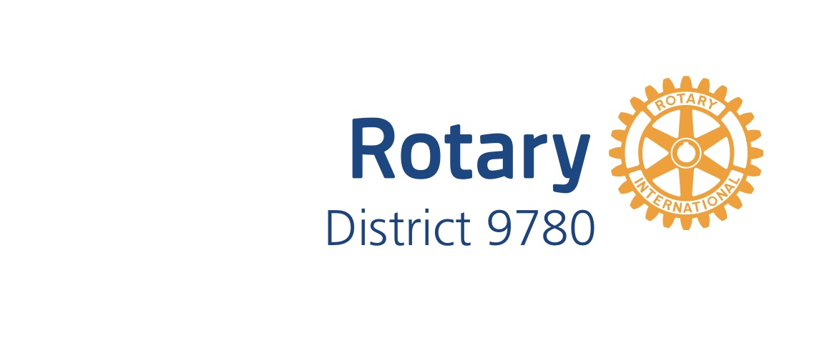District 9780 EnviroClub Awards

Application Form – Gold Award
A Gold Award is the third of three levels of recognition of your club’s environmental achievements. The District 9780 Environment Committee will review your application on the basis of criteria at the appropriate level for the Award. The Committee will then make a recommendation to the District Governor who will make the final decision as to whether your club receives this level of Award. Refer to the EnviroClub Awards Information Pack for further details about requirements and assessment criteria. Please complete all sections below and attach at least one photograph for each project to the application when submitting.
Please be aware that photographs and details of your environmental projects may be used by the District 9780 to showcase your project to the wider Rotary community. To avoid any copyright infringements please ensure that you have the permission of the original photographer to use their images.

Rotary Club Name

Rotary Year

Name of Club Environment Officer
Club ES Committee formed | - YES  - No
Holds current Silver Award | - YES  - No
Consent for Rotary to use photographs and project details in promotions. | (please yes or no here)
Signature of Club Environment Officer
Name and signature of Club President
Date

Summarise your club’s application for a GOLD Award below
- Please list at least TWO additional environmental activities, projects, and events to those reported in the application for the SILVER Award, including relevant information to describe each project, and date (month/year) commenced and/or completed. Refer to the assessment criteria in the information pack when writing about your projects.

- Demonstrate that the projects and events described in the SILVER Awards application have been significantly improved or completed. (month/date)

- Please show evidence of communicating the environmental initiatives reported in the application for the SILVER Awards (e.g. in the club/District newsletters and/or the media/significant social media)

For official use only
Date received

Date considered by District Sustainable Communities Committee
Committee’s observations and recommendations
Date approved by District Governor
Initials of District Governor
Date Award presented to club

