APPENDIX F14: Rotary project risk assessment form

  - Rotary Project Risk Assessment Plan
  - Template v0.1 202509

Project Title: [Insert Project Title]
Project Manager: [Name and Contact Information]
Project Location: [Location(s)]
Assessment Date: [Date]
Team Members Involved in Risk Assessment: [List Names and Roles]

  - Introduction
Provide a brief overview of the project/event and the purpose of this risk assessment.

  - Project Objectives:
- [Objective 1]
- [Objective 2]
- [Objective 3]

  - Purpose of Risk Assessment:
Describe why this risk assessment is being conducted and its importance to the project's success.

  - Risk Identification and Classification
List and describe potential risks that may affect the project/event. Categorize them into groups such as financial, operational, environmental, reputational, or safety risks. (Add categories and rows as needed.)

 | Step 1  Identify the hazards |  | Step 2  Assess the current risk, use tables 1, 2, 3 | Step 3  Control the risk | Step 4  Assess the remaining risk, use tables 1, 2, 3 again | Step 5  Action to be taken | Step 6  Accountable person to implement action and date by
No. # | Identify the hazards | What is the harm associated with the hazard? | Is the risk low, medium, high, or extreme? | What controls are already in place and what else needs to be done to reduce or remove the risk? | Now that controls have been put in place, reassess the risk | List the actions to be taken | List the person who will implement the action
Financial
1
2
Operational
Environmental
Reputational
Safety
Other

  - Monitoring and Review
Describe how risks will be monitored throughout the project lifecycle and how adjustments will be made.

  - Monitoring Plan:
- Regular check-ins: [Frequency]
- Reports: [Type and Frequency of Reporting]
- Updates to the risk plan: [Describe Process]

  - Review Schedule:
- [Describe how often the plan will be reviewed and updated.]

  - Emergency Response Plan
Prepare for unforeseen circumstances that may require immediate action.
Risk ID | Emergency Response Strategy | Contact Information
1 | [Description of Emergency Response Strategy] | [Name/Phone/Email]
2 | [Description of Emergency Response Strategy] | [Name/Phone/Email]
3 | [Description of Emergency Response Strategy] | [Name/Phone/Email]

  - Approval and Sign-Off
Document acknowledgment and approval of the risk assessment plan by key stakeholders.
Prepared By:
Name: [Preparer's Name]
Role: [Preparer's Role]
Date: [Date]
Approved By:
Name: [Approver's Name]
Role: [Approver's Role]
Date: [Date]

Table 1: Consequence Rating Table

Consequence | Description
Insignificant | Won’t cause serious injuries or illnesses
Minor | Can cause injuries or illnesses only to a mild extent
Moderate | Can cause injuries or illnesses that may require medical attention but limited treatment
Major | Can cause irreversible injuries or illnesses that require constant medical attention
Catastrophic | Can result in fatality

Table 2: Likelihood Rating Table

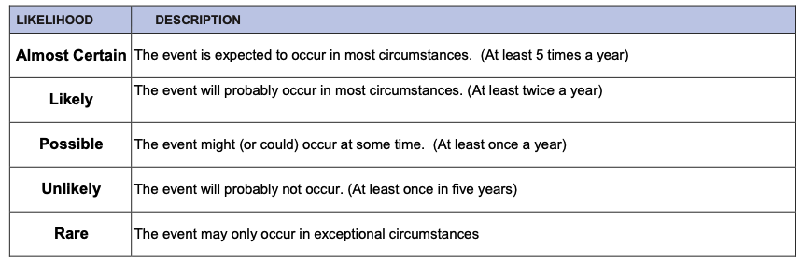

Table 3: Risk Analysis Matrix

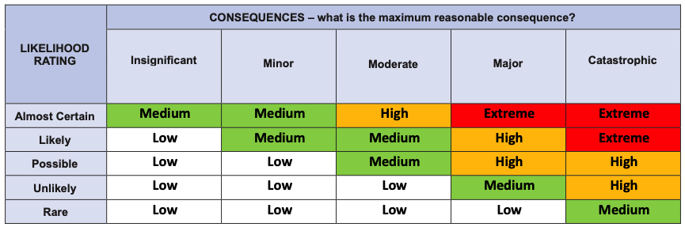

Table 4: Hierarchy of Control

You may like to use the Hierarchy of Control and its levels to help you work out the best control for your risks. Start at the top (Level 1) for the most effective way of reducing your hazard and work your way down until you are happy that you have controlled your risk.


