How do I transfer a member to my club?
ClubRunner gives you the ability to transfer members between clubs. This requires action to be taken both at the member's club of origin and at the new club. The steps required for both clubs are outlined below.
Terminating a Transferring Member
1. The transferring member should be removed from the rolls of his or her previous club. To do this, you must login to your ClubRunner site. Then, click on the Membership tab.
2. Next click on the Member Lists link.

3. This brings you to the Active Members List, where you may view all your currently active members. Locate the member who is transferring to another club and click Change Status under the Actions column. Doing so will start the removal of the member from your club.
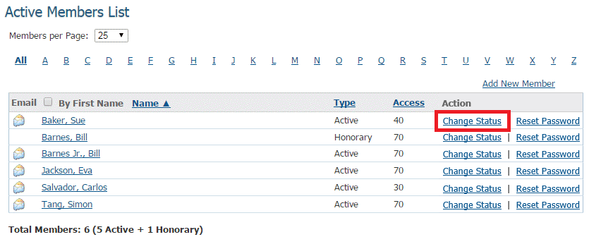

4. You are now on the Change Status page. There are three choices. Click on Terminate Membership to remove the member from the club.
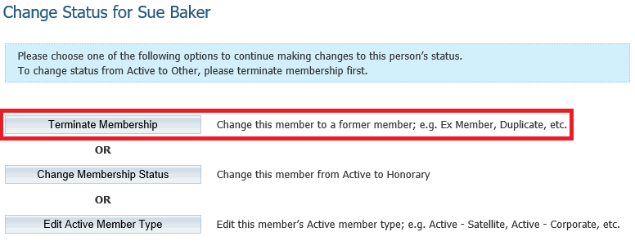

5. Enter the date the member left the club. By default, this is set to the current date. However, you can select a future or past date as appropriate.
Note: Rotary Clubs cannot set the date of termination more than 30 days into the past, or 30 days into the future.
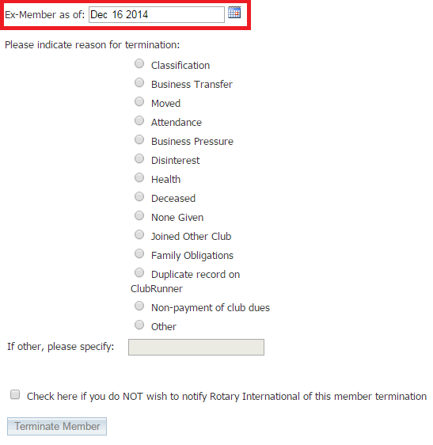
5. Next, select Joined Other Club as the reason for termination.
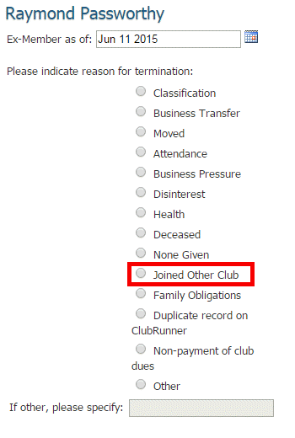

6. Finally, if you do NOT want to inform Rotary International of the transfer, click on the box above the Terminate Member button. Otherwise, leave it unchecked. Then, click on Terminate Member to complete the process. The member has now been removed from your membership lists.
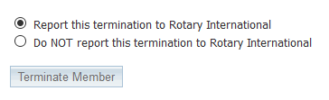
Adding a Transferred Member to Your Club
Please follow the steps below after the previous club removes the member from their club.
1. To add a new member who has transferred from another club, you must be first logged in to your ClubRunner site. Then, click on the Membership tab.
2. Next click on the Member Lists link.

3. This brings you to the Active Members List, where you may view all your currently active members. To add your new member, click on the Add New Member link at the top right of this list.
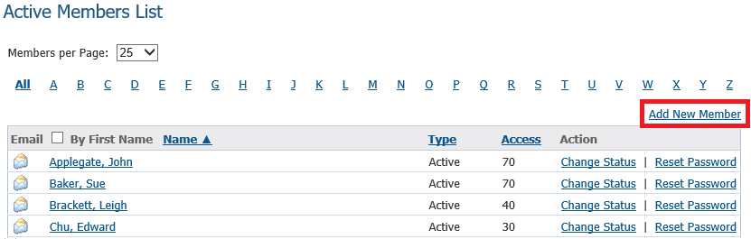

4. You are taken to the New Member screen, where you may enter the member's personal details in the fields provided. Work through this page to add their contact details and address.
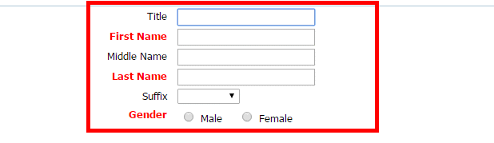

5. In the section labelled Transferring Member? check on the Yes option.
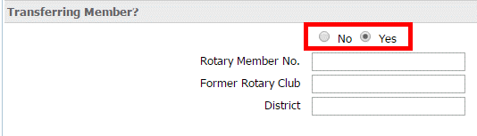

6. Next, fill in their Rotary Member Number, the name of their former club, and the name of their former district.
Note: Members will often transfer within a district. As such their "former" district name may well be the same as their new district.
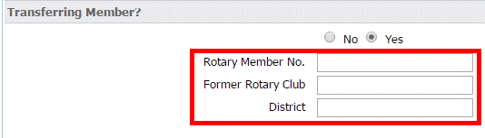

7. You may fill in their ClubRunner Account details as noted below:
- Email: Enter the new member's email account in this field. This represents your primary means of contacting the transferring member through ClubRunner.
- Login Name: A login is automatically generated based on the member's own name, but you may change this as desired.
- Temporary Password: A temporary password is automatically generated, but you may edit it. The new member should change the temporary password once they have logged in.
- Send Email Notification to this Member?: Click on the checkbox next to this field to confirm that you wish to send a welcome email. Then, select the welcome email template from the dropdown menus next to the checkbox.
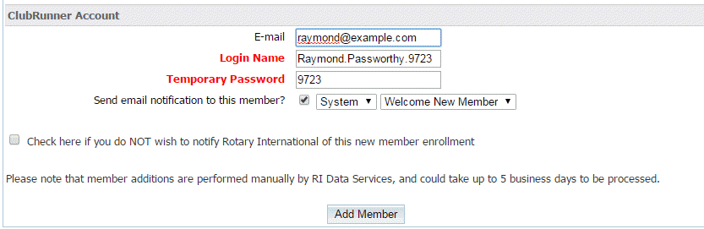

8. Finally, click the checkbox provided if you do NOT wish to notify Rotary International of the new enrollment. Then, click on the Add Member button.

